DO NOT CONSIDER FOR TALK
2021 SEA Symposium Abstract
Gonzaga University
Spokane WA
Corresponding Faculty Member: Ann-Scott Ettinger (ettingera@gonzaga.edu)
Sulamita Skala
Alex Kaiser
Kylie Urbanek
Brooke Rogers
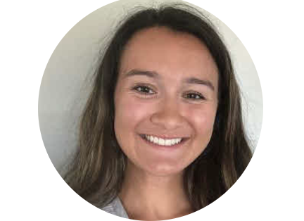
Madeline Garcia
Five New EG Cluster Phages: Phabia, Rudy, Namago, Jehoshaphat, and Blab
Sulamita Skala, Alex Kaiser, Kylie Urbanek, Brooke Rogers, Madeline Garcia, Alli Lombardo, Jacky Marr, Jack Mudge, Hannah Sparber, Sarah Vetsch, Sam Sampinos, Kailey Phillips, Claire Ballard, Joshua Bramwell-Butcher, Lani Abrams, Ann-Scott Ettinger
The Microbacteriophage examined; Phabia, Rudy, Namago, Jehoshaphat, and Blab, are all lytic phages that were isolated from enriched soil samples in Spokane, WA by Gonzaga University using the host Microbacterium foliorum NRRL B-24224. Three of these phages, Phabia, Namago, and Rudy’s sequences and annotations were published this year and 2 are still drafts (Blab and Jehoshaphat). These phages are members of the EG cluster, range from 61769 to 62294 bp in length, and have between 102-107 protein coding genes. Preliminary research shows significant variation upstream of gene 12 (~ 5 Kbp) between all of the phages. This first section of the genome (0-5 Kbp) also corresponds to the initial reverse coding region of the genome, in the pattern of reverse, forward (~5 K bp - 35 Kbp), and then reverse again (~35 Kbp - ~62 Kbp). Our research will include analysis of the high number of repeated sequences in gene #68-72 (gene number varies depending upon the phage). This gene is in Pham 29626, approximately 1600 bp in length and is in every phage in the EG cluster but currently has no known function. There are other areas of nucleotide repeats to be explored as well. We are going to investigate phylogeny, using ClustalW and other programs, to learn more about evolutionary relationships of these newly discovered EG cluster phages before the SEA-Phages Symposium. These 5 new phage bring the total number of EG cluster phage to 24.

