CONSIDER FOR TALK
2021 SEA Symposium Abstract
Arizona State University
Tempe AZ
Corresponding Faculty Member: Susanne Pfeifer (spfeife1@asu.edu)
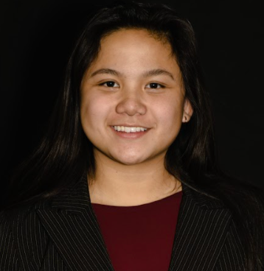
Tiana Hua
Lillian Llyod
Jueliet Menolascino
Saige Munig
Complete genome sequence of Mycobacterium bacteriophage Stinson
Cyril Versoza, Adele Crane, Tiana Hua, Rohan Kapoor, Lillian Llyod, Jueliet Menolascino, Abraham Morais, Saige Munig, Zeel Patel, Brandon Schmit, Makena Sy, Susanne P Pfeifer
The complete genome sequence of Siphoviridae bacteriophage Stinson is 59.9kb long and comprises 78 putative protein coding genes. This subcluster K1 phage, infecting Mycobacterium smegmatis mc²155, has a temperate life cycle which is maintained by the immunity repressor protein, responsible for suppressing lysogenic gene expression.

