DO NOT CONSIDER FOR TALK
2021 SEA Symposium Abstract
Howard University
Washington DC
Corresponding Faculty Member: Courtney Robinson (courtney.robinson@howard.edu)
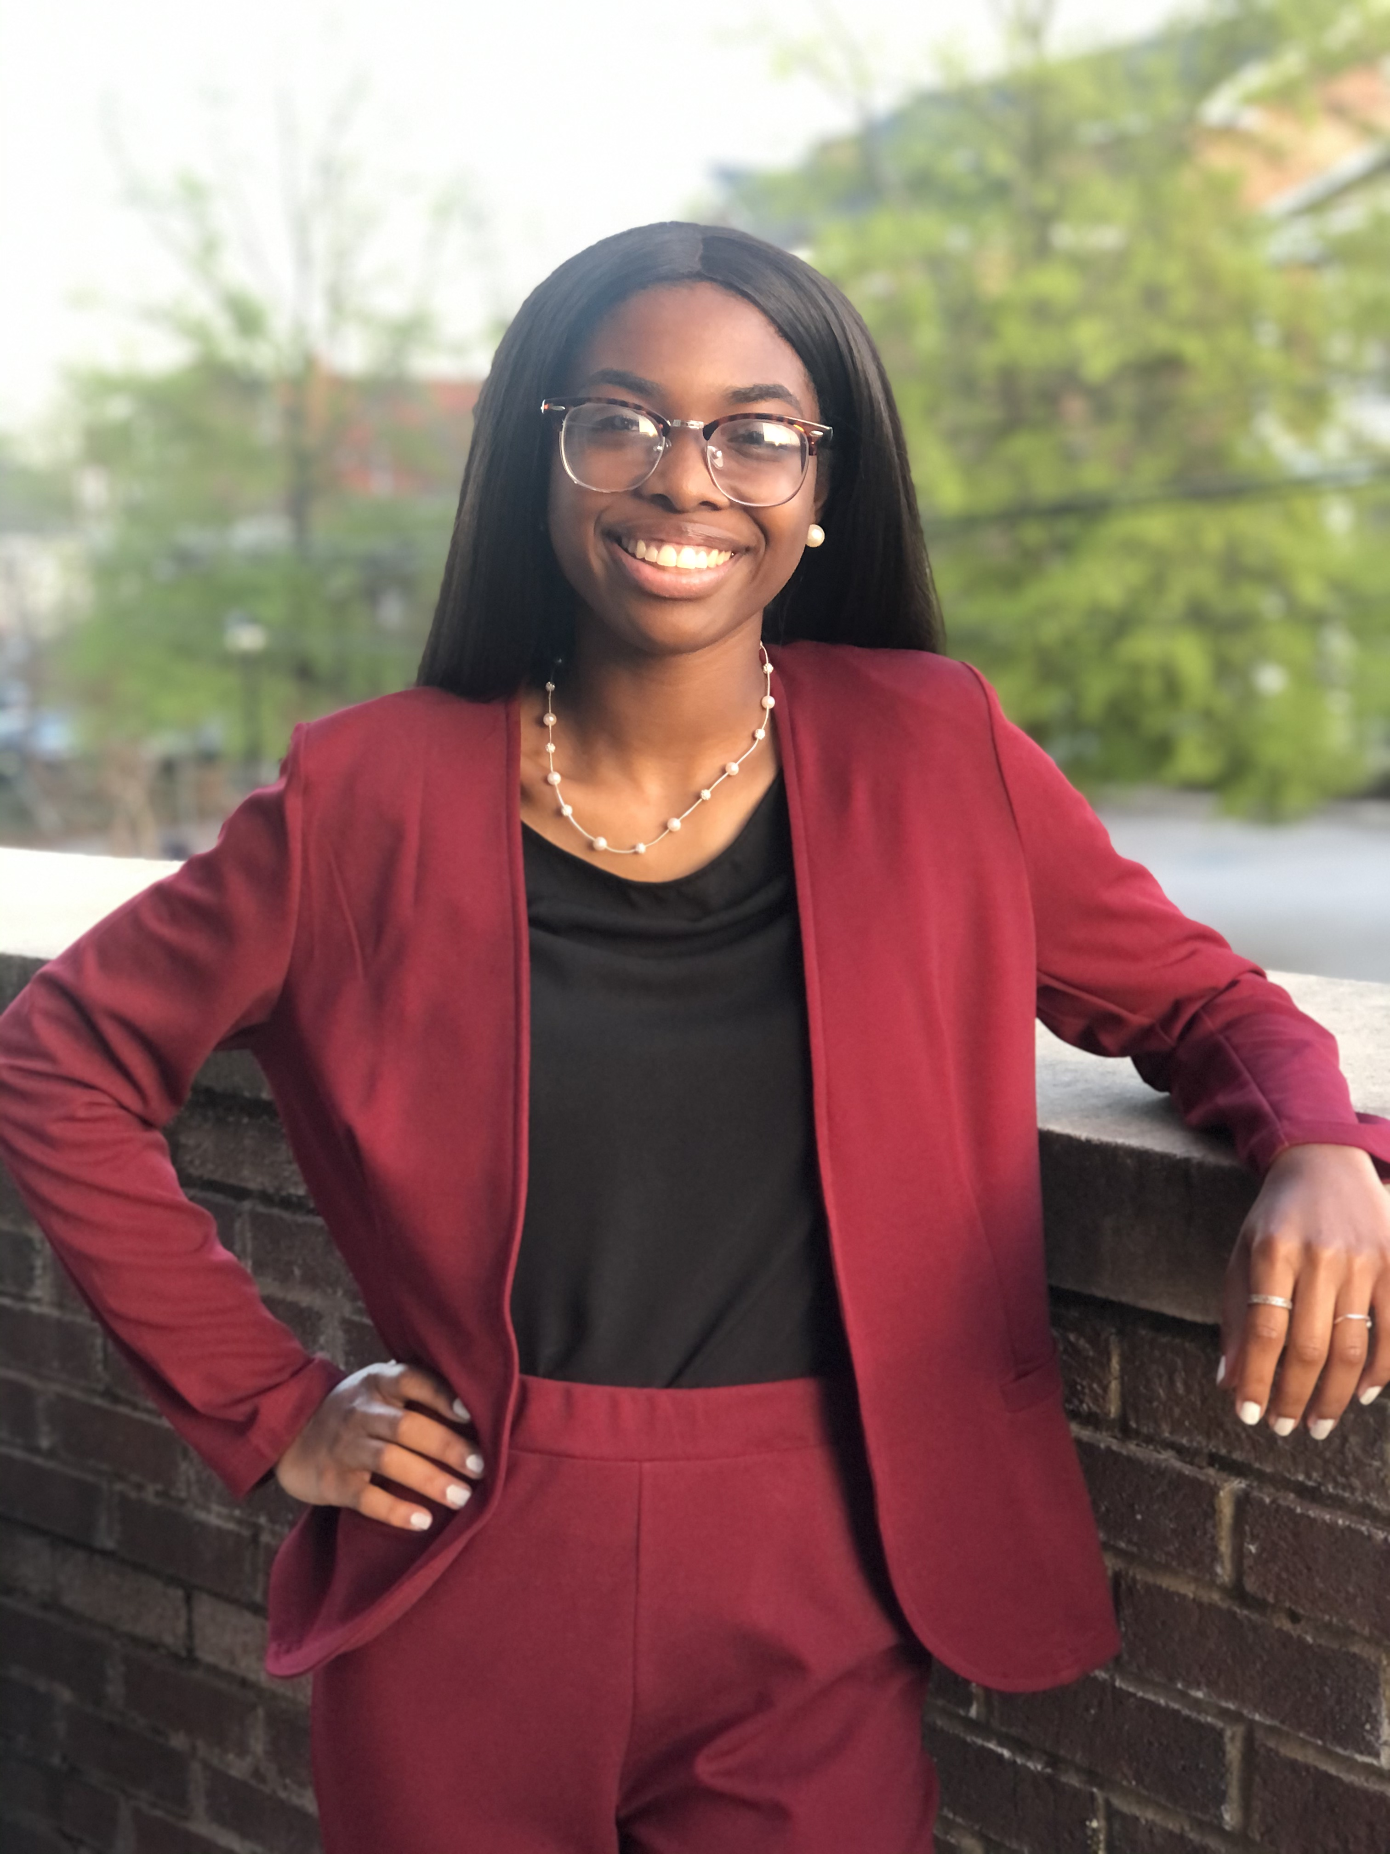
Charis E Haynes
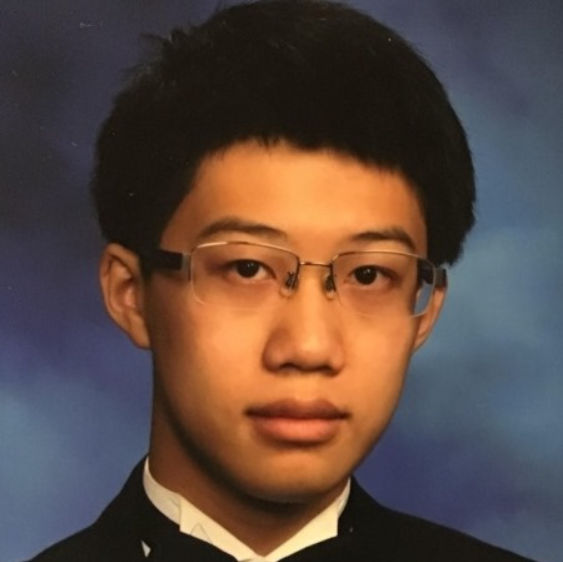
James Z Hsia
Annotation of Cluster B Phages Freya, True and Lars
Charis E Haynes, James Z Hsia, Dayna . Carson, Robert L Sjoholm, Jonathan . Williams, Rachelle . Allen-McFarlane., Glory Bassey, Ayele Gugssa, Madison M Moore, Benedict K Quagraine, Ghosh . Somiranjan, Mary A Ayuk, Courtney J Robinson
Mycobacteriophages Freya and True, isolated by students at Howard University, and Lars isolated by students at Hope College were purified from enriched soil samples using Mycobacterium smegmatis mc2 155 as the host. Genome annotation was carried out by freshmen at Howard University during the 2020-2021 academic year. All of the three phages were of the siphoviridae morphotype and sequence assembly revealed that they had characteristic circularly permuted genome ends. The genome sizes ranged from 67468 to 68922 base pairs with the G+C content ranging between 66.4% to 68.9%. All three phages affiliated with cluster B, with Freya and True belonging to subcluster B1 and Lars being a subcluster B2 phage. Annotation was carried out using PECAAN and HHpred and BLASTp analyses with a cutoff E-value of 10e-4. Genome organization across the three phages was consistent with that of other cluster B phages.

