DO NOT CONSIDER FOR TALK
2021 SEA Symposium Abstract
Montclair State University
Montclair NJ
Corresponding Faculty Member: Kirsten Monsen-Collar (monsenk@mail.montclair.edu)
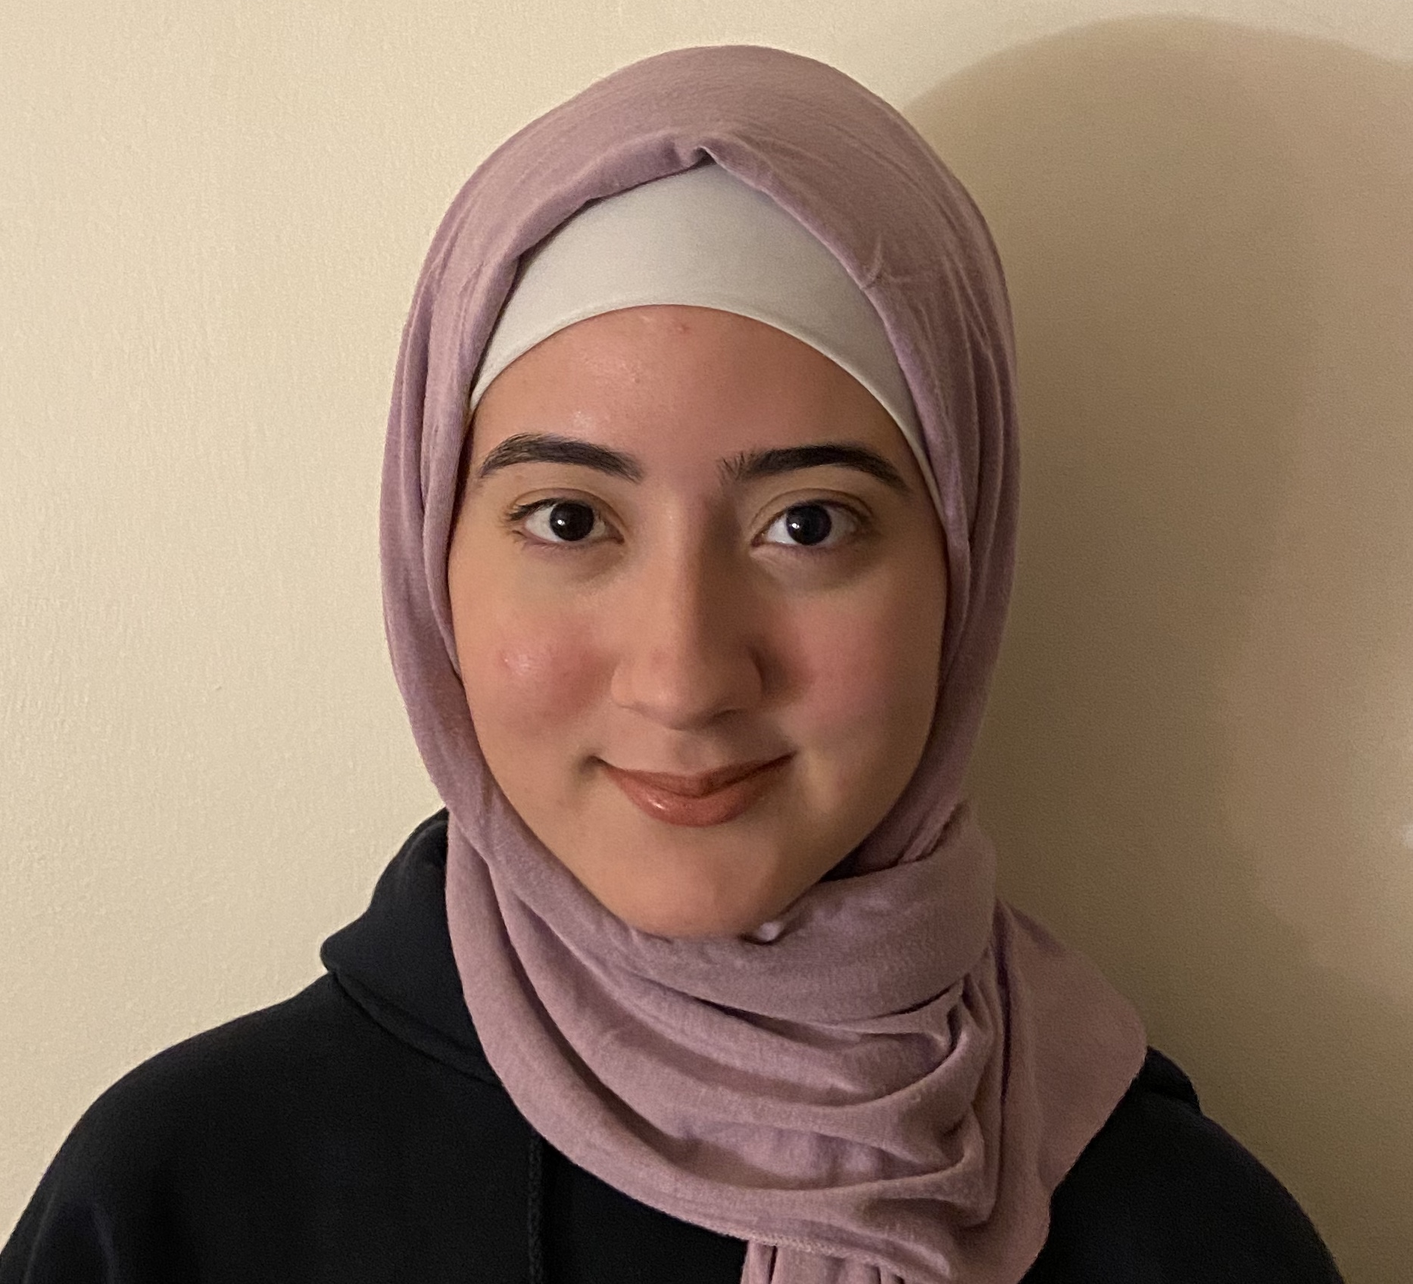
Nedeen Khashashina
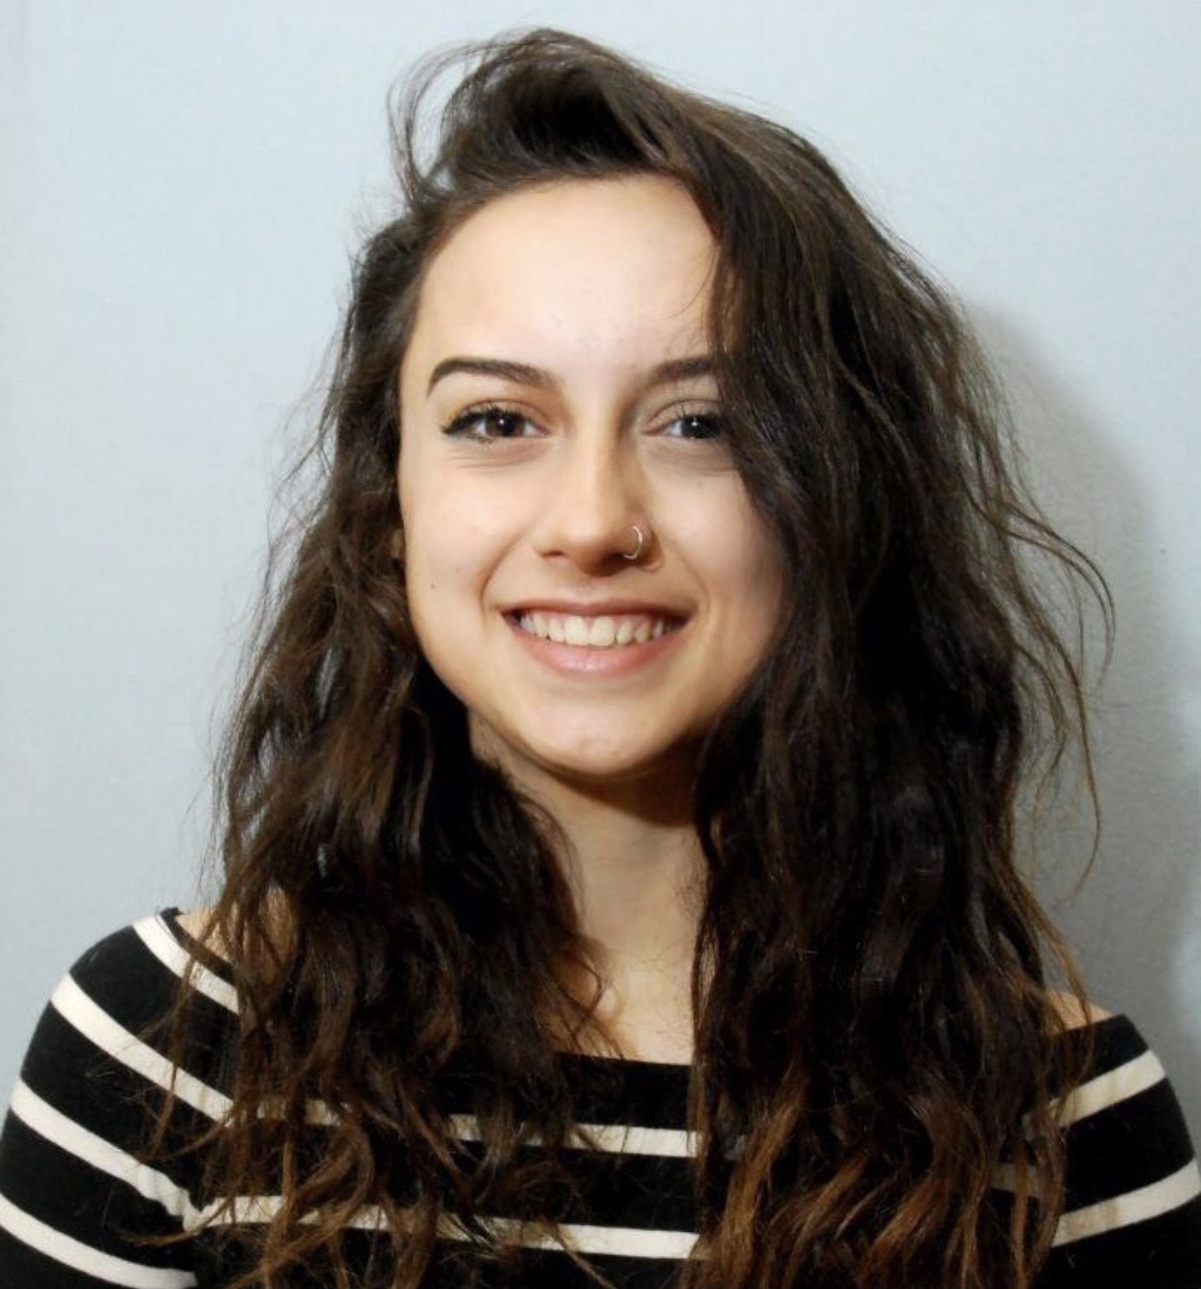
Jessica Scheinbaum
Tomlarah, Jemmno, and Sham4: Three Novel Mycobacterium phage
Nelab Ahmadi, Nancy Alomawi, Samantha Alvarado, Reem Aly, Tomasz Bartoszewicz, Haylee Berry, Paula Chuquimarca Narvaez, Natasha Convertino, Amy Cordero, Liliana Deosaran, Makedonka Dimkova, Damian Dudzik, Ashley Flores, Rileigh Glynn, Giannit Gonzales, Denzel Griffith, Daniela Guerra, Asadi Hamida, Oliver Hernandez, Naserallah Jaber, Farhana Khan, Nedeen Khashashina, Carol Kotry, Hurchille Laguerre, Kyndall Lennon, Devin Lopez, Madeline Lucas, Kingsley Maduka, Maria T Marintobar, Ligia Marques, Jay Marquina, Loren Mengersen, Garret Negron, Emma O'Brien, June Odonnell, Marissa Panarello, Yasmin Panjabi, Angelina Pasquella, Megha Patel, Parth Patel, Erika Perez, Sadia Rahman, Keshvi Rana, Ria Roy, Jessica Scheinbaum, Phillip Sherman, Britney Suero, Peter Tayo, Jacqueline Tilly, Michelle Urrego, Maggy Val, Carlie Van Tassel, Sean Victory, Satoni Zaccaro
To date, students at Montclair State University have isolated 177 phage using Mycobacterium smegmatis, and Arthrobacter sp. as hosts. Of these 177 phage, 19 have been sequenced and 16 have been deposited in GenBank. During the spring of 2021, MSU students are working to annotate the genomes of three novel M. smegmatis phage: Tomlarah, Sham4, and Jemmno. Tomlarah is a subcluster B1 phage with approximately 101 coding genes, Sham 4 is a subcluster A11 phage with approximately 95 coding genes, and Jemmno is a subcluster C1 phage with approximately 265 coding genes. Like other C1 phage, Jemmno’s genome is large (154,848 bp) with an astonishing number of tRNA genes (approximately 28). Work on these annotations is ongoing and the students at MSU anticipate their annotations to be complete by May 1, 2021.

