DO NOT CONSIDER FOR TALK
2021 SEA Symposium Abstract
Tarleton State University
Stephensville TX
Corresponding Faculty Member: Dustin Edwards (dcedwards@tarleton.edu)
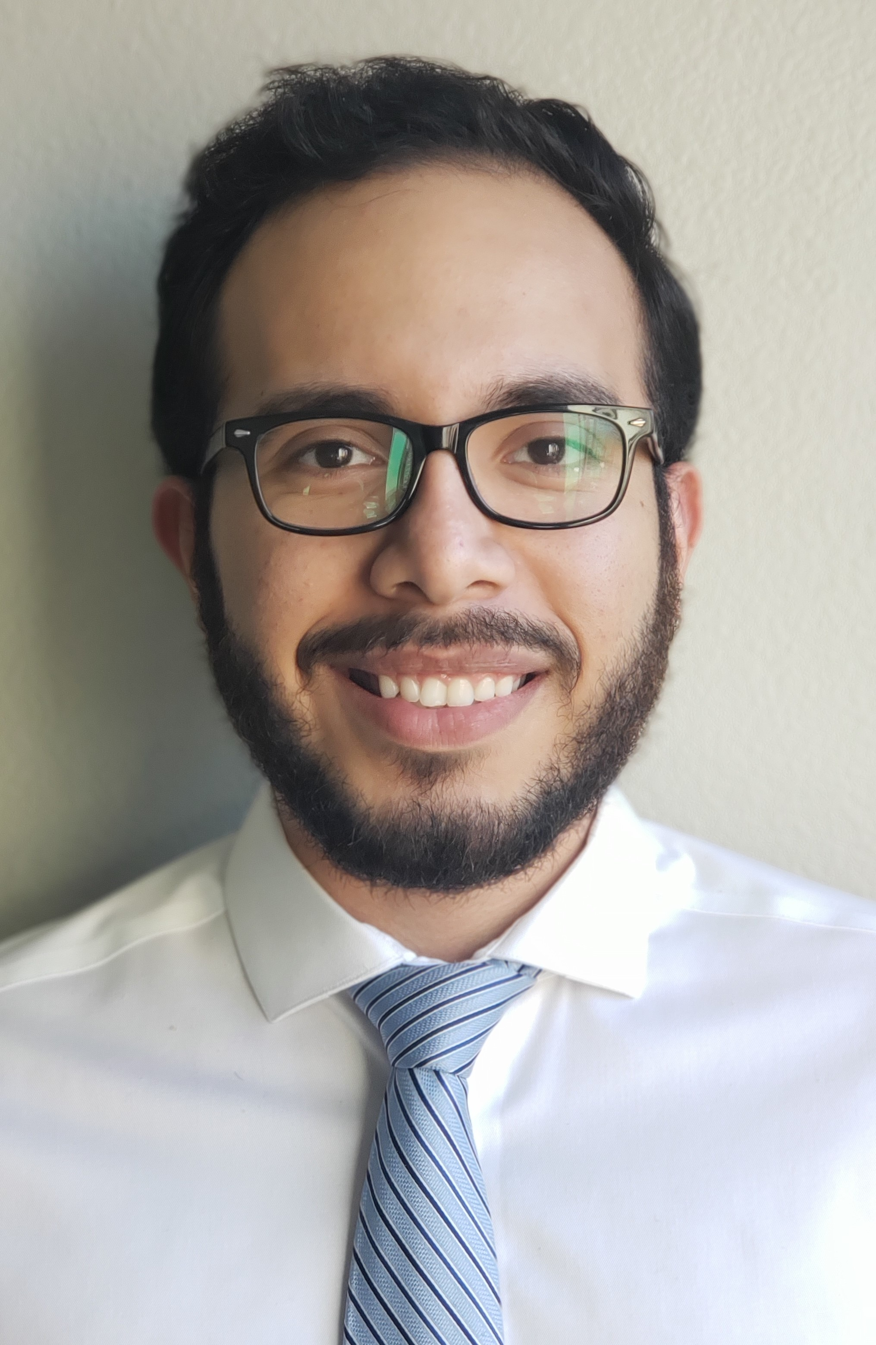
Benjamin Olivo
Amplification and Cloning of Mycobacteriophage Pixie Genes
Benjamin Olivo, Ashley Suris, Philipp Orbe, Abigail Ballard, Yabram Basurto, Jocelyn Garcia, Idalia Gonzalez, Ryan Huckaby, Jill Johnson, Love Leigh Sansom, Angel Thomas, Eric Tovar, Selina Alvarado, Faith Cox, Harold Rathburn, Dustin Edwards
Certain strains of bacteria have evolved to be resistant to antibiotics. Bacteriophages are viruses that infect and replicate in bacteria. Many proteins within bacteriophage genomes remain uncharacterized and their functions are unknown. Some of the proteins that are produced by these bacteriophages have cytotoxic effects and can be used as an alternative treatment for antibiotic-resistant bacteria. As part of the Howard Hughes Medical Institute Science Education Alliance Gene-function Exploration by a Network of Emerging Scientists (SEA-GENES) program, we are amplifying and cloning genes from bacteriophage Pixie, cluster K3, to determine their role in bacteriophage replication. Previously, the lab PCR-amplified 45 out of 100 genes and cloned 32 genes of those genes into expression plasmids for study in cytotoxicity and superinfection phenotype assays. We have continued to build the plasmid library by PCR-amplifying an additional 39 genes. Successful gene amplification was confirmed by agarose gel electrophoresis of the PCR products and verification of the correct predicted size. The PCR products were then purified by column purification or gel extraction and the concentration of insert determined. The additional 39 genes will be ligated into a pExTra plasmid and transformed into 5-alpha F’ Iq Escherichia coli, a strain of E. coli optimized for the replication of plasmids containing potentially toxic genes. Purified plasmids will be electroporated into, Mycobacterium smegmatis mc2155 for cytotoxicity and superinfection assays.

