DO NOT CONSIDER FOR TALK
2021 SEA Symposium Abstract
Tarleton State University
Stephensville TX
Corresponding Faculty Member: Dustin Edwards (dcedwards@tarleton.edu)
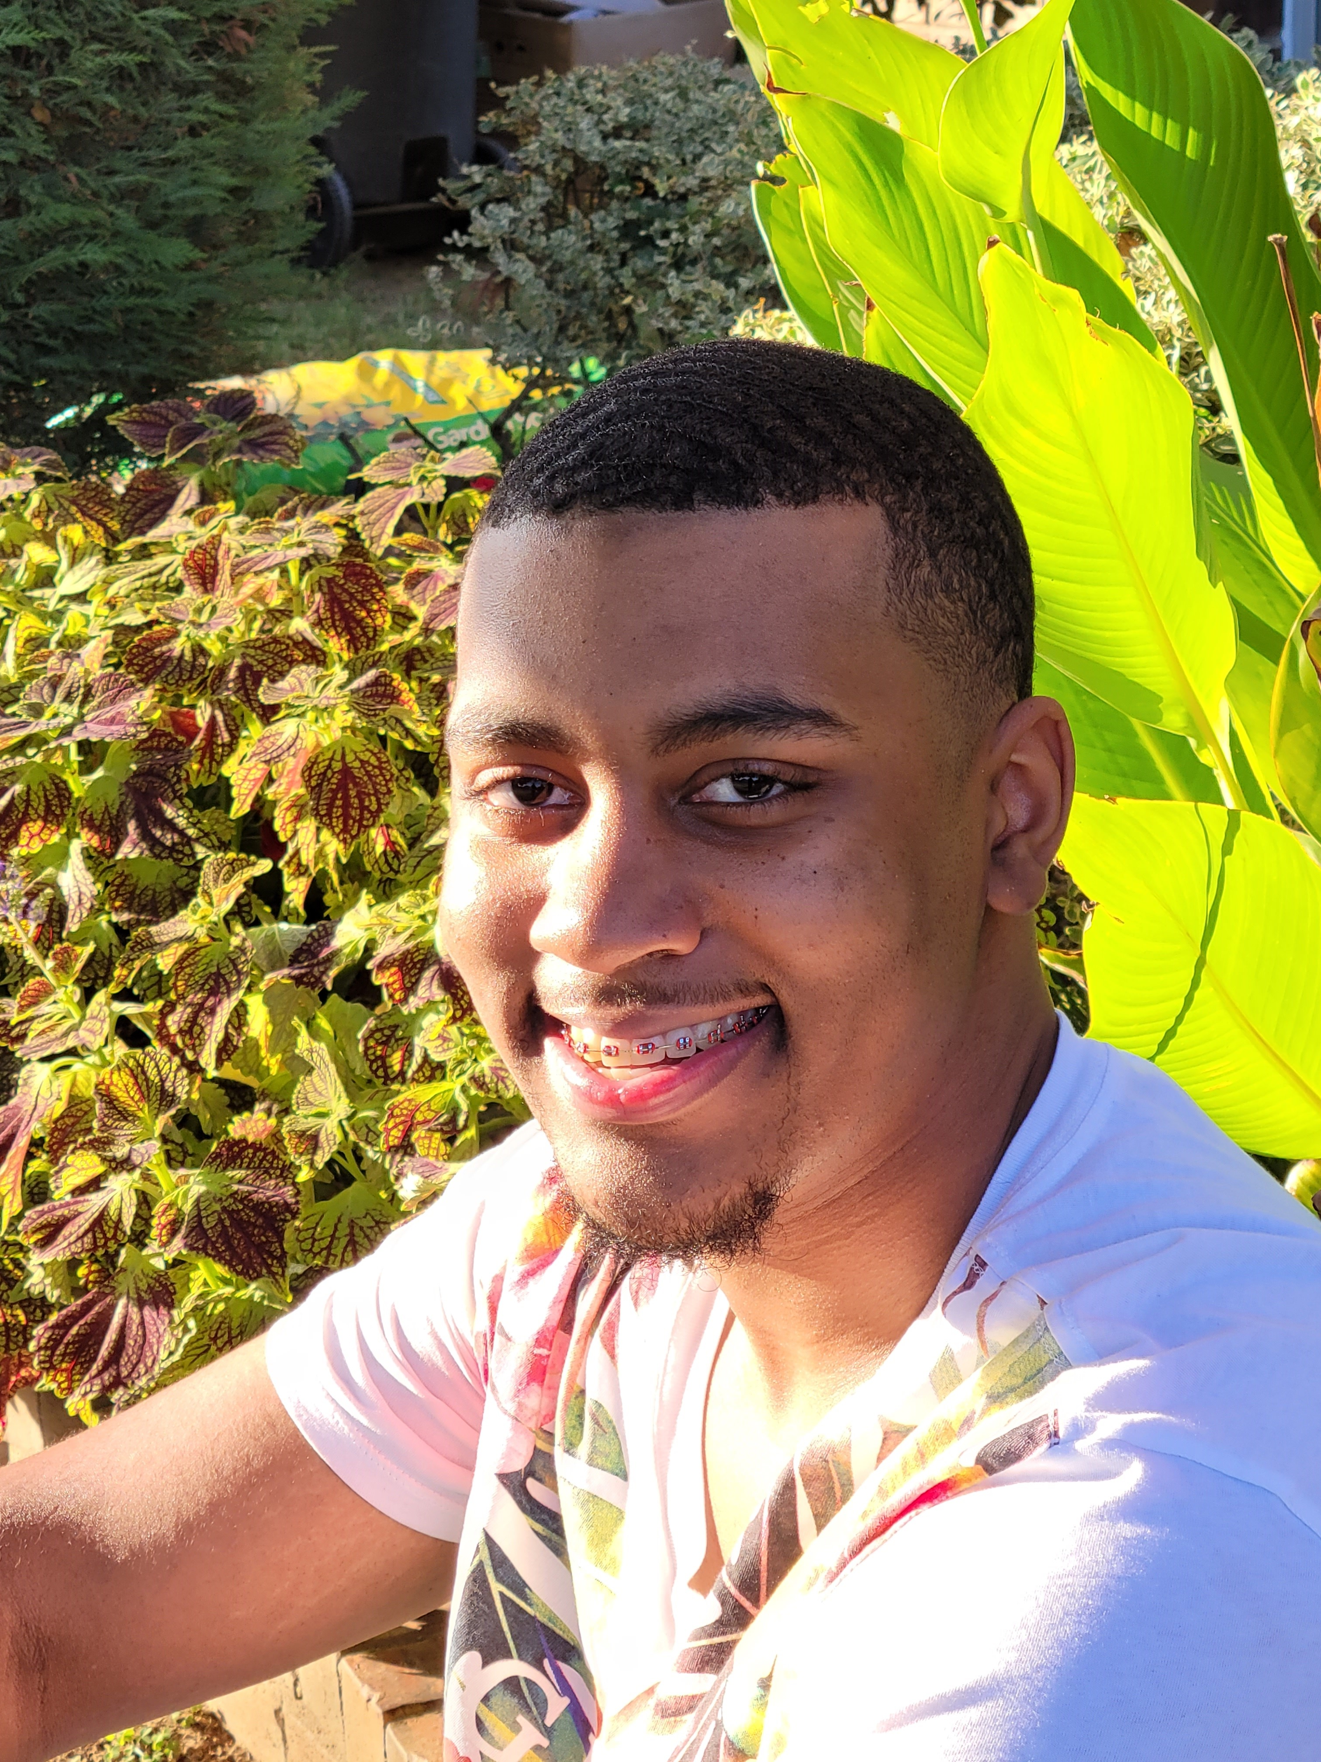
Raylon Huckaby
Bacteriophage Tank18, Isolated from a Microbacterium foliorum Culture
Raylon Huckaby, Jesse Laposky, Faith Cox, Dustin Edwards
Bacteriophages are viruses that replicate within the domain bacteria. Tarleton State University, as part of the Howard Hughes Medical Institute SEA-PHAGES Program, has worked to collect liquid and soil samples to isolate and characterize novel bacteriophages to learn more about bacteriophage biology and for their potential use as a therapy for antibiotic resistant bacterial infections. Bacteriophage Tank18 was discovered in a sandy environment, at approximately one-centimeter depth, near a horse barn in Stephenville, Texas, and was directly isolated and incubated with the host Microbacterium foliorum NRRL-24224. Following two rounds of serial dilution and plaque assays 2mm lytic plaques were formed. Negative-staining transmission electron microscopy showed that Tank18 had a Siphoviridae morphology with a tail length of 115 nm and a capsid diameter of 45nm. Restriction enzymes HaeIII, NspI, and SalI incompletely digested bacteriophage Tank18 DNA, while SacII appeared to completely digest. The phage Tank18 was archived at the Pittsburgh Bacteriophage Institute and Tarleton State University.

