DO NOT CONSIDER FOR TALK
2021 SEA Symposium Abstract
University of West Florida
Pensacola FL
Corresponding Faculty Member: Kari Clifton (kclifton@uwf.edu)
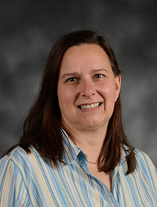
Kari Clifton
MrGreen, in the lab, with a pipette
Chandler Grammer, Elizabeth Hargis, Rachel Lackaye, Allie Linkous, Eli Mayo, Daniel Neidigk, Kari Clifton
Five bacteriophages were successfully isolated and characterized using the host bacterium Microbacterium foliorum NRRL B-24224. The bacteriophages were isolated using enrichment, purified, and amplified to high titer lysates. Two samples were sent to the University of Pittsburgh for sequencing. Interestingly, the first sample was found to be identical to not one but two others currently in the Actinobacteriophage Database. The second sample, dubbed MrGreen, was manually annotated by Cohort 8.6 at UWF. MrGreen was isolated from a sandy loam soil sample from Santa Rosa County in Northwest Florida. Transmission electron microphotography revealed an isomeric head and a long flexible tail characteristic of the family Siphoviridae, which was confirmed by sequencing. MrGreen is a typical cluster EE phage, with a genome length of 17421 base pairs, lytic, with 68.6% CG content, and 25 predicted protein-coding genes.

