CONSIDER FOR TALK
7th Annual SEA-PHAGES Symposium Abstract
Carnegie Mellon University
Pittsburgh PA
Corresponding Faculty Member: Javier Lopez (jlaa@andrew.cmu.edu)
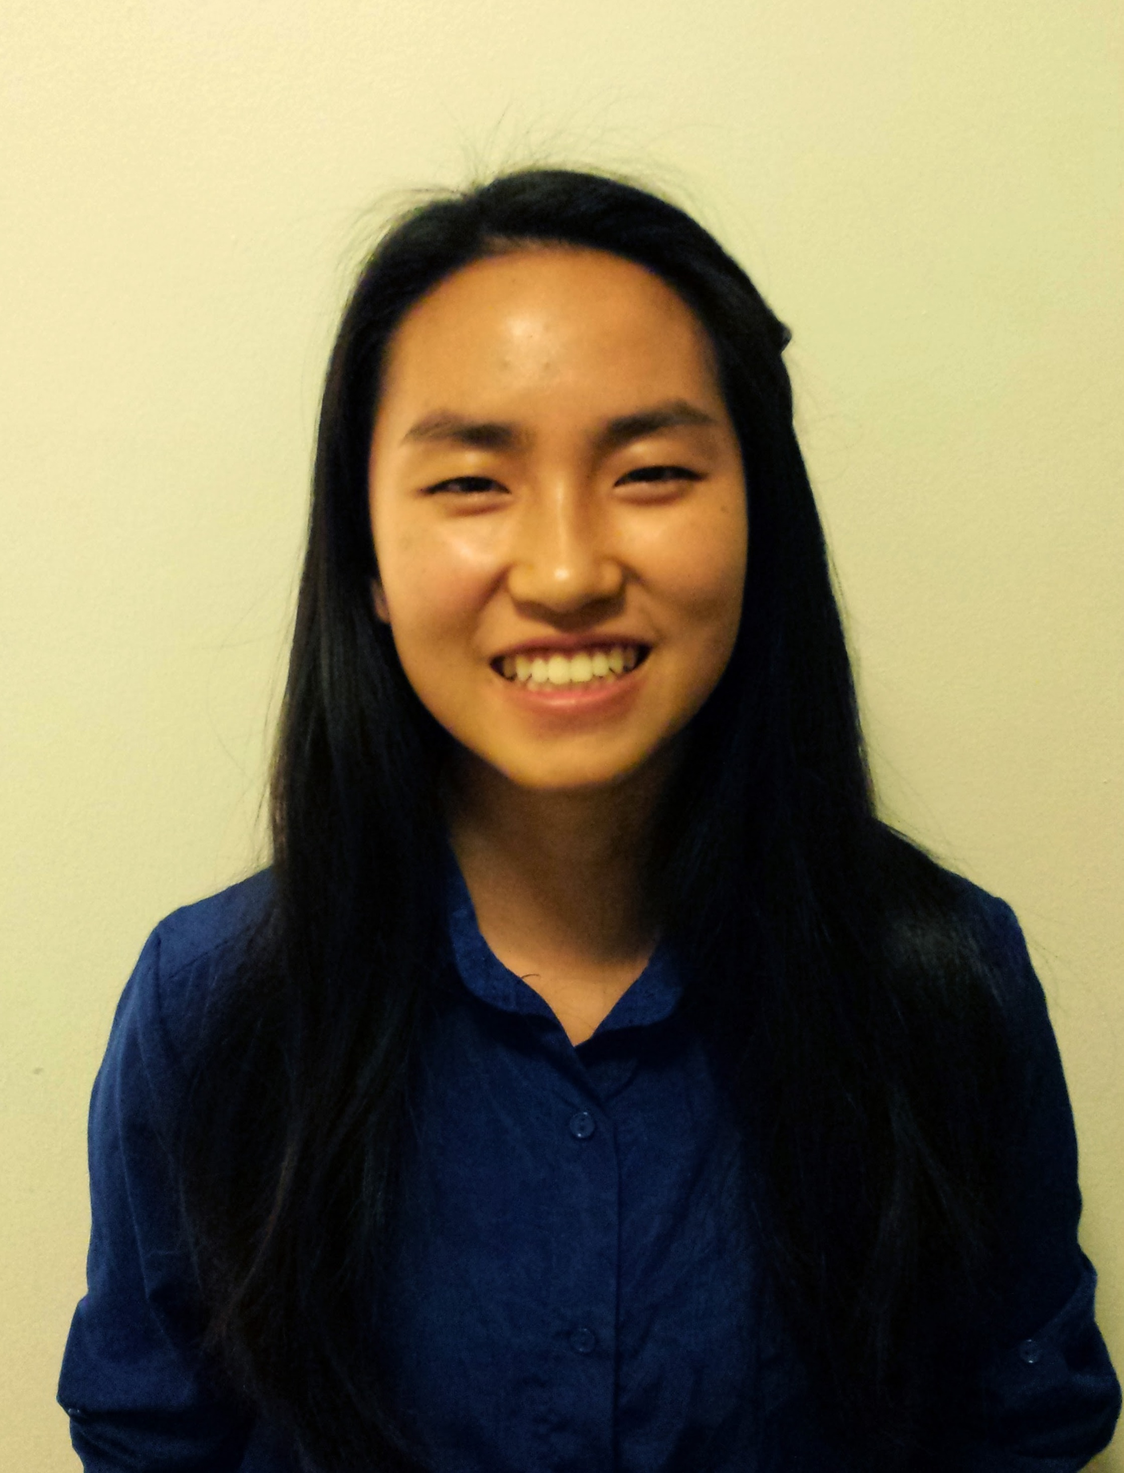
Nathalie Chen
Kathryn Hanson
Expanding our Knowledge of Arthrobacter and Rhodococcus Phage Diversity
Apeksha Atal, Gaurav Begur, Matthew Bofemkamp, Alyssa Brandt, Nathalie Chen, Sarah Deluty, Jenny Gao, Kathryn Hanson, Ben Kaplan, Jonathan Kim, Hannah Nourie, Jenna Shin, Erin Sipple, Hannah Soltz, Tanya Talwar, Tuan Azmal Thahireen, Carolyn Vanek, Annabella Wong, Sharon Wu, Ling Xu, Jonathan Jarvik, A. Javier Lopez, Swarna Mohan
Bacteriophages are the most numerous biological entities on the planet. They have important ecological roles, and there is renewed interest in their potential therapeutic applications. A continuing exploration of bacteriophage diversity in different host systems will enhance our understanding of their evolution, biological impact and potential uses.
We isolated 20 phages that infect Arthrobacter sp. plus one that infects Rhodococcus globerulus and we sequenced their genomes using IonTorrent technology. Arthrobacter phage Moki was also sequenced using Illumina technology at U. Pittsburgh and has been completely annotated. Genomes for the other phages have been completely assembled, but not finished, and are partially annotated.
The Rhodococcus phage (Tina, isolated from soil in Providence, RI) is a Siphovirus closely related to RER2 and RGL3 previously isolated from wastewater in Australia. This trio is distinct from other reported Rhodococcus phages. Their genomes are circularly permuted, and all three contain a cluster of three tRNA genes near the end of the right arm. The predicted lysin and holin genes are widely separated in their genomes. We showed experimentally that Tina is temperate on R. globerulus. This is consistent with the finding of integrase and excisionase ORFs in its genome. These ORFs are conserved in RER2 and RGL3, although these phages are reported to be virulent on R. globerulus.
Seventeen of our Arthrobacter phages are siphoviruses and 3 are myoviruses. Of these, 19 phages are closely related to previously known Arthrobacter phages, including 3 similar to cluster A, 6 C1, 4 C2, and 3 D. The 3 myoviruses are most similar to Steve, Brent and Shade, respectively. The last phage (Swalo, isolated in Pittsburgh, PA) is currently unique. It’s left arm, comprising the structural and assembly genes, has strong similarity to ArV2, a singleton isolated in Lithuania, but its right arm is highly divergent. Both phages contain predicted integrase and repressor ORFs, suggesting they are temperate, although we have not confirmed this experimentally. The region containing these lysogeny genes is inverted between the two phages.
As observed in our first round of Arthrobacter phage screening (2013-2014), siphoviruses with unusually small genomes (<16 kb; cluster D) continue to be isolated frequently, suggesting that they represent a highly successful viral strategy in this niche. Interestingly, the Arthrobacter myovirus genomes so far are also significantly smaller (~50kb) than Mycobacterium myoviruses (~155 kb).
Ten of our phages belong to an intriging group (clusters C1, C2) comprising siphoviruses with low GC content (<50%) and similarity to Rhodococcus phages ReqiPoco6 and Pepy6. As previously suggested for Mycobacterium phage Patience (Pope et al 2014), the discrepancy in GC content with Arthrobacter may indicate that this group evolved in a different host.

