DO NOT CONSIDER FOR TALK
2021 SEA Symposium Abstract
Doane University
Crete NE
Corresponding Faculty Member: Erin Doyle (erin.doyle@doane.edu)
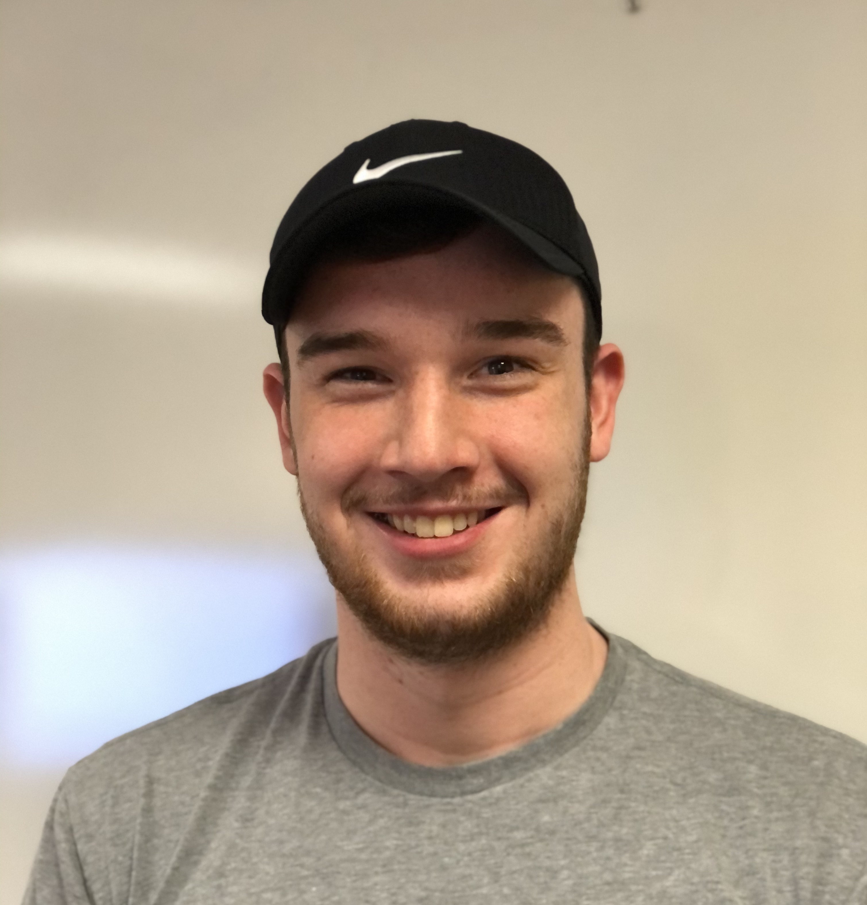
William Jewell
GENOME ANNOTATION OF GORDONIA PHAGE NORVS IN THE CQ SUBCLUSTER
William Jewell, Dane M Bowder, Erin L Doyle
There are an estimated 10^31 bacteriophages on the planet, more than any other organism including all combined bacteria. The Gordonia phage Norvs was found from an enriched soil sample that was collected in Lincoln, NE in January of 2019. The structure of the phage was examined using Transmission Electron Microscopy (TEM), which showed that it is a siphovirus. Norvs’ DNA was extracted at Doane University and sent to the Pittsburgh Bacteriophage Institute for sequencing, which revealed that the phage was temperate and belonged to the CQ subcluster. Norvs had a genome length of about 92405 base pairs containing 178 predicted genes. Using DNA Master software along with Phamerator, Starterator, and BLAST data we examined the predicted ORFs for coding potential and possible start sites. Future work will include calling the functions of genes.

