CONSIDER FOR TALK
7th Annual SEA-PHAGES Symposium Abstract
Johns Hopkins University
Baltimore MD
Corresponding Faculty Member: Emily Fisher (efisher@jhu.edu)
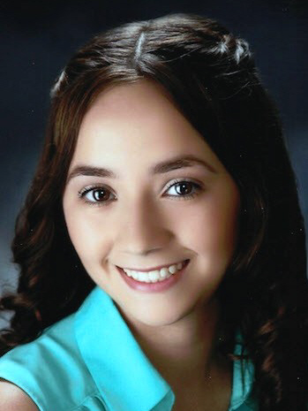
Stephanie Hernandez
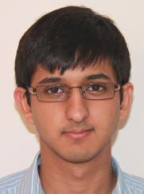
Ajay Mehta
Cluster C Mycobacteriophages at Johns Hopkins: ChickenPhender and Melpomini
Stephanie Hernandez, Ajay Mehta, Garlyn Colas, Yevgeniya Miglo, Stephanie England, Greg Konar, Allen Chen, Megha Talur, Michael Shang, David Ramirez-Chavez, Daniel Choi, Joel Schildbach, Emily Fisher
Two mycobacteriophages of subcluster C1 were isolated in fall 2014. Melpomini was isolated from a lawn on the JHU campus and found by enrichment. ChickenPhender was isolated from direct plating of soil from a stream near campus. Annotation yielded over 200 genes apiece and both have GC% of 64.7%. We wil present an analysis of GC found at first, second, and third codon positions in annotated genes. Conserved genes in both new genomes and other C1 subcluster members were used to create phylogenetic trees. Chicken Phender burst dynamics were investigated and found to be slow and have a very small burst. Growth of Chicken Phender in various pHs, salt concentrations, and cations were also characterized.

