DO NOT CONSIDER FOR TALK
2021 SEA Symposium Abstract
College of St. Scholastica
Duluth MN
Corresponding Faculty Member: Daniel Westholm (dwesthol@css.edu)
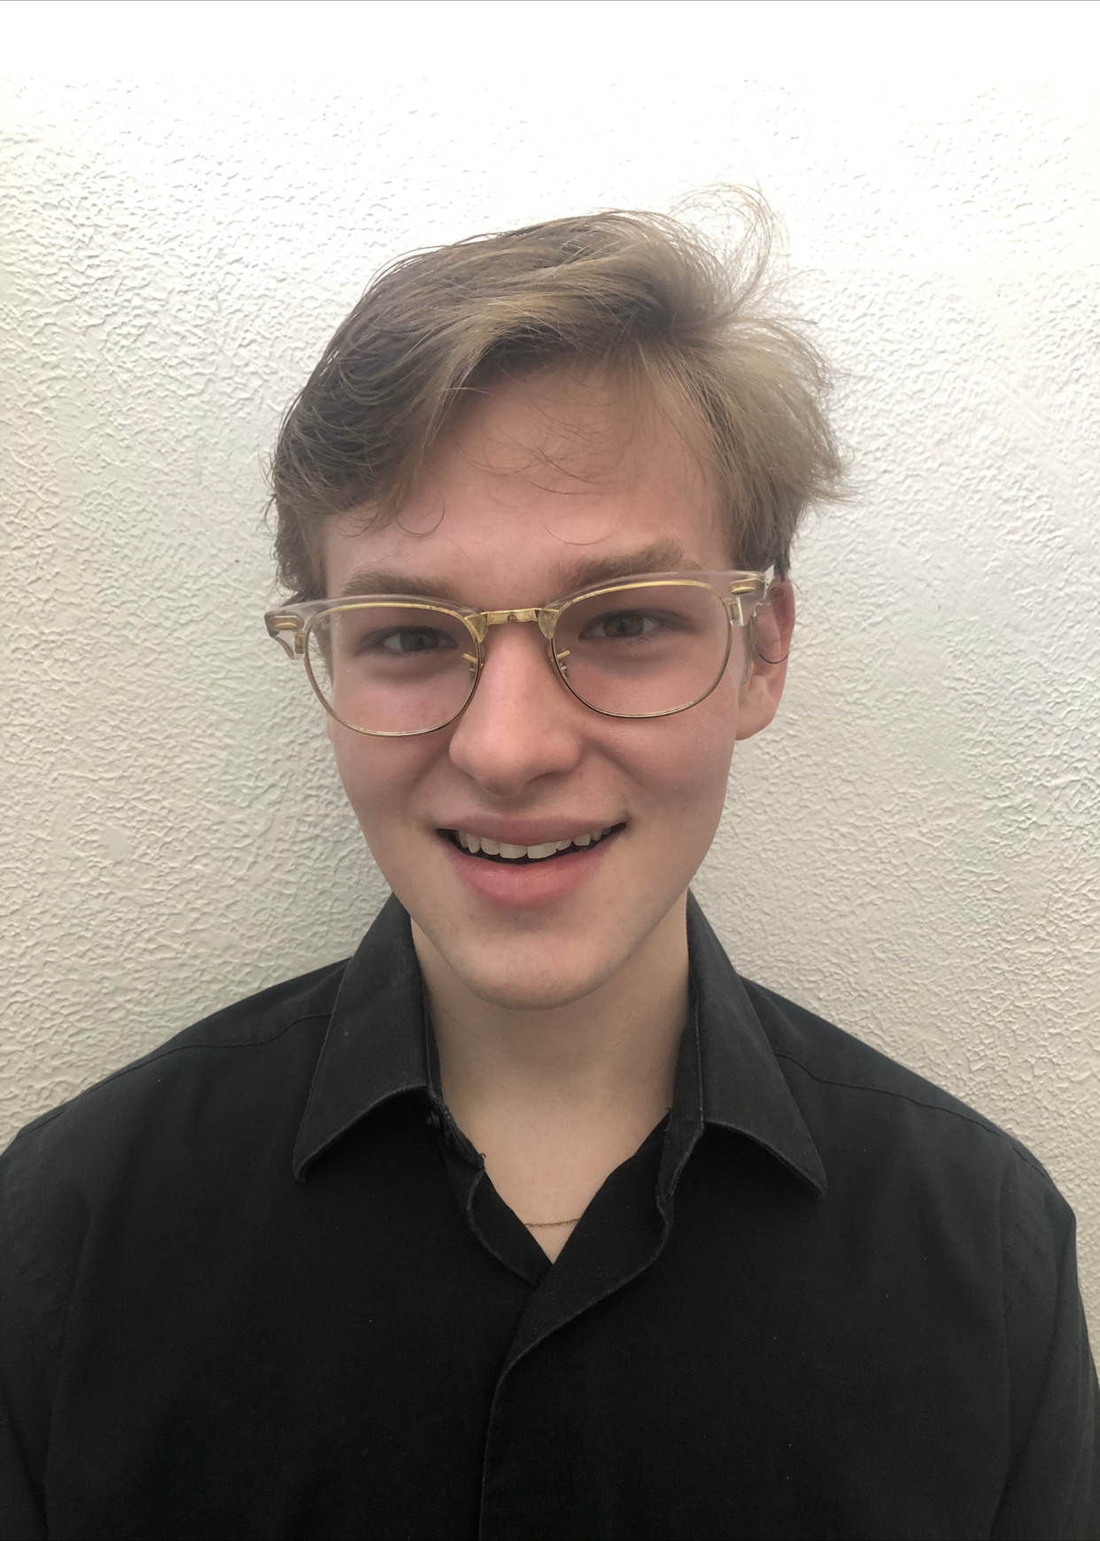
Austin Armon
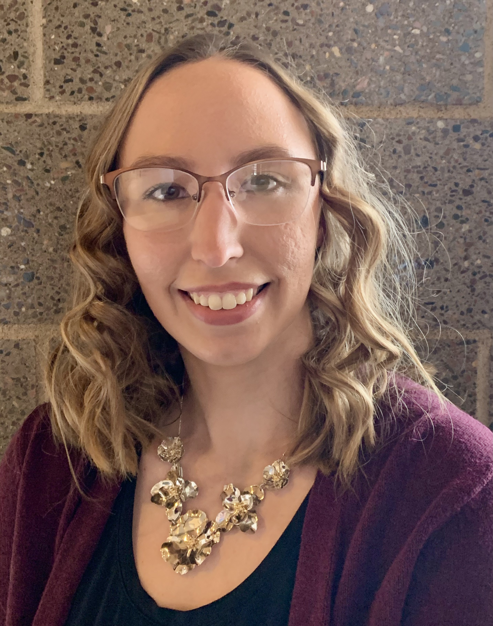
Emily King
Elucidation of Gene Function in Cluster P Mycobacteriophage Brusacoram
Austin Armon, Maethe Butterfield, Emily King, Kara Thoemke, Daniel Westholm
Through the SEA-GENES research program, we are working to clone and phenotypically characterize each individual gene in Mycobacteriophage Brusacoram. Brusacoram was isolated and sequenced as part of the SEA-PHAGES program at The College of St. Scholastica in 2014. Genome annotation identified 78 protein coding genes, of which over half have no known function (NKF). LC-MS/MS data indicate many of these genes with NKF are expressed and likely play a role in supporting phage infection. Since September 2019, students have cloned over 75% of the genes in the Brusacoram genome into the pExTra expression vector. We have conducted preliminary gene function assays on 37 of these genes. Upon expression in Mycobacterium smegmatis, we have identified 4 genes with cytotoxic phenotypes, some with no previously identified function. We encountered technical and pandemic related difficulties with defense assays, so data is not yet available regarding the role each gene may play in superinfection immunity. Here we present our supporting phenotypic data for several Brusacoram genes along with our future directions in the project.

