CONSIDER FOR TALK
2021 SEA Symposium Abstract
Arizona State University
Tempe AZ
Corresponding Faculty Member: Susanne Pfeifer (spfeife1@asu.edu)
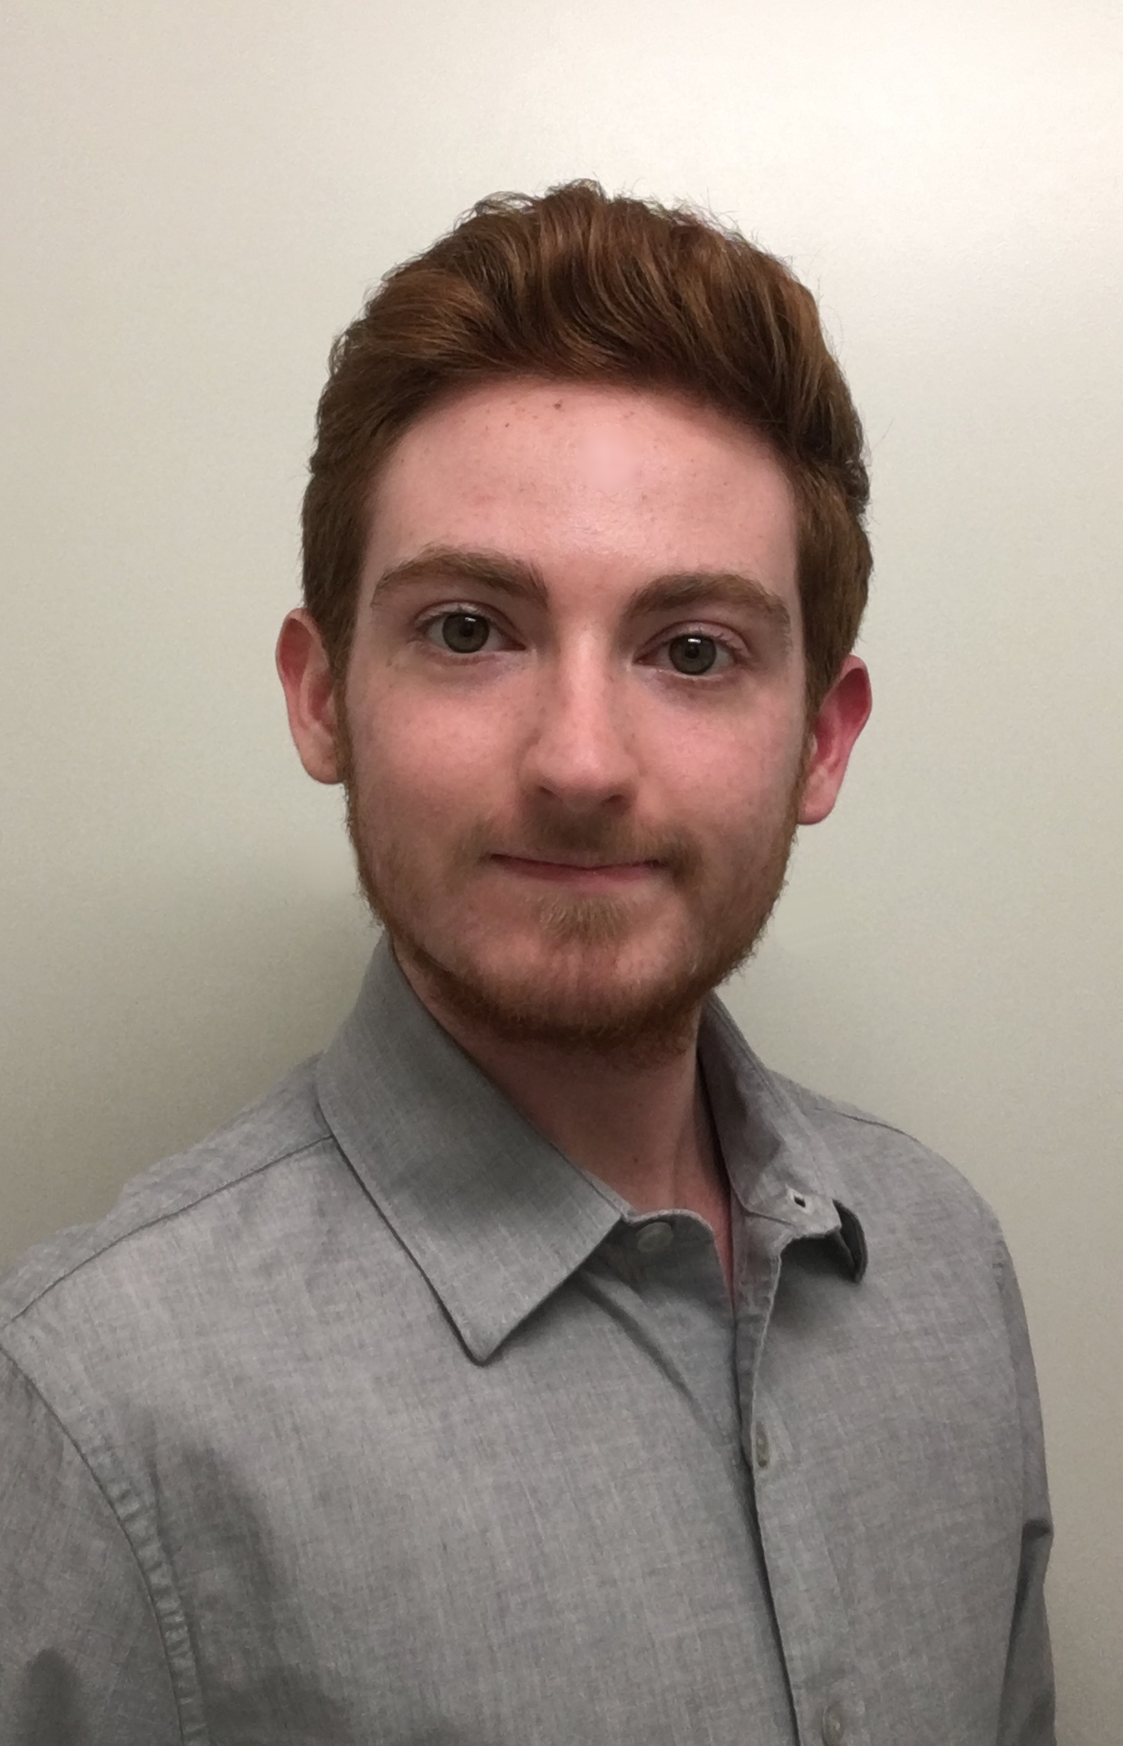
Leo Cevallos
Aram Nejad
Daniel Sackett
Complete genome sequence of Microbacterium bacteriophage Erla
Mark Milhaven, Erin Hastings*, Danielle Brister, Leo Cevallos, Sriya Chilukuri, Arshia Diyya, Aman Garg, Rosaura Hernandez, Daniel Kelly, Karina Lazo, Jennifer Le, Garett Maag, Palak D Marfatia, Rithik Mehta, Aram Nejad, Jade Porche, Alexander Queiroz, Daniel Sackett, Pablo Santos Molina, Taylor Slade, Minerva So, Karan Thakur*, Angelica Urquidez Negrete, Sage Wackett, Sarah Weiss, Liam McCarthy*, Keith Wheaton*, Adam D Rudner*, John P McCutcheon, Susanne P Pfeifer
* University of Ottawa, Ottawa
We characterized the complete genome sequence of Siphoviridae bacteriophage Erla, an obligatory lytic subcluster EA1 bacteriophage infecting Microbacterium foliorum NRRL B-24224, with a capsid width of 65 nm and a tail length of 112 nm. The 41.5-kb genome, encompassing 62 predicted protein-coding genes, is highly similar (99.52% identity) to that of bacteriophage Calix.

