DO NOT CONSIDER FOR TALK
2021 SEA Symposium Abstract
Carthage College
Kenosha WI
Corresponding Faculty Member: Deb Tobiason (dtobiason@carthage.edu)
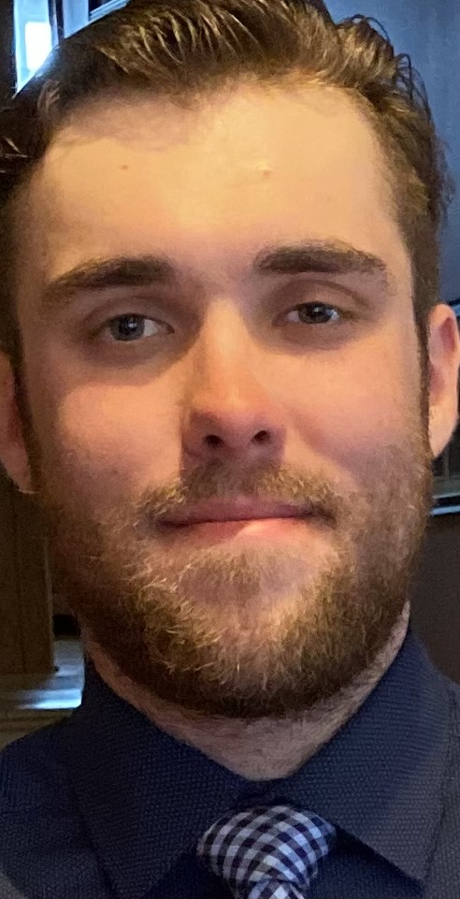
Alex Papiez
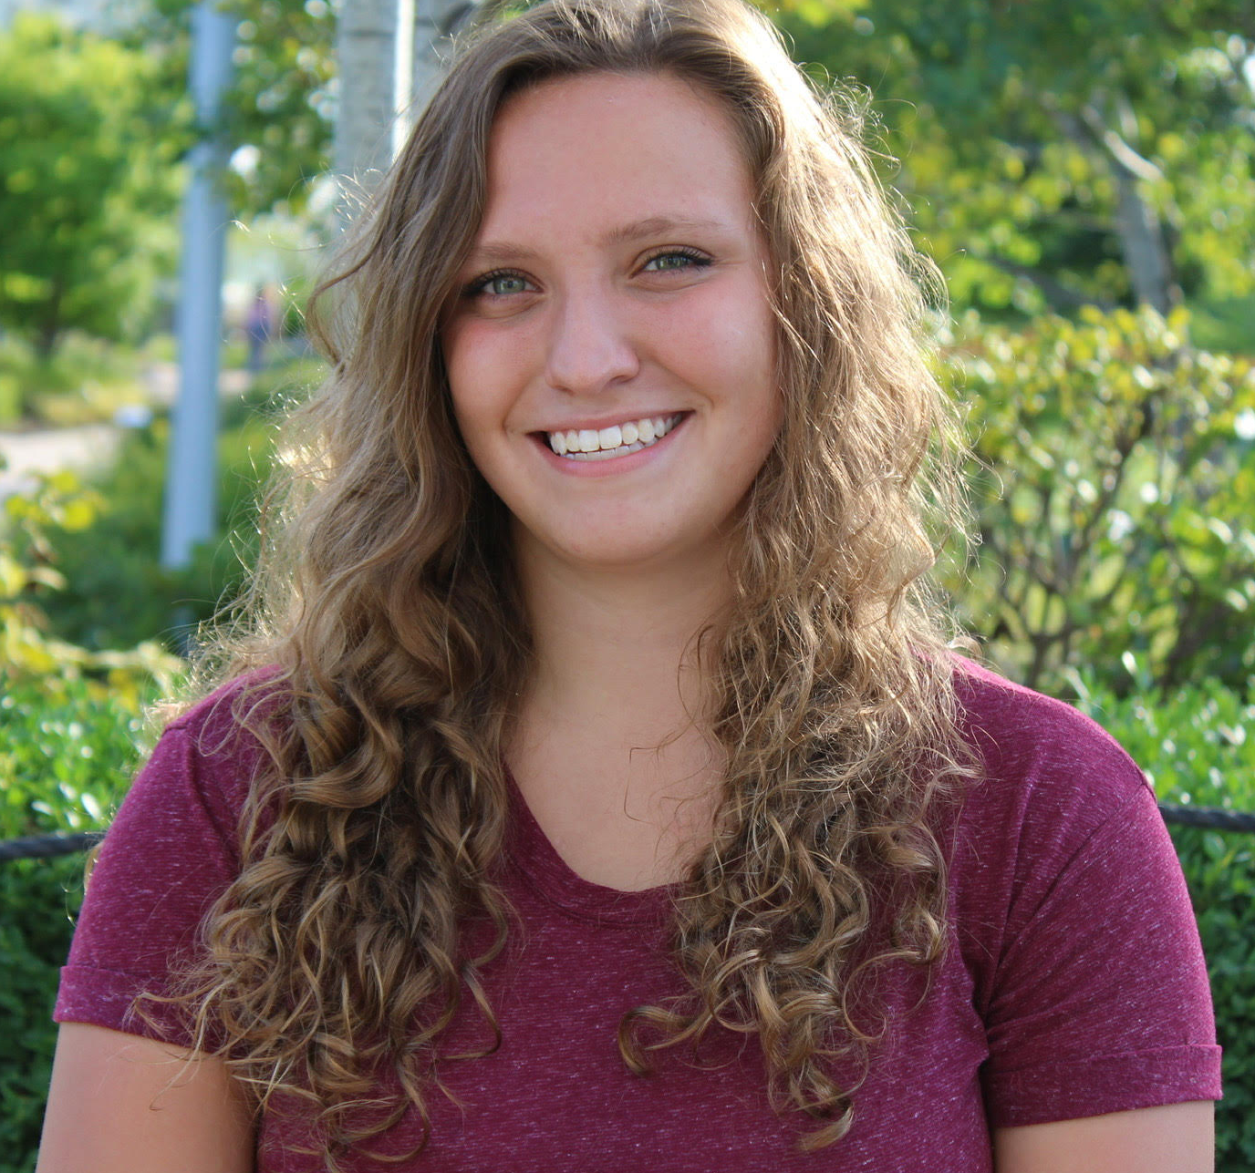
Sara Sobczyk
Hybrid Hunting for Phages: Discovery and Isolation of Six Mycobacteriophages
Alex Papiez, Sara Sobczyk, Anna Battaglia, Alexis Cabell, Larissa Cartagena, Alyssa Gulsvig, John Hamer, Cole Hanson, Tyler Hartmann, Sebastain Haske, Jillian Hiatt, Andrew Jansen, Abygayle McGonegle, Michael Neu, Hannah Poff, Emma Smith, Lisa Sulla, Connor Wiseman, Jeanelle Young, Deborah Tobiason
Despite the COVID19 pandemic, we were able to successfully hunt for phages in a hybrid format. In a typical year, we isolate over 50 phages at Carthage College, but due to a mixture of remote labs and hybrid labs this past year, we can only report on six bacteriophages successfully isolated using the host Mycobacterium smegmatis. All six phages were obtained using soil samples from the Carthage campus, and four were isolated using direct isolation methods. Five of the isolated phages have halos and are possibly temperate while one phage was clearly lytic based on plaque morphology. Mycobacteriophage, Weher20, was sequenced and is a cluster B1 phage. Weher20 plaques had large haloes, but based on genomic analysis, it is a lytic phage. Comparison of its genome with other cluster B1 phages found at Carthage since 2011 indicate that these genomes are very similar with one distinct gene product difference.

