DO NOT CONSIDER FOR TALK
2021 SEA Symposium Abstract
College of Charleston
Charleston SC
Corresponding Faculty Member: Christine Byrum (byrumc@cofc.edu)
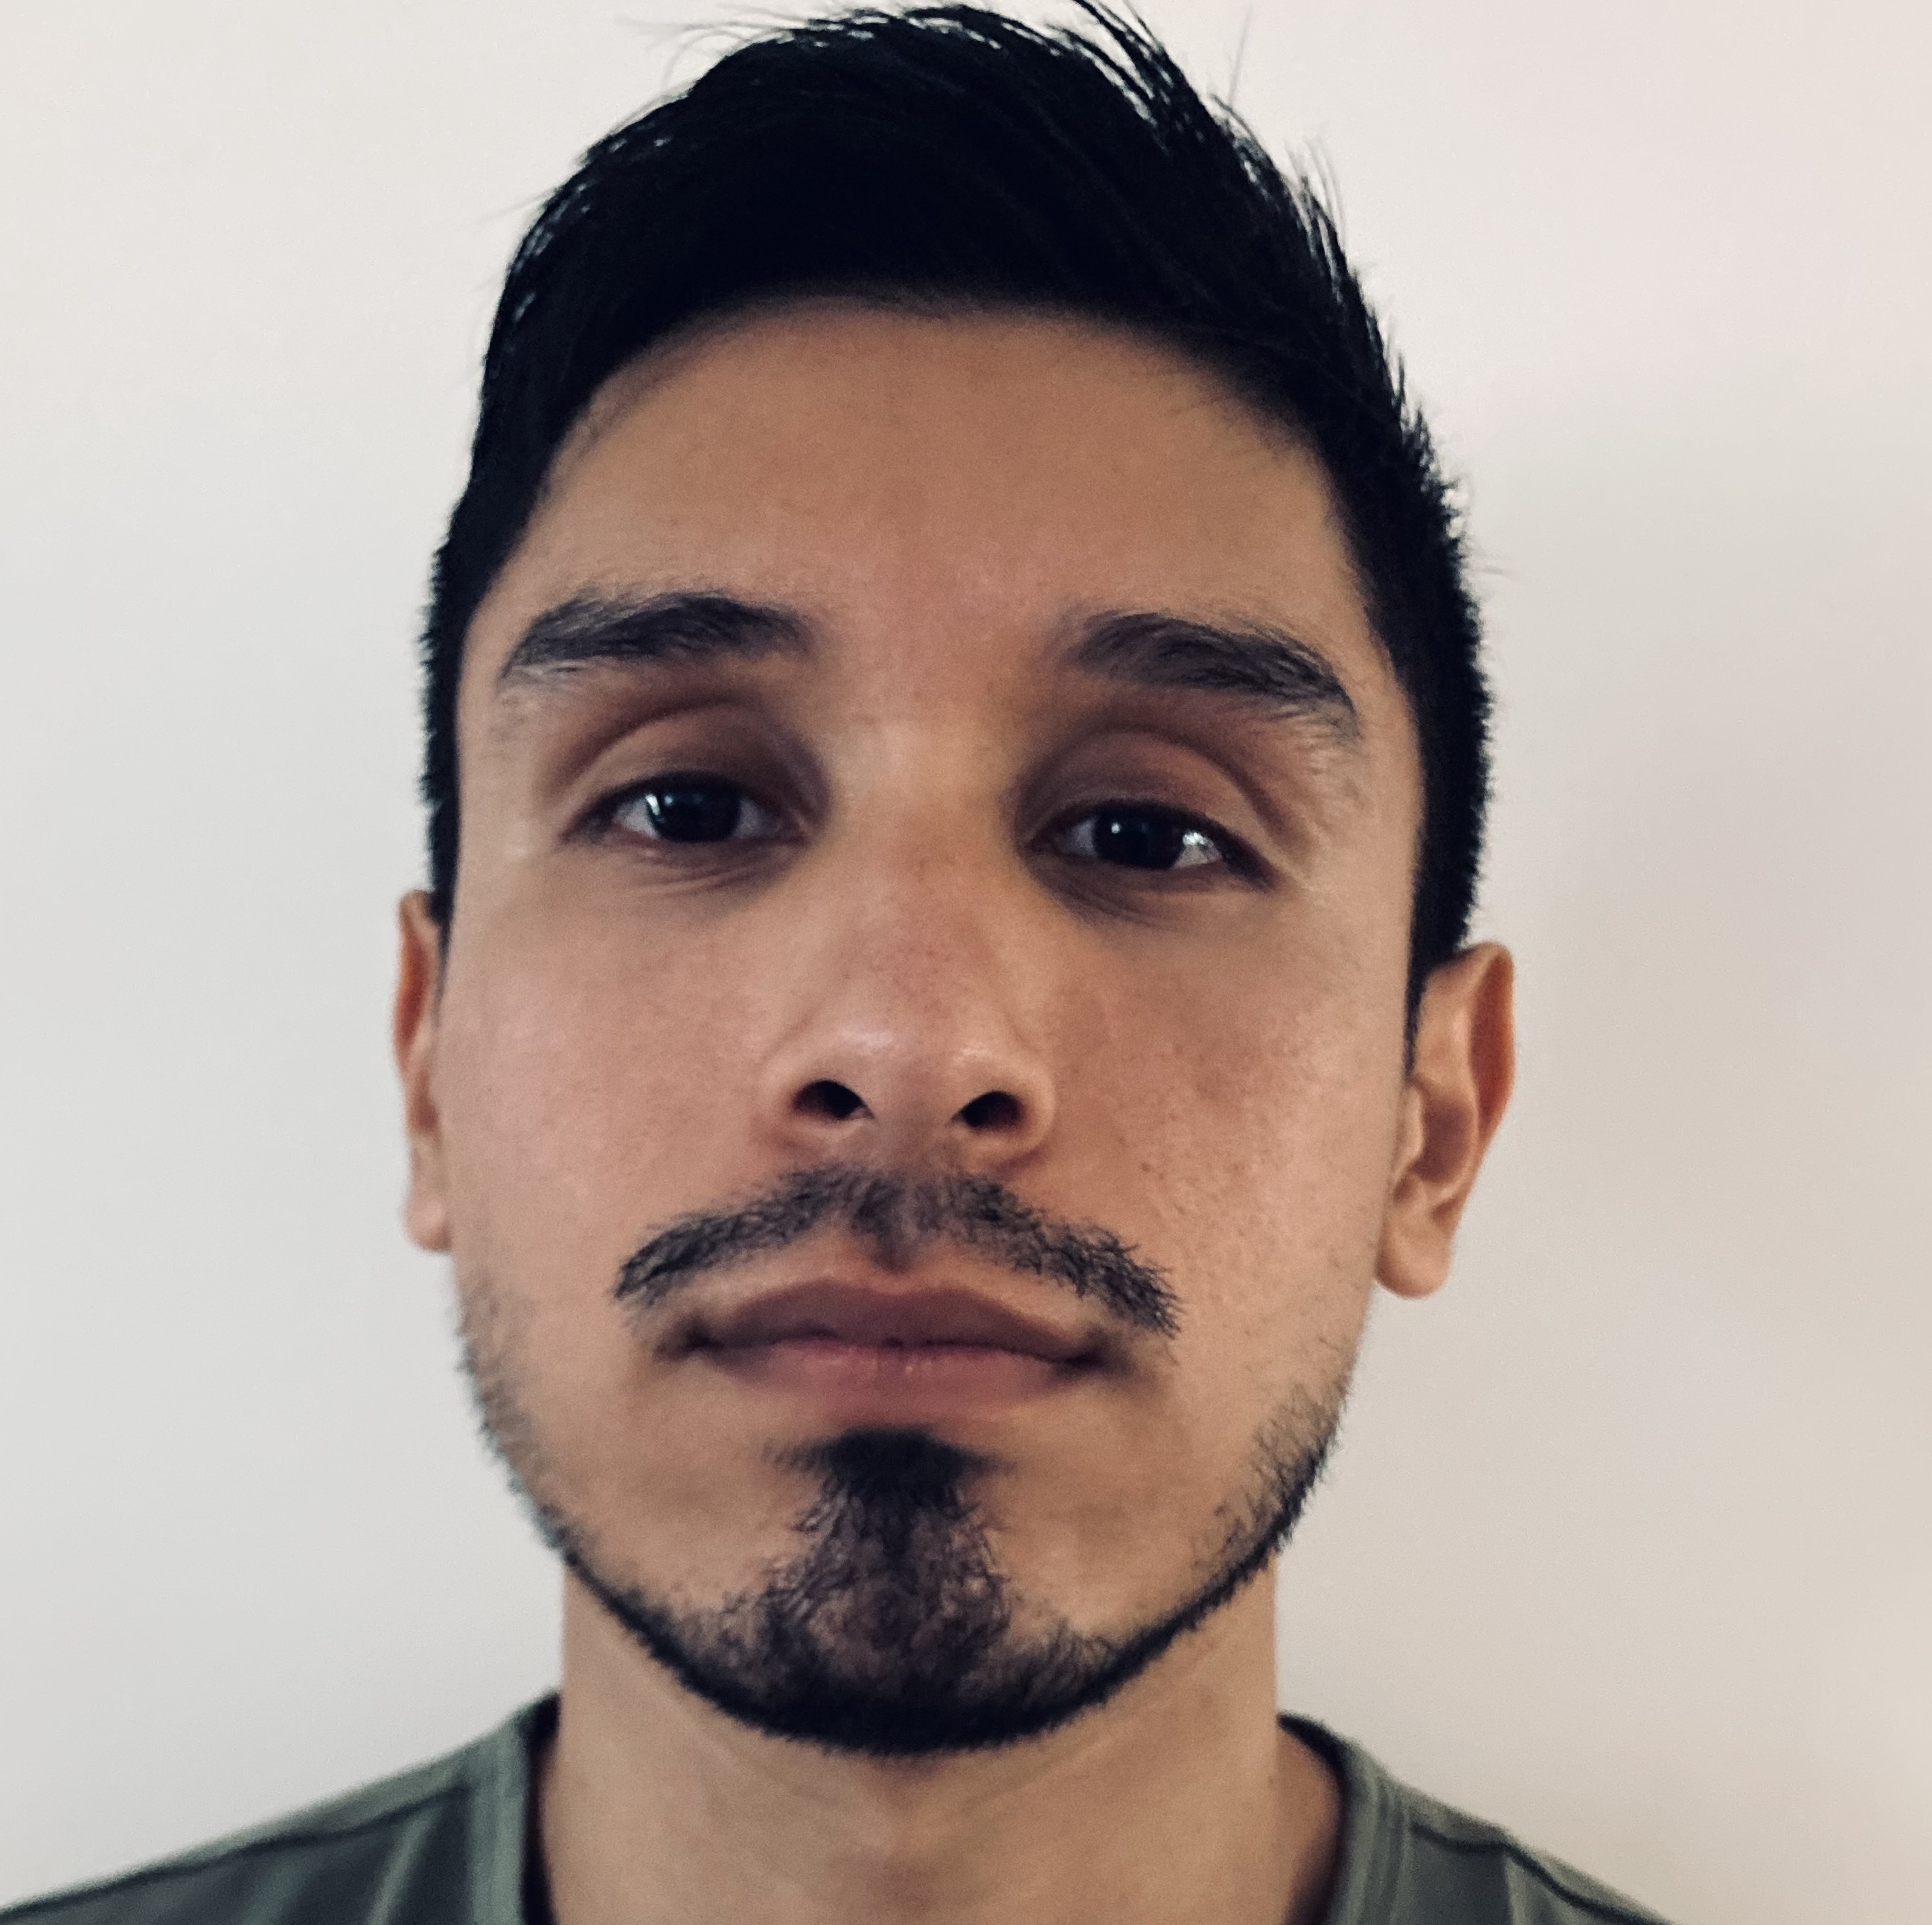
Maximiliano F Flota
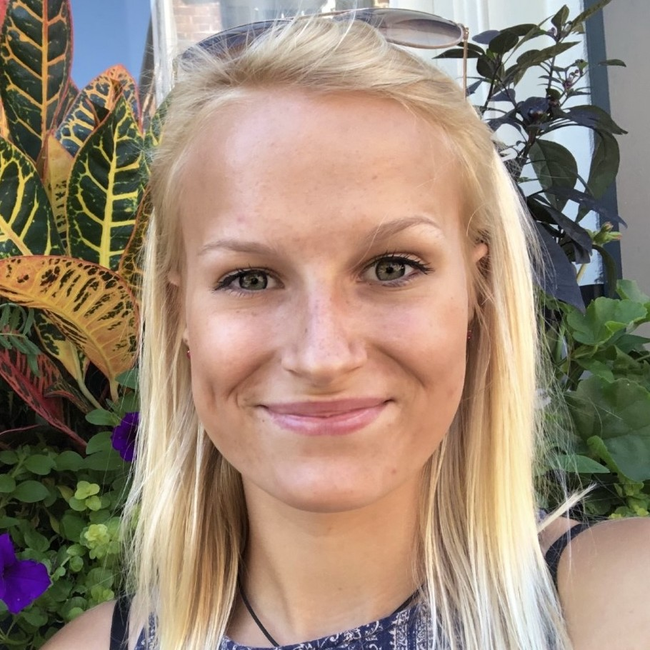
Avery A Goff
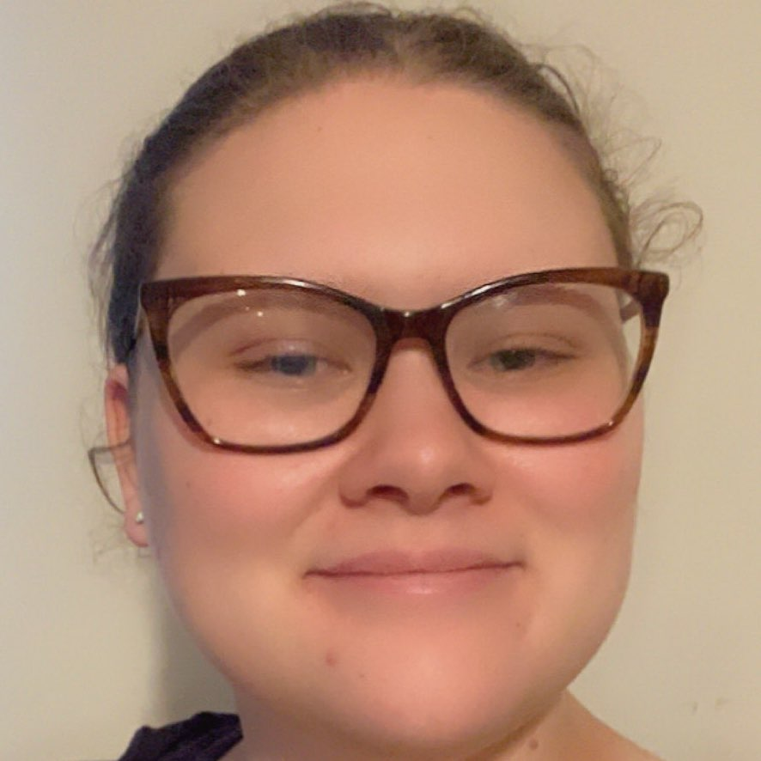
Caitlyn R Moss
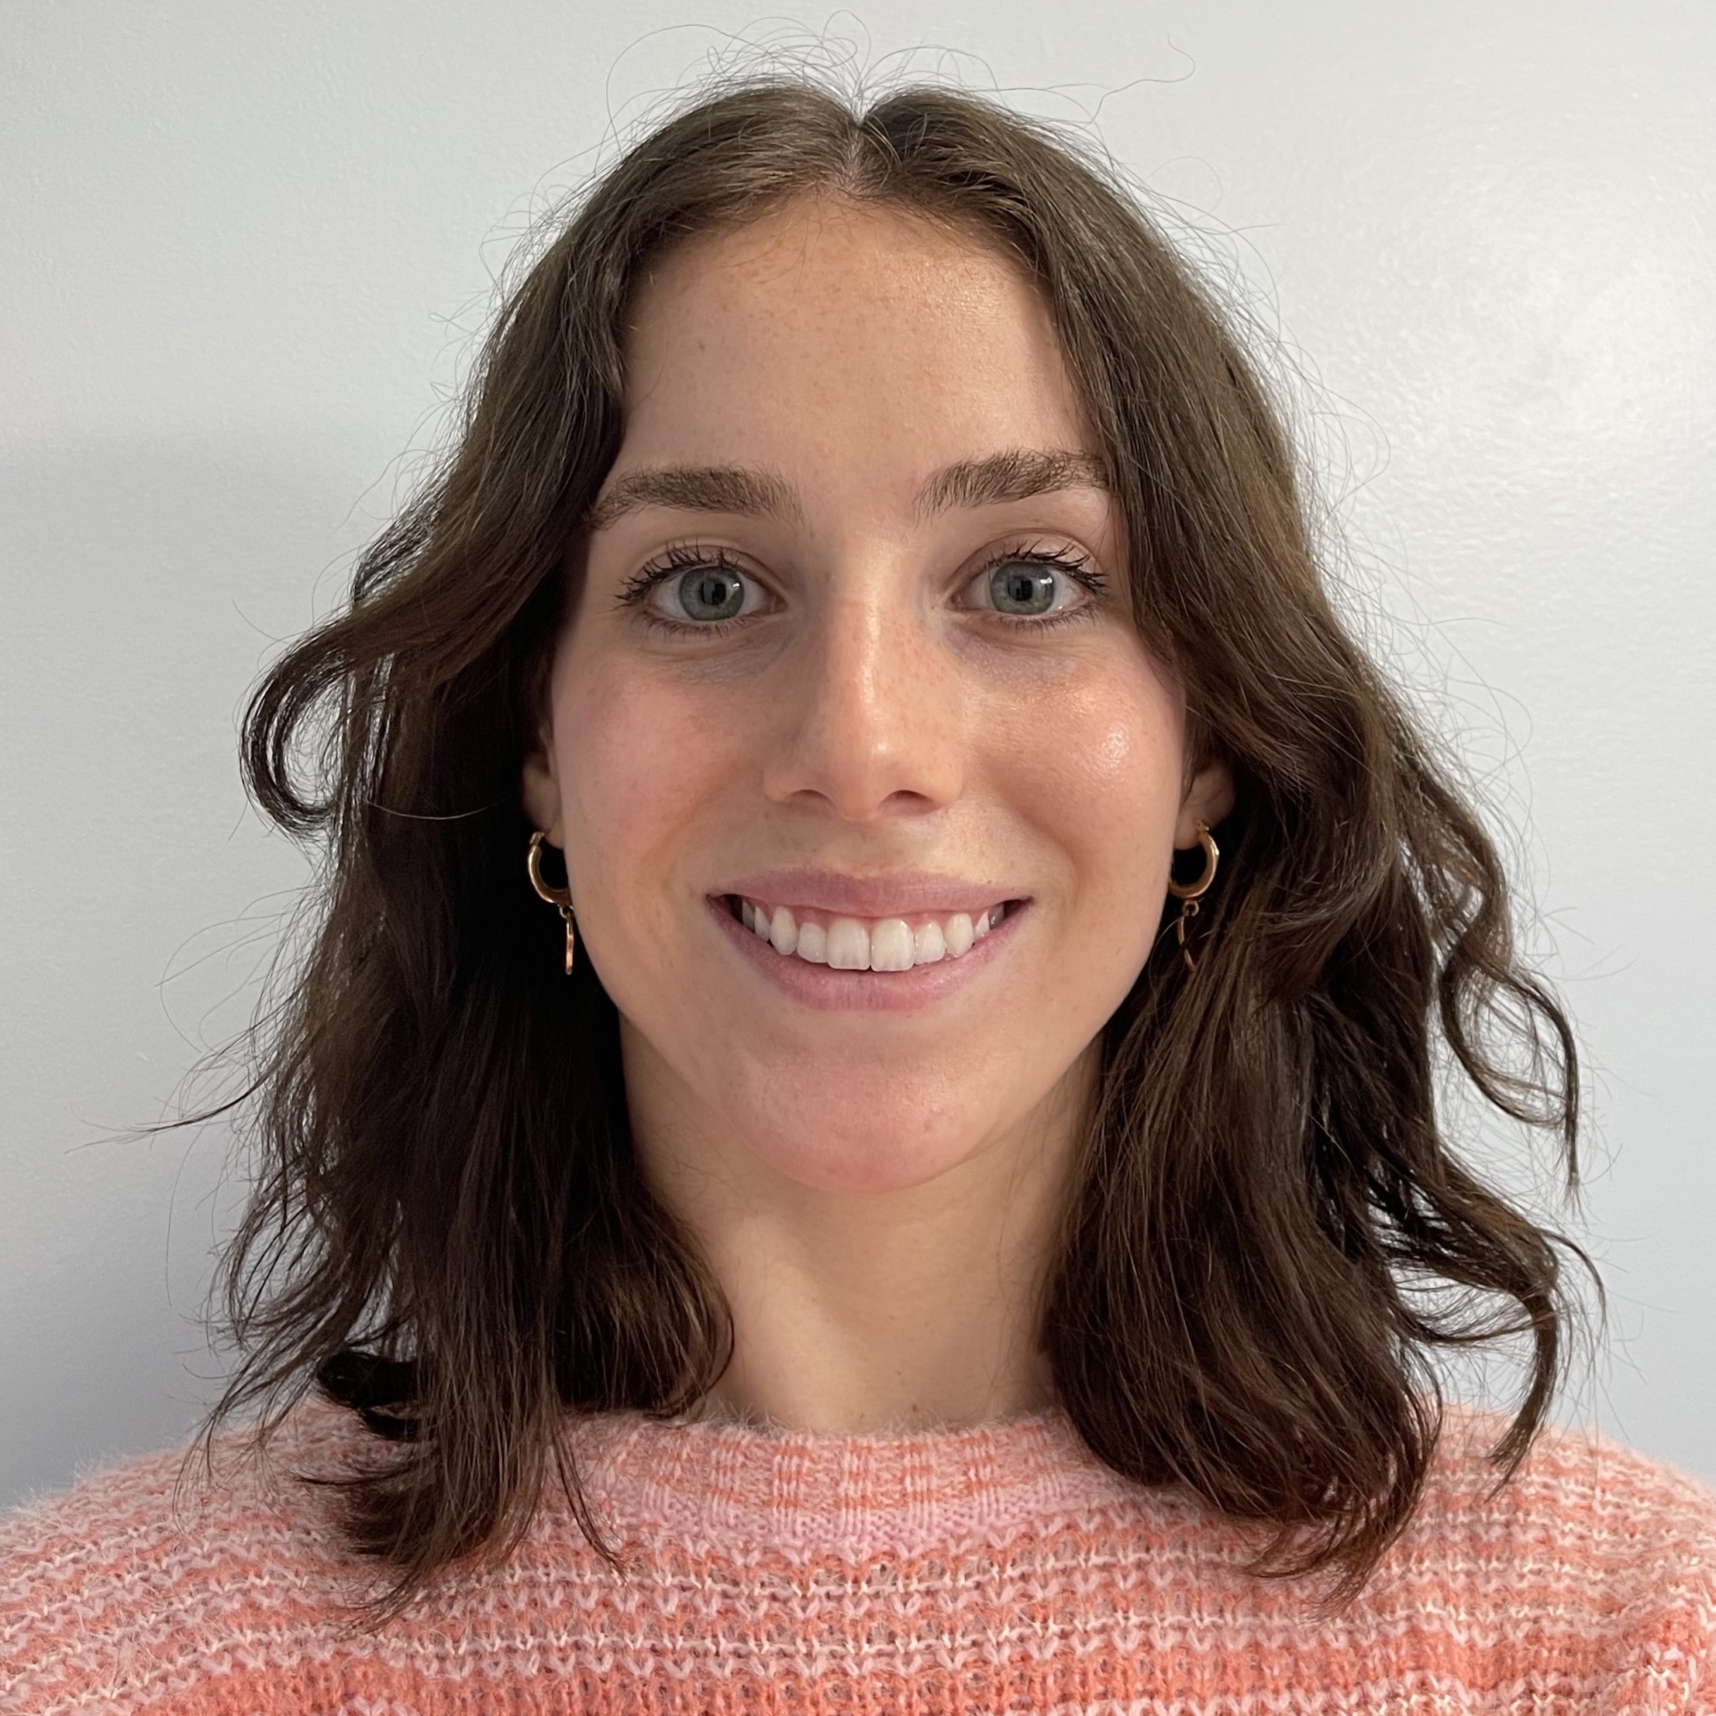
Isabella E Raieta
Genome Annotation of Subcluster L2 Mycobacteriophage Netyap
Maximiliano F Flota, Avery A Goff, Caitlyn R Moss, Isabella E Raieta, Christine A Byrum
The genome of the bacteriophage Netyap was examined in collaboration with the SEAPHAGES Program of Howard Hughes Medical Institute (HHMI) and Sydney Winchel at Western Carolina University, who isolated Netyap from an enriched soil sample in Cullowhee, North Carolina. This virus infects Mycobacterium smegmatis mc²155 and is a member of the L2 subcluster, exhibiting Siphoviridae morphology. The genome is 76,366 bp with 58.9% GC content containing 129 predicted protein-coding genes and is a linear double-stranded DNA genome with 10-base 3’ sticky overhangs. The Biology Department of the College of Charleston adopted the Netyap genome following DNA extraction and sequencing performed by Western Carolina University. The sequence was annotated by members of the Fall 2020 BIOL 312L course (Molecular Biology Lab). Students examining this genome made protein-coding gene predictions using GeneMark, Glimmer, and Starterator in the PECAAN workflow tool. Functional assignments for the genes were made utilizing Phamerator, TOPCONS, TMHMM2, HHpred, and NCBI BLASTP searches against all predicted protein sequences in the Actinobacteriophage Database and the NCBI Conserved Domain Database. Utilizing ARAGORN and tRNAscan-SE, 12 tRNA sequences were confirmed. No tmRNA sequences were detected. Key structural and assembly genes of the Netyap genome were found on the left arm, while nonstructural coding sequences were located on the right arm. The Netyap genome contains genes with predicted functions related to capsid assembly, tail assembly, and lysis as well as two orphams. In BLASTP searches, the Netyap genome was found to be most similar to genomes of the L2 mycobacteriophages Faith1, BobsGarage, and BigCheese.

