DO NOT CONSIDER FOR TALK
2021 SEA Symposium Abstract
College of Charleston
Charleston SC
Corresponding Faculty Member: Christine Byrum (byrumc@cofc.edu)
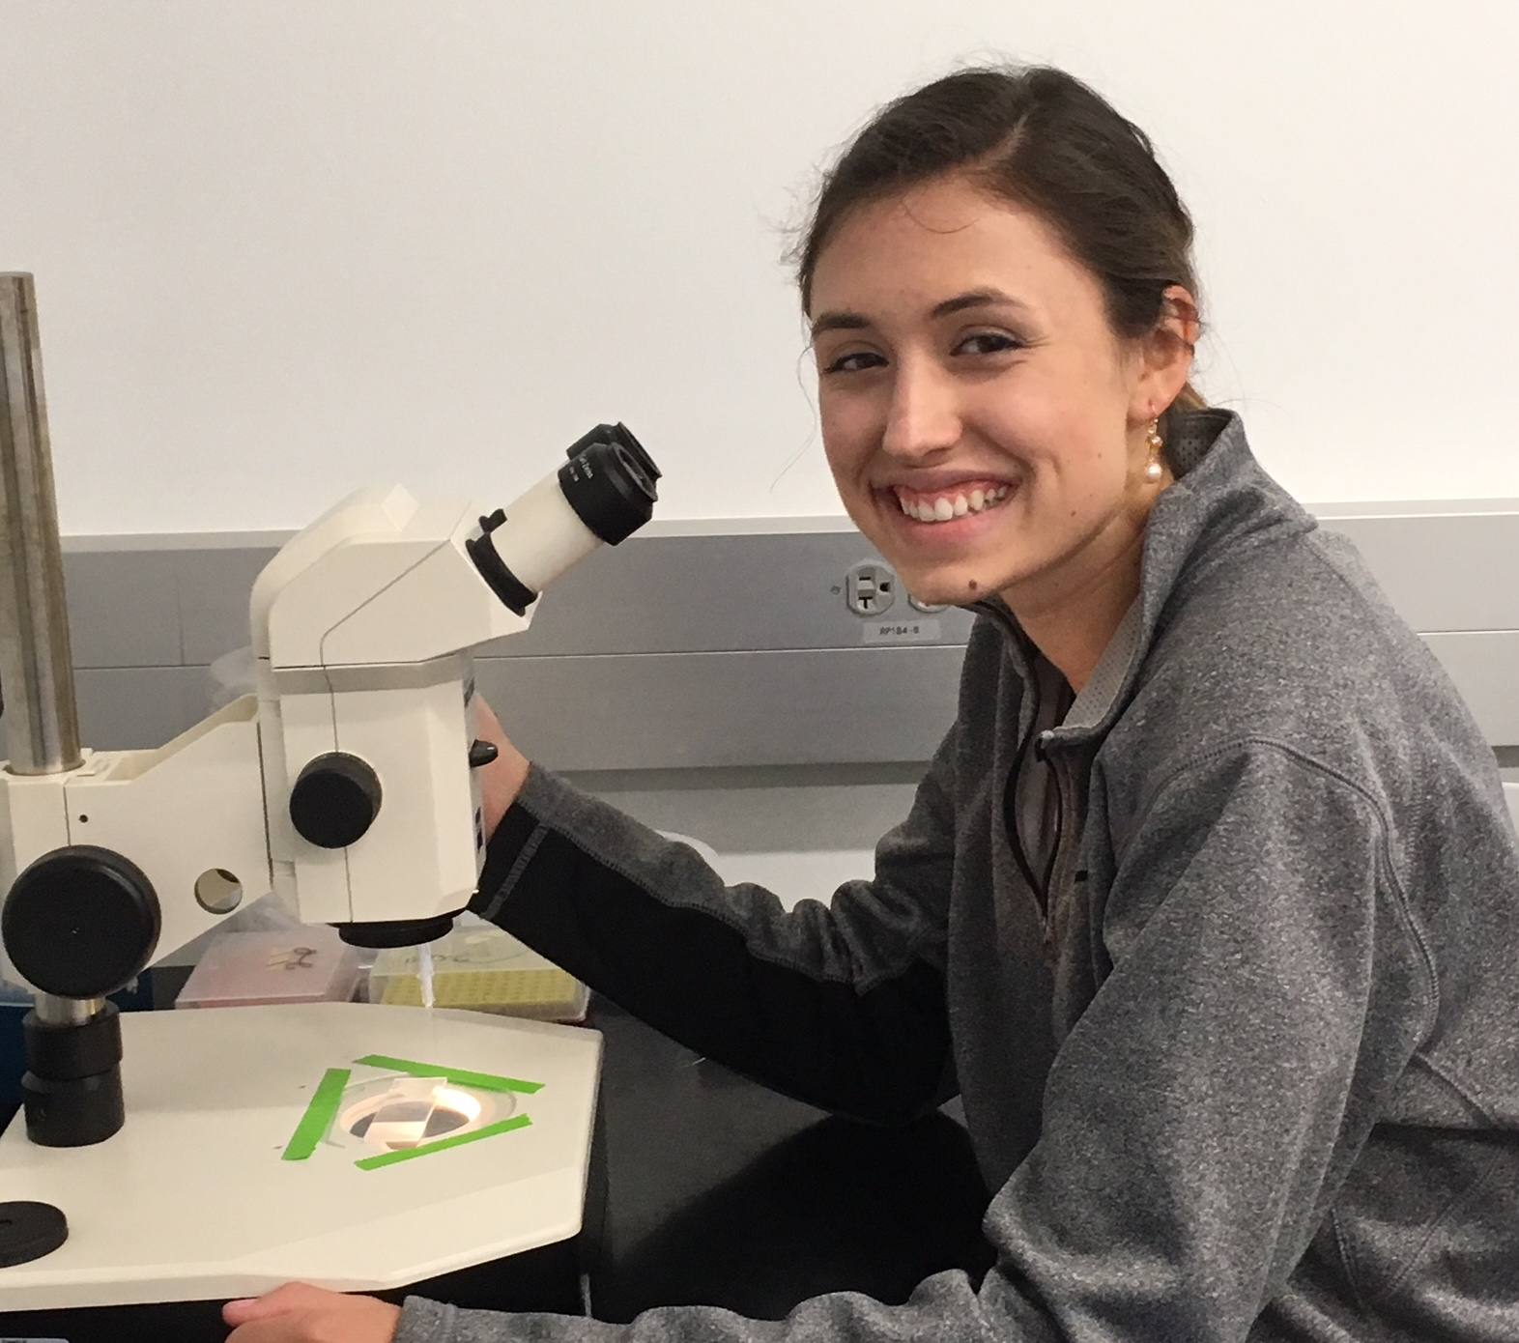
Madison E Davis
Genome Sequences of the F1 Subcluster Mycobacteriophages Awesomesauce and LastJedi
Madison E Davis, Christine A Byrum
This project characterizes the genomes of two F1 bacteriophages, Awesomesauce and LastJedi, in collaboration with the Science Education Alliance-Phage Hunters Advancing Genomics and Evolutionary Science (SEA-PHAGES) program in efforts to characterize viral diversity. Both bacteriophages infect Mycobacterium smegmatis mc²155, a prominent acid-fast Gram-positive soil bacterium. Awesomesauce was found in damp, shaded soil at Brown University by Charlotte Merzbacher, while LastJedi was from mud near shrubs at the State University of New York College at Old Westbury and was found by Jewel Joseph and Don Kiriella. Following DNA extraction, sequence libraries were produced by the Pittsburgh Bacteriophage Institute at which point, each genome was adopted by the College of Charleston for genome annotation. Annotation of Awesomesauce and Last Jedi was performed by Maddie Davis and the Fall 2019 Genomics course respectively using programs available in the PECAAN workflow tool including Glimmer, GeneMark, Phamerator, Starterator, ARAGORN, tRNAscan-SE, BLASTp, HHpred, THMM2, TOPCONS, and the NCBI Conserved Domain Database. The Awesomesauce genome is 57,054 bp with 94 protein-coding genes and 62.9% GC content while the LastJedi genome is 55,149 bp with 94 protein-coding genes with 61.8% GC content. Both genomes displayed key structural and assembly genes on the left arm and nonstructural coding sequences on the right. Whole-genome BLASTn alignments revealed that Awesomesauce is most similar to F1 mycobacteriophages TootsiePop, Misha28, and Piper2020. Interestingly, these four genomes share a synteny block (gp49 to gp61) which is unique within the F1 cluster but is also found in the singleton LilSpotty, suggesting a common origin. LastJedi is highly homologous to F1 bacteriophages Clifton and Brocalys. Notable features include a toxin/anti-toxin system (gp35 and gp36), two helix-turn-helix DNA binding domains (gp53 and gp54), and a HNH endonuclease (gp59). LastJedi may also be found under the name MargotMini, a duplicate of the genome.

