CONSIDER FOR TALK
2021 SEA Symposium Abstract
Austin Peay State University
Clarksville TN
Corresponding Faculty Member: Sergei Markov (markovs@apsu.edu)
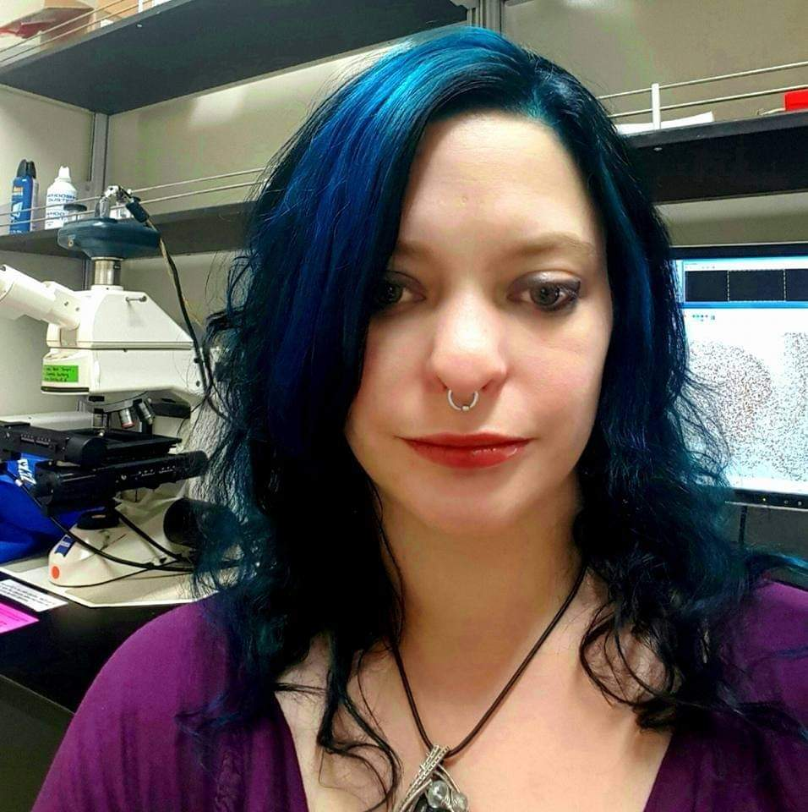
Robin J Zimmer
Montana H Simpson
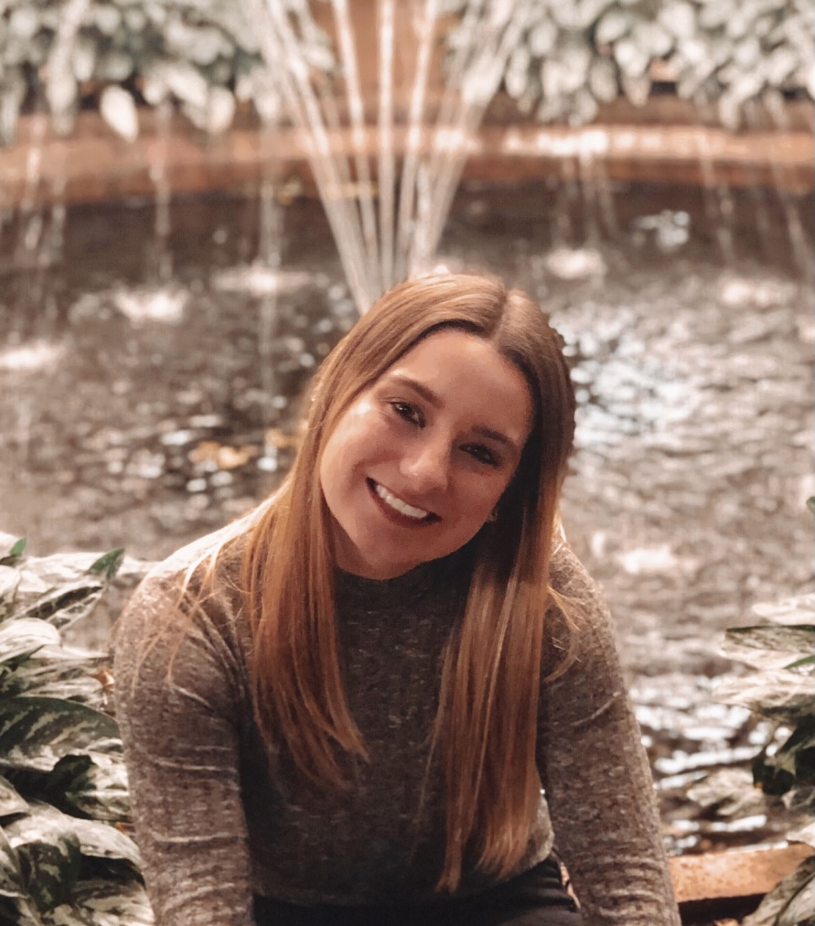
Kaitlin M Hutson
Isolation, characterization and genome annotation of bacteriophages from Clarksville, TN.
Robin J Zimmer, Montana H Simpson, Kaitlin M Hutson, Sarah D Binkley, Cole M Bell, Kevin M Bouma, Christina L Cagle, Alexandria M Hudson, Gregory S Markov, Elizabeth C Mason, Dillon Nall, Gerald B Reed, Christina M Ross, Gabrielle B Rueff, Taiwo O Sennuga, Diana G Villalpando, Leong Lee, James C Church, Sergei A Markov
Eleven new bacteriophages were isolated and characterized from soil samples of APSU campus and other Clarksville, TN areas using a host bacterium Microbacterium foliorum NRRL B-24224. Bacteriophages were purified and amplified to high titer lysates and examined using transmission electron microscopy. All bacteriophages were from the Siphoviridae family with a flexible tail.
The University of Pittsburgh sequenced the five bacteriophage DNAs isolated at APSU. Only three of these sequences were unique. Interestingly, the sequence of our bacteriophage Phabliaux matched the bacteriophage Rhysand found in South Carolina in 2018. Three unique bacteriophage genomes (Danno, Otwor, and Scumberland) were manually annotated at APSU and published at GenBank. Bacteriophages Danno and Otwor are from the same cluster EE. Bacteriophage Danno DNA size is 17452 bp, and bacteriophage Otwor is 17454 bp. Both bacteriophages have 25 predicted protein-coding genes on their DNA. Twenty-four of those genes are exactly identical (96%). Bacteriophage Scumberland (53276 bp genome size) is from a different cluster EC and has 92 predicted protein-coding genes.
The general genomic architecture in all described bacteriophages is canonically organized. The majority of genes transcribed rightward, the left part of each genome contains genes for structural proteins, and the right side of genome has genes for DNA replication and DNA binding proteins.

