CONSIDER FOR TALK
2021 SEA Symposium Abstract
University of Colorado Boulder
Boulder CO
Corresponding Faculty Member: Christy Fillman (christy.fillman@Colorado.EDU)
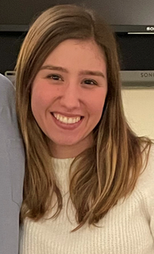
Daria Nicke
Characterizing Genetic Elements in the Cluster O Mycobacteriophage Blessica
Daria Nicke, Daniel Feeny, Nancy A Guild, Christy L Fillman
In this study we compared the genome of a new cluster O mycobacteriophage, Blessica, to seven other cluster O mycobacteriophages to identify sites where horizontal gene transfer had occurred. Cluster O bacteriophage genomes are highly conserved with over 97% nucleotide identity. The variation usually consists of insertions or deletions of one to three genes. Comparing the number of inserted or deleted genes and their phamilies common clusters, the geographical origin of these phages and the presence of SigA promoters, a phylogenetic tree with a hypothetical common ancestor of cluster O mycobacteriophages has been constructed. Firecracker was identified as the most similar to the hypothetical common ancestor of O cluster phages having the least number of deletions or insertions (3) while Catdawg had the highest number of deletions or insertions (14).

