DO NOT CONSIDER FOR TALK
2021 SEA Symposium Abstract
Northwestern College
Orange City IA
Corresponding Faculty Member: Sara Tolsma (stolsma@nwciowa.edu)
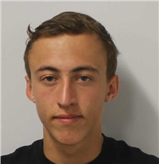
Riley Chartier
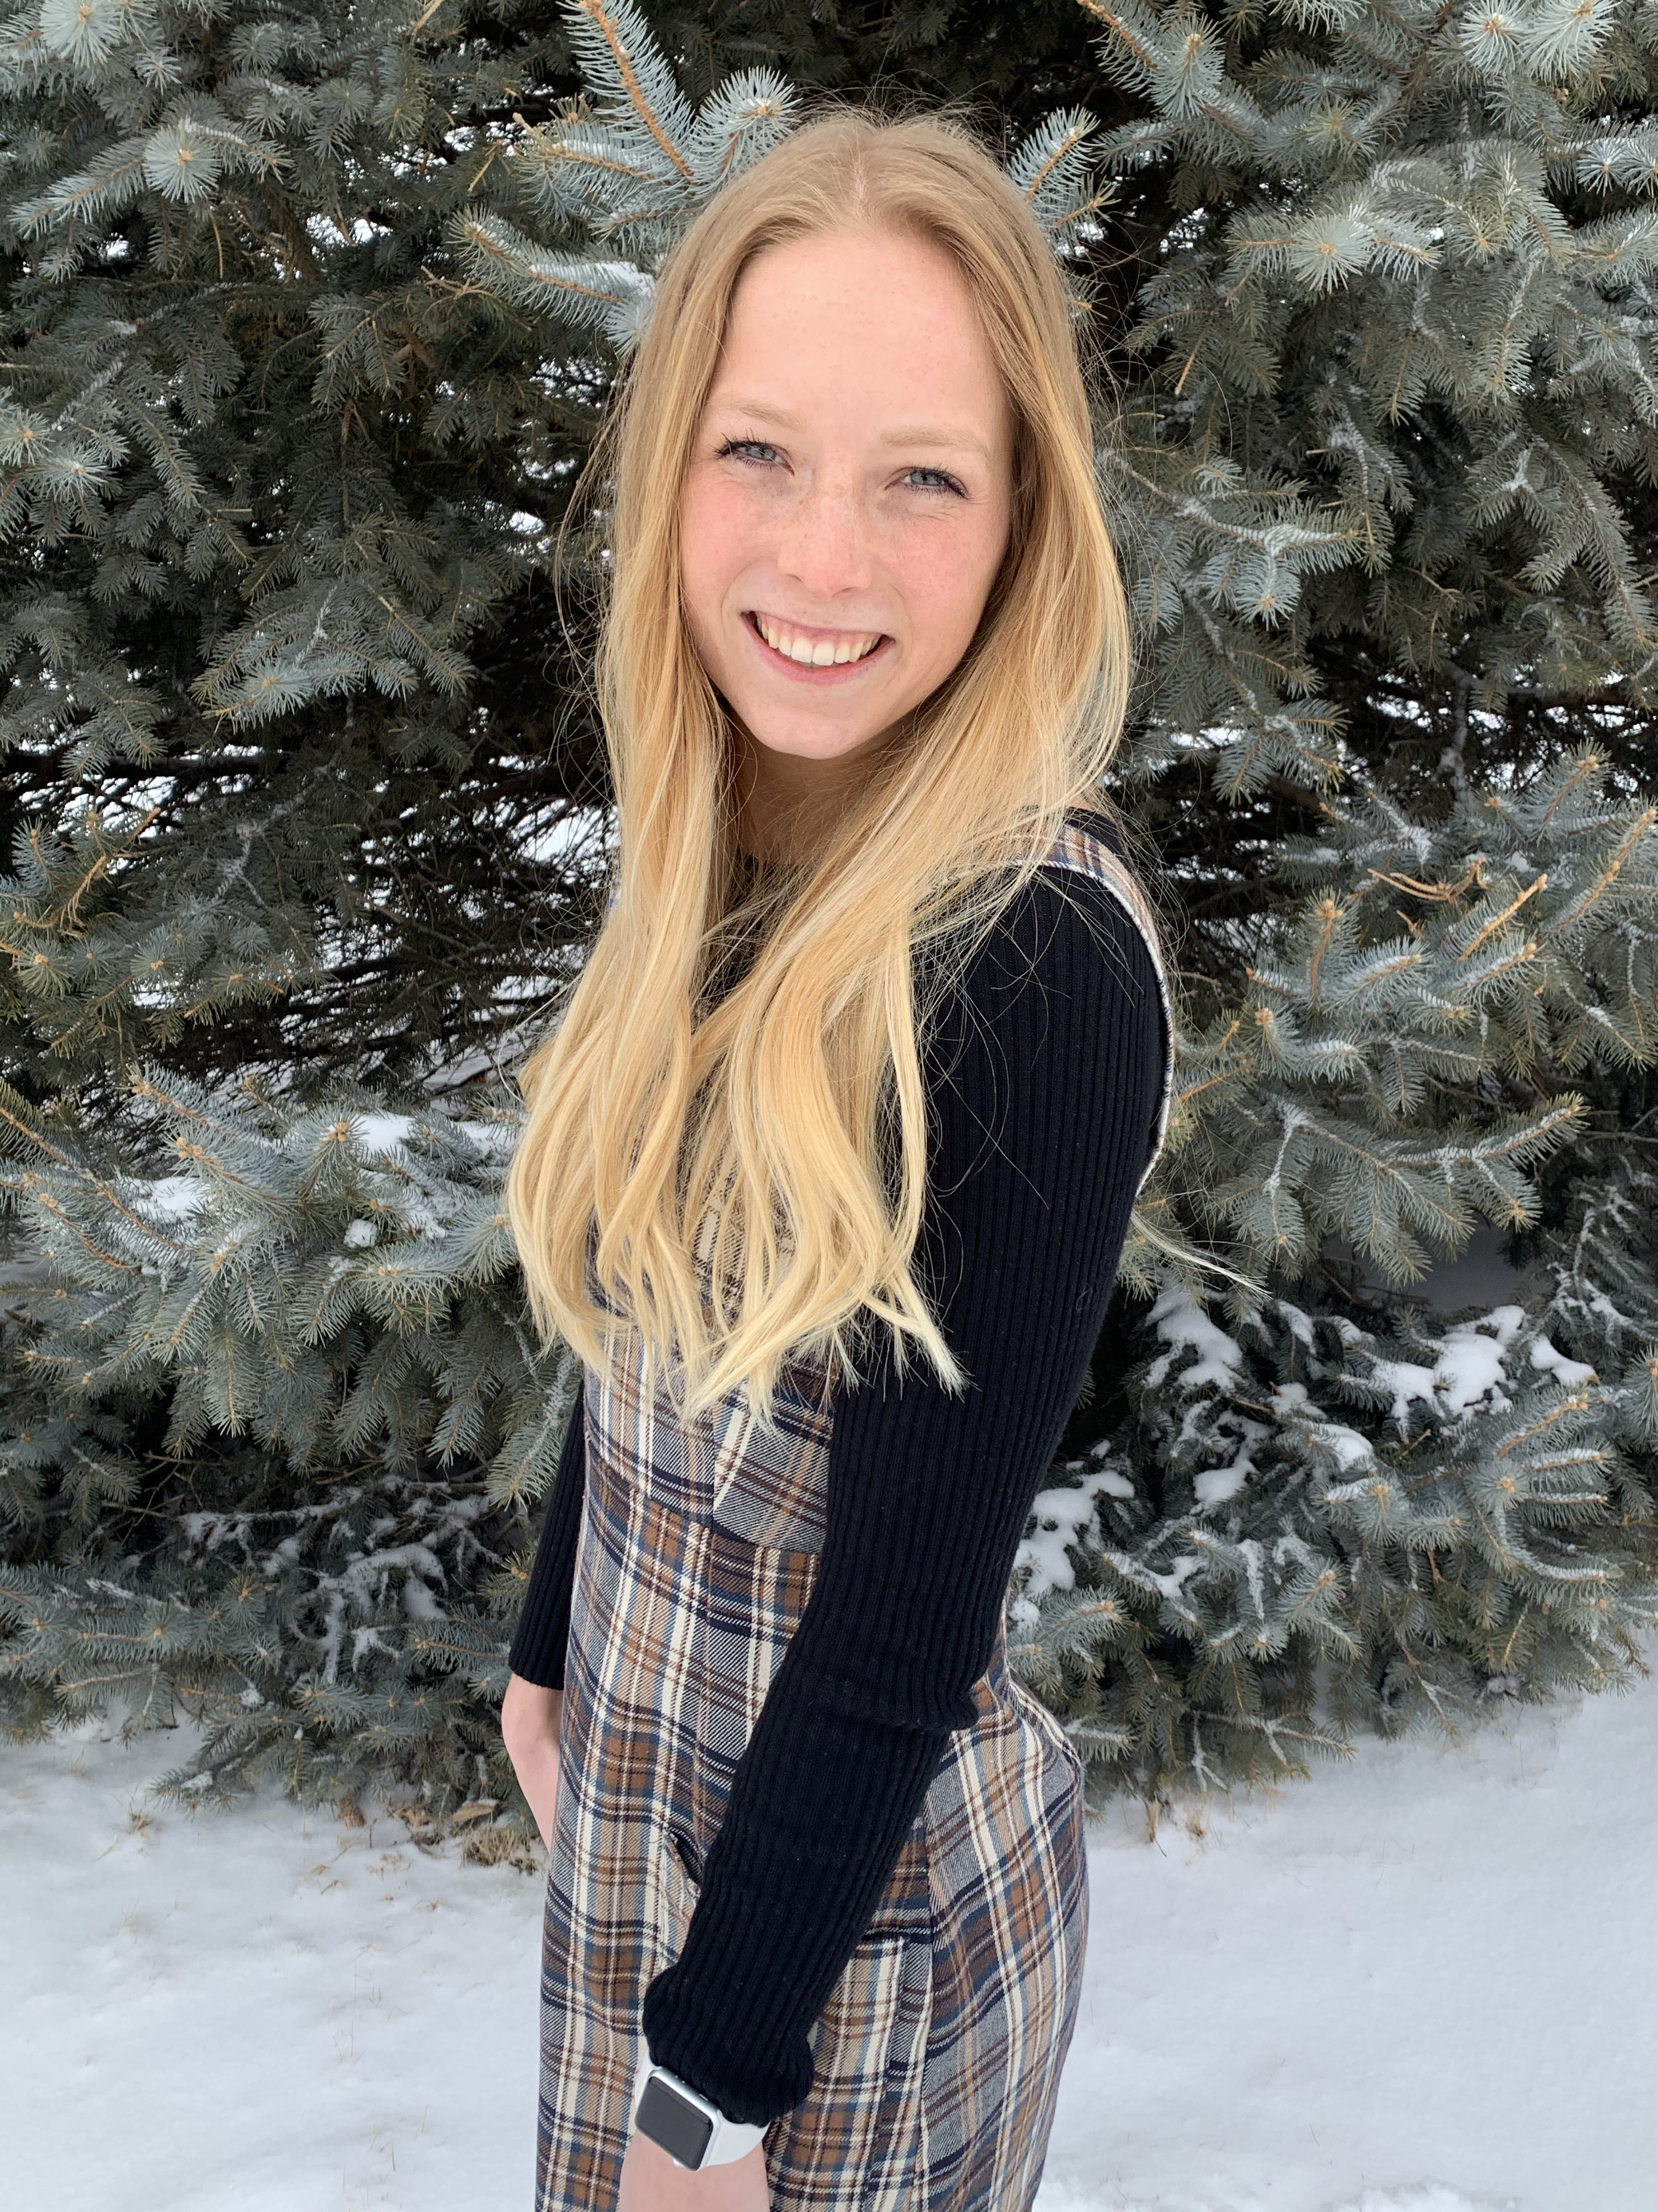
Abigail Clarke
Lindsey Groen
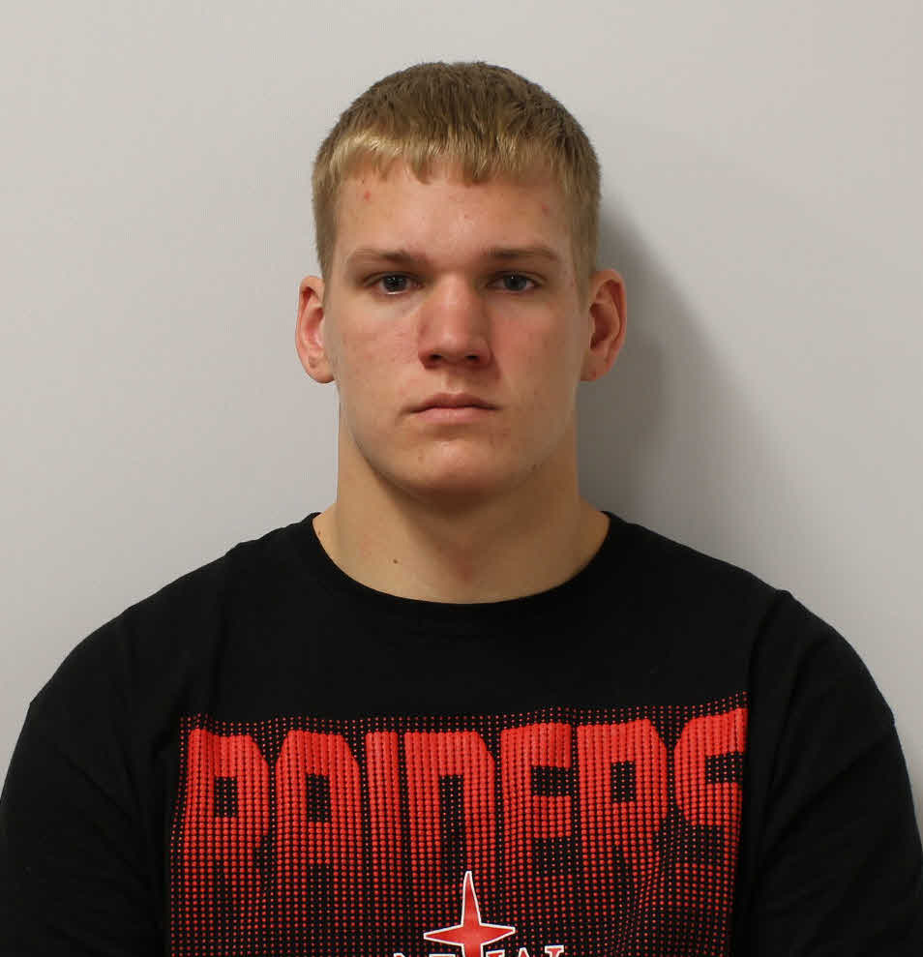
Marshall Kleinhesselink
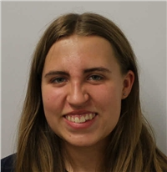
Cassandra Koel
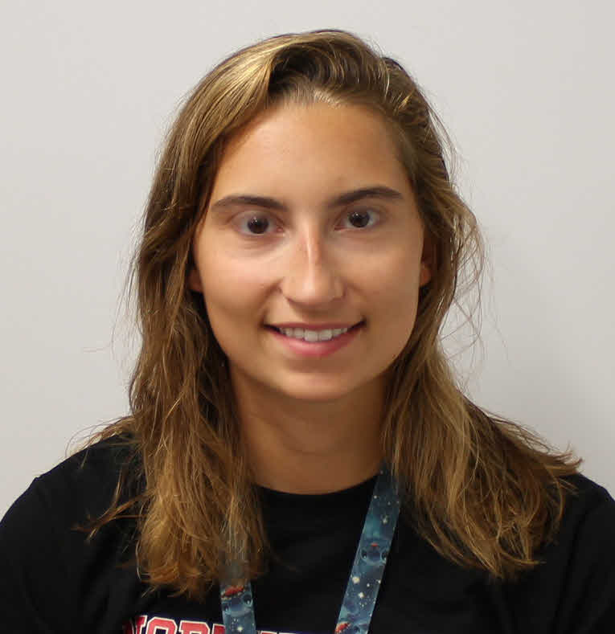
Madison Korthals
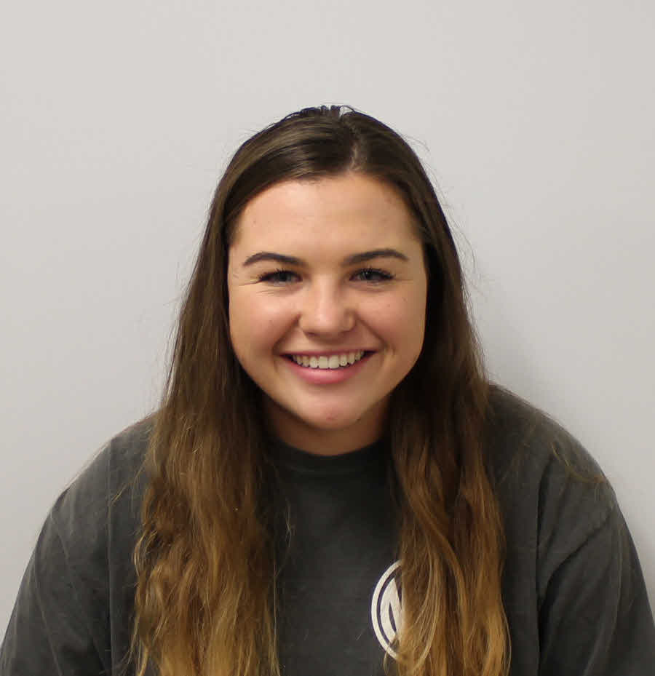
Jordyn Kramer
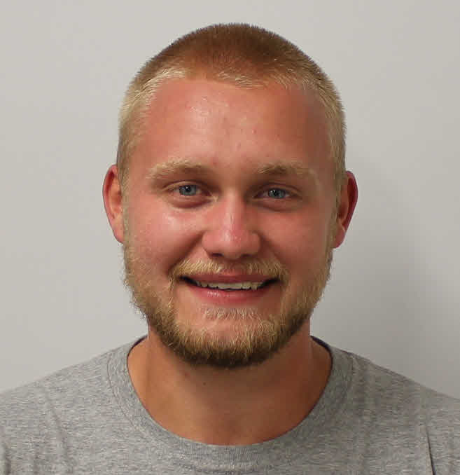
Garrett Raymon
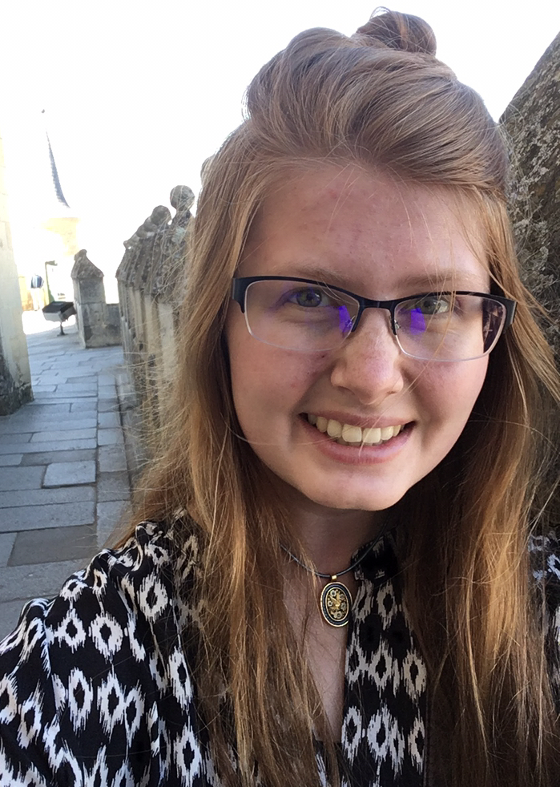
Krista Riensche
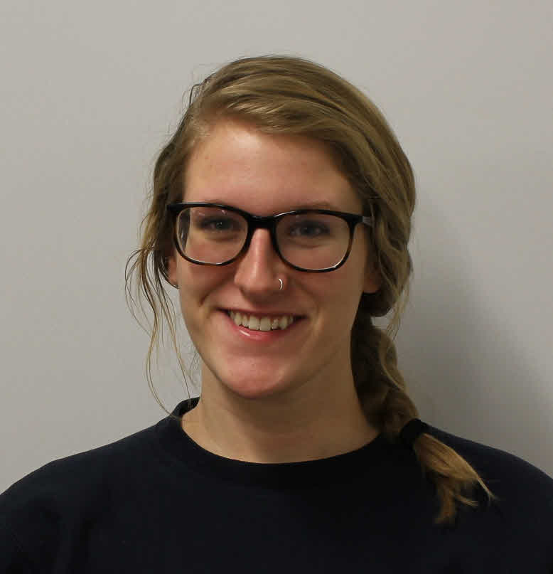
Sadie Sandbulte
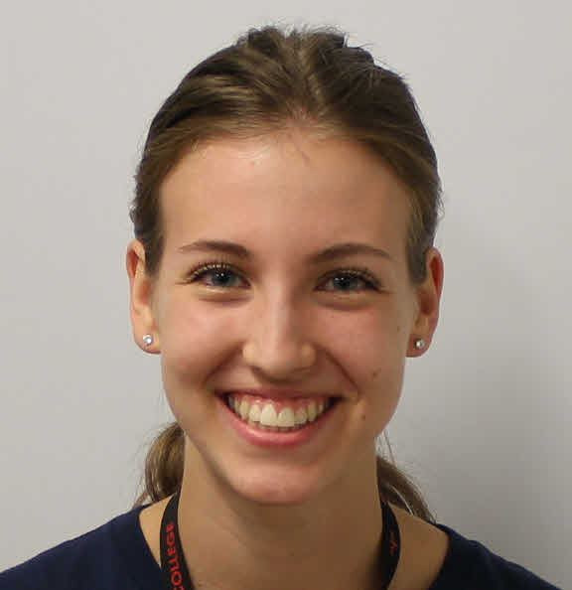
Annika Stecker
Daniel Strand
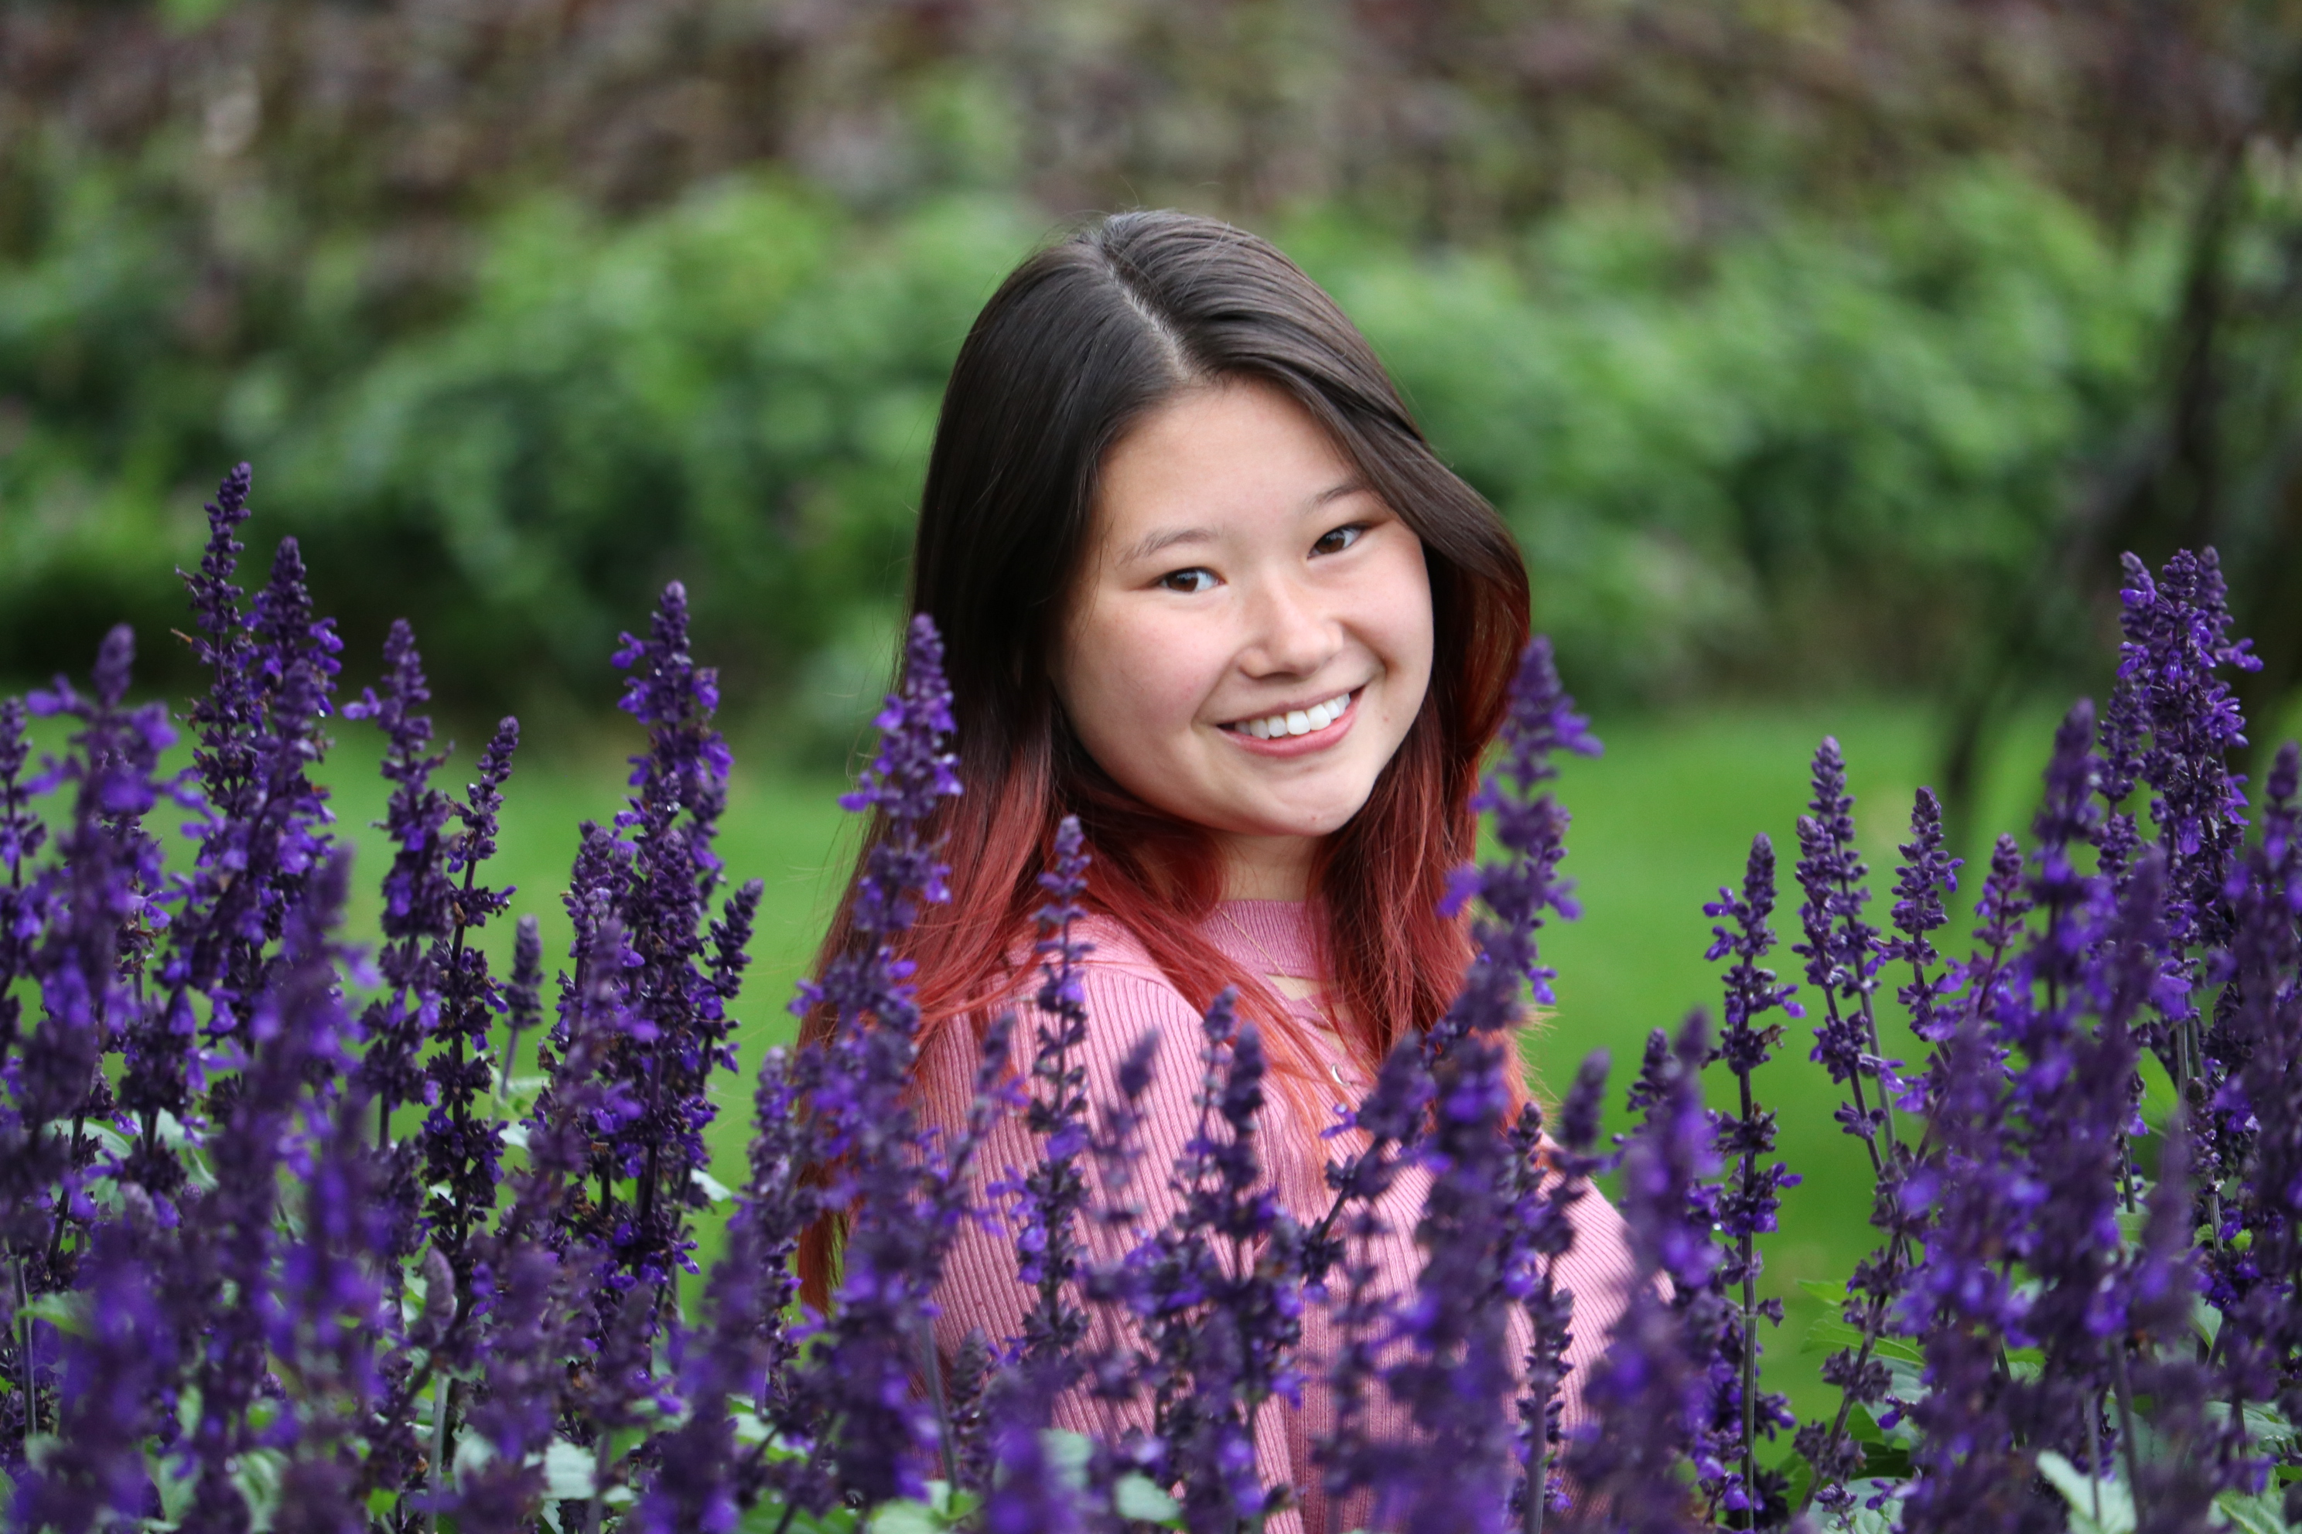
Kaytlin Wojciechowski
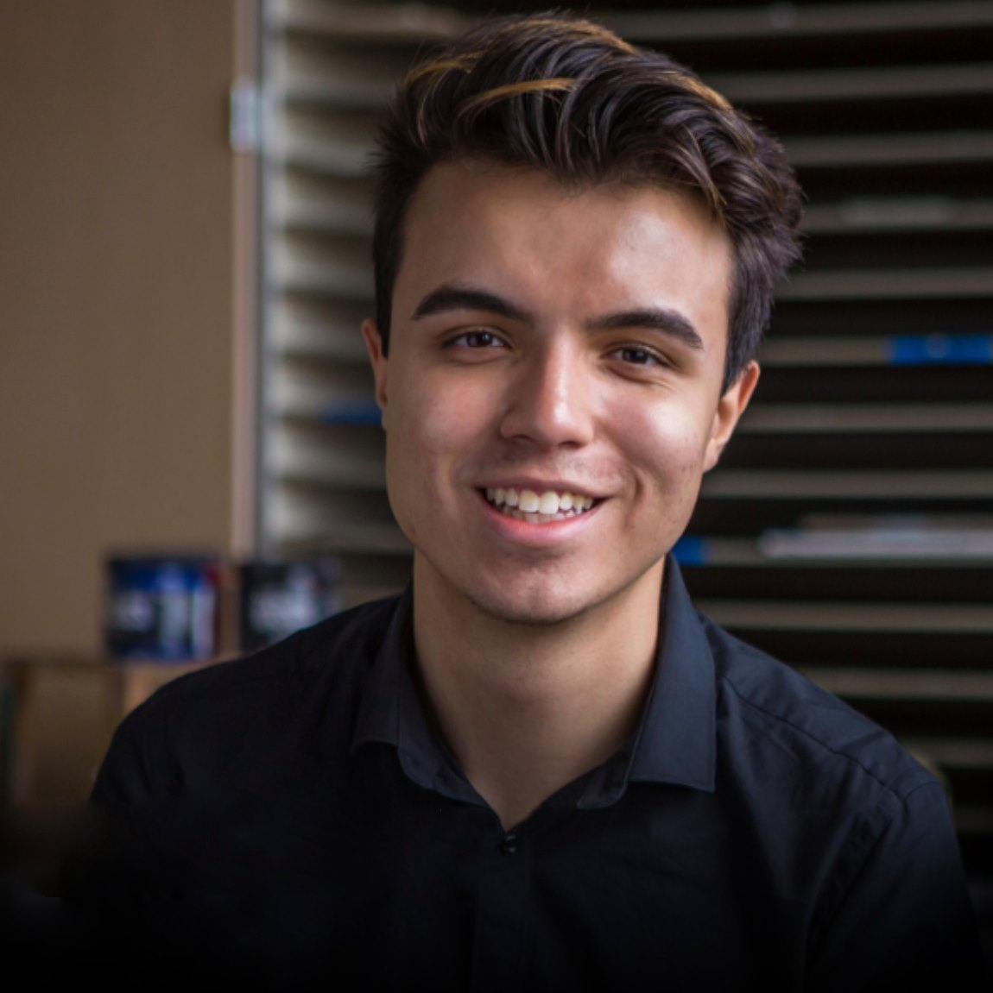
Ali Almail
Stormbreaker8 and A3Wally Bacteriophage Genome Annotations
Riley Chartier, Abigail Clarke, Lindsey Groen, Marshall Kleinhesselink, Cassandra Koel, Madison Korthals, Jordyn Kramer, Garrett Raymon, Krista Riensche, Sadie Sandbulte, Madison Korthals, Jordyn Kramer, Garrett Raymon, Krista Riensche, Sadie Sandbulte, Annika Stecker, Daniel Strand, Kaytlin Wojciechowski, Ali Almail, Byron Noordewier, Sara S Tolsma
Stormbreaker8 and A3Wally are two novel bacteriophages isolated and purified on Microbacterium foliorum NRRL B-24224 by students in the Fall 2020 Discovery course. Stormbreaker8, an EA1 cluster lytic phage, was isolated from soil collected in Orange City, IA. Its circular permuted genome contains 41,751 base-pairs with 63.4% GC content. A3Wally, a GD cluster phage, was isolated from soil collected in Sioux Center, IA. Its genome is 60.1% GC, contains 194,724 base-pairs, and its ends are direct terminal repeats. Spring 2021 Genetics students annotated the genomes using bioinformatics software.

