CONSIDER FOR TALK
2021 SEA Symposium Abstract
Monmouth College
Monmouth IL
Corresponding Faculty Member: James Godde (jgodde@monm.edu)
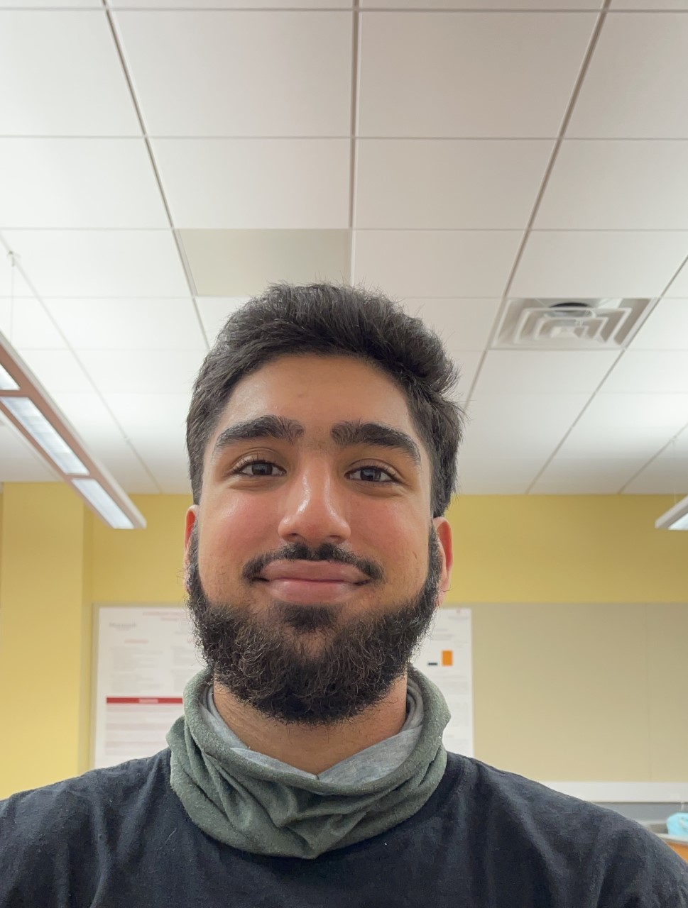
Yuvraj S Sidhu
Geovirology: Does geographic proximity correlate with genetic difference?
James S Godde, Elizabeth M Guzman, Madison M Meldrum, Alexis M Shields, Yuvraj S Sidhu, Timothy J Tibbetts
BrokMonster, the phage we characterized last semester, was found 1/3 mile away from McShie, a phage that was previously characterized by our school. Sequencing revealed a difference of a single base pair between the two. We therefore began to wonder whether phages that are genetically close to one another are often typically found in close geographic proximity. Phagesdb BLAST searches were used to characterize the closest relative of each phage studied and the corresponding GPS coordinates from Phagesdb were used to measure the distance between isolation sites.

