CONSIDER FOR TALK
2021 SEA Symposium Abstract
University of Pittsburgh
Pittsburgh PA
Corresponding Faculty Member: Kristen Butela (kab340@pitt.edu)
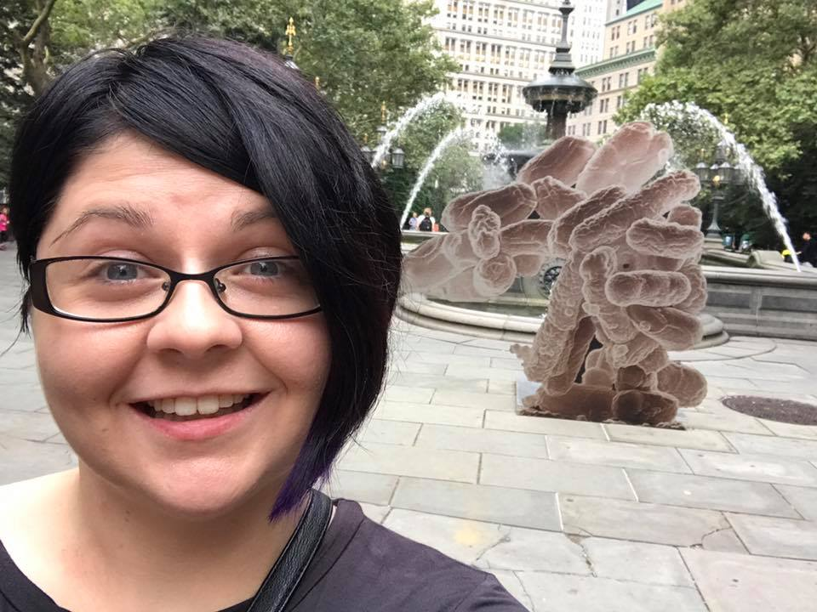
Kristen A Butela
A Hybrid Approach to Teaching the SEA-PHAGES Phage Discovery Lab Course
Meghan Bechman, Rebecca L Bortz, Kristen A Butela
Due to COVID-19 restrictions, the Fall 2020 SEA-PHAGES Phage Discovery labs at the University of Pittsburgh were offered as hybrid courses with each section having simultaneous online and in-person delivery available in synchronous and asynchronous formats. Accommodation of these multiple participation options with social distancing requirements in the lab classroom was accomplished by dividing the course into four three week-long modules: Isolation, Purification, Amplification, and Characterization, with each student having the opportunity to participate in-person for one module. Students were organized into teams of four, with each student fulfilling a different role in the experimental process. The Experiment Manager served as the only in-person member of the team and was responsible for performing all experiments in the module. The Protocol Manager was responsible for recording the protocol in the shared lab notebook and guiding the Experiment Manager through performing the protocol. The Data Manager recorded all data in the lab notebook, and the Communications Manager reported experimental results back to the rest of the class and took responsibility for curation of the lab notebook. Students worked in breakout rooms on Zoom during experiments so that online students could follow along with the Experiment Manager physically performing the experiments in the classroom. At the end of each module, student teams reported on their progress during lab meetings. Students switched roles after each module, with the exception that the role of Experiment Manager was only filled by students who opted for in-person learning. Detailed demonstration videos were recorded and assigned to all students to watch before coming to lab, with low-stakes, repeatable quizzes accompanying the videos to ensure preparedness and to reinforce key concepts. Despite the challenges of COVID-19, the Fall 2020 SEA-PHAGES student cohort (24 sections of 20 students per section) successfully isolated 144 phages and obtained sequence-quality DNA for 49 phages.

