DO NOT CONSIDER FOR TALK
2021 SEA Symposium Abstract
Northwestern College
Orange City IA
Corresponding Faculty Member: Sara Tolsma (stolsma@nwciowa.edu)
David M Adair
Lindsey L Craig
Keziah J Knudson
Kaylee A Maasdam
Kaarina M Marttila
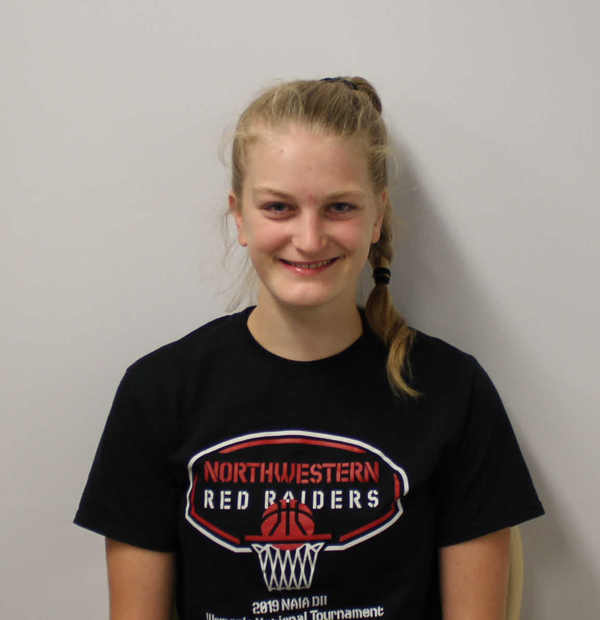
Katie M Meyer
Alexa Olguin
Mitchell Renschler
Emily Schmidt
April S VanTol
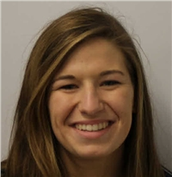
Samantha Blum
Samantha Blum
Genetic Annotation of Bacteriophages MScarn, Knocker, and Neos5
David M Adair, Lindsey L Craig, Keziah J Knudson, Kaylee A Maasdam, Kaarina M Marttila, Katie M Meyer, Alexa Olguin, Mitchell Renschler, Emily Schmidt, April S VanTol, Samantha Blum, Byron Noordewier, Sara S Tolsma, Emily Schmidt, April S VanTol, Samantha Blum, Byron Noordewier, Sara S Tolsma
We annotated the genomes of three recently discovered bacteriophages to learn more about their genetic composition. MScarn is a lytic bacteriophage that infects Gordonia terrae 3612. It was discovered and purified from soil collected in Iroquois, SD. MScarn is a cluster CT phage, one of only 37 discovered to date. Its genome is 45,677 base pairs long and has 10-nucleotide 3’ sticky overhanging ends. Its GC content is 60.3% which is typical of CT cluster members. Knocker is a cluster B9 phage that was isolated on the host Mycobacterium smegmatis mc²155 from soil collected in Watertown, SD. Its circularly permuted genome contains 71,459 base pairs, and it has a high GC content of 69.7%. Similar to the other three members of the B9 cluster, it exhibits a lytic life cycle. Neos5, a lytic bacteriophage, was also isolated on Mycobacterium smegmatis mc²155 from soil collected in Baltimore, MD. It is a cluster B3 phage with a circularly permuted genome of 68,886 base-pairs and a 67.5% GC content, synonymous to the other 37 members of the cluster. All three phages were discovered, purified, and annotated by Northwestern College students.

