CONSIDER FOR TALK
11th Annual SEA Symposium Abstract
Massey University
Auckland Campus
Corresponding Faculty Member: Heather Hendrickson (h.hendrickson@massey.ac.nz)
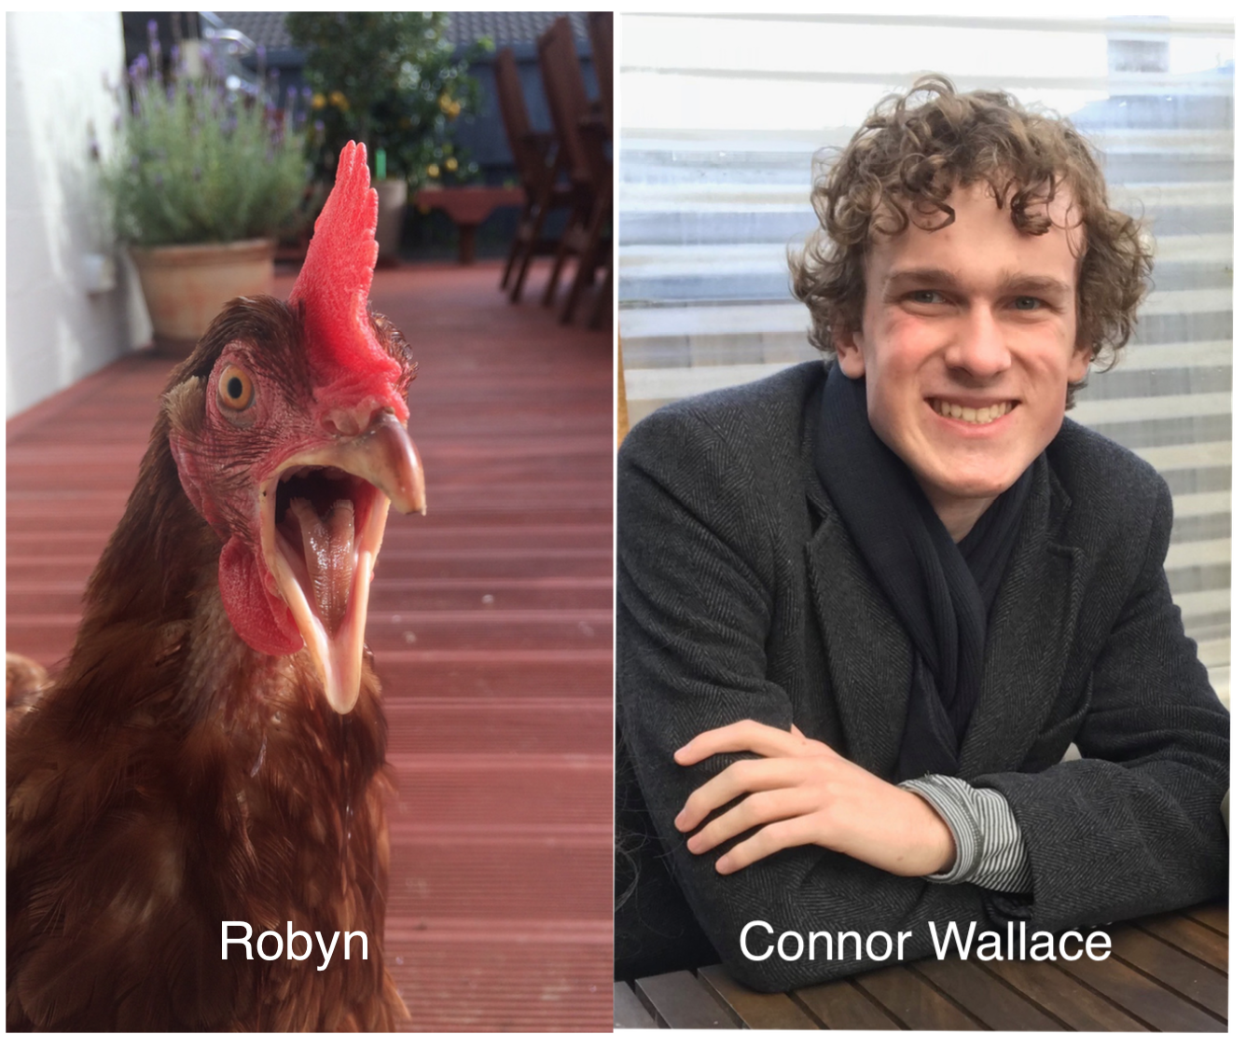
Connor J Wallace
A First, New Zealand B1 & F1 Phages; Genetic Homology & Distinction
Connor J Wallace, Alicia Baxter, Josh S Elder, Oliver Massey, Anna Wong, Jarod Young, Nikki E Freed, Heather L Hendrickson
Massey University was the first university outside of the United States of America to join the SEA-PHAGES programme and our Massey Phage Whānau has continued to catalogue and discover novel New Zealand phages since 2015.
In 2018, we used Mycobacterium smegmatis mc2155 as a host bacterium and successfully isolated six novel mycobacteriophages from around the Auckland region, New Zealand. These phages were named ABax, Caramel, Carthage, Fancypants, Phlubub and Robyn. Of these six phages, Carthage, Fancypants and Robyn were sequenced by the Pittsburgh Bacteriophage Institute. The B1 cluster phages Robyn and Carthage and the F1 cluster phage Fancypants are the first of their respective clusters to be isolated in New Zealand.
Electron microscopy was conducted at the Auckland University microscopy facility and revealed that all six 2018 mycobacteriophages belong to the family Siphoviridae.
Gene annotation through PECAAN, Phamerator & DNA Master revealed that phages Robyn and Carthage are highly homologous. Phages Robyn and Carthage share 95 phams and are overall 93.6% alike, differing in length by only 515 nucleotides, the product of three insertion/deletion events. Gene annotation also uncovered a gene that is 557 base pairs long at gene position 38 in phage Fancypants, this gene is yet to be catalogued in any other phage globally.
Experimentation on robustness to temperature indicated that concentrations of phages Fancypants, Phlubub and Robyn decrease as temperatures approach 80ºC (176ºF).

