DO NOT CONSIDER FOR TALK
11th Annual SEA Symposium Abstract
Radford University
Radford VA
Corresponding Faculty Member: Joy Caughron (jcaughron2@radford.edu)
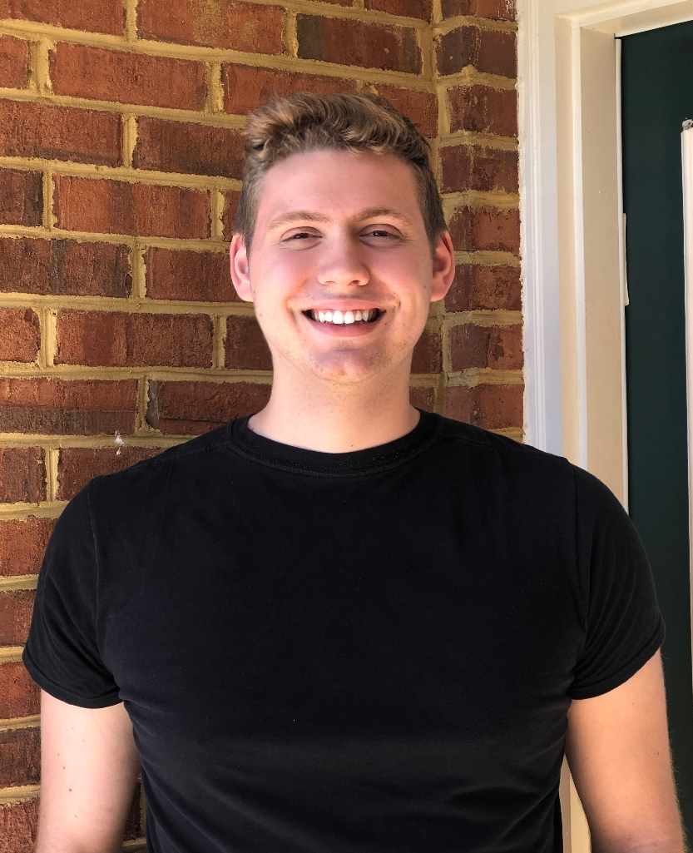
Connor Fox
Exploring the effects of environmental factors on the phylogeny of bacteriophages
Maxwell Barney, Connor Fox, Pravin Garskof, Jonathan Gibson-Cromer, Maria Gonzalez, April Hiett, Kelly Hodges, Laneigh Jones, Clint Krysa, Autumn Roberts, Jessica Wyllie, Joyce Caughron, Robert Sheehy
The purpose of this experiment is to collect environmental data gathered during the initial collection of the chosen EA1 sub-cluster phages and use this data to find trend in environmental significance of phage survival and phage distribution. By taking the data found and documented during phage collections, the environmental trend of selected phages can be examined as well as the likely displacement patterns of phages. The distribution is then overlaid with the phylogenetic analysis of the phage genomes at specified open reading frames that contain tail protein structure products. Two regions were specified to be tested, one containing high similarity in sequence analysis and synteny and another containing a higher variability region with open reading frames with tail protein products in the chosen phages. Two additional open reading frames were of particular interest due to one being annotated as a large gap of over one hundred base pairs consistently in the EA1 cluster phages as well as another open reading frame that has a possibility of being a recent horizontal gene transfer due to the coding potential of the host and phage not lining up in an expected pattern. These analyses are done using information gathered on Phages DB, NCBI Blast, Phamerator, MEGA 7, and information supplied by the institutions where phages were collected. If environmental factors impact the distribution and survival capability of phages, then the distribution of sub-cluster EA1 phages will likely overlap with phylogenetic analysis data of the following bacteriophages: Knox, Aubergine, HanSolo_Draft, BonesMcCoy, Draft, Tenda, AlexAlder, Gello, Peep, Bonino, StingRay, Schubert, Gargoyle, and Dave.

