DO NOT CONSIDER FOR TALK
11th Annual SEA Symposium Abstract
Johns Hopkins University
Baltimore MD
Corresponding Faculty Member: Emily Fisher (efisher@jhu.edu)
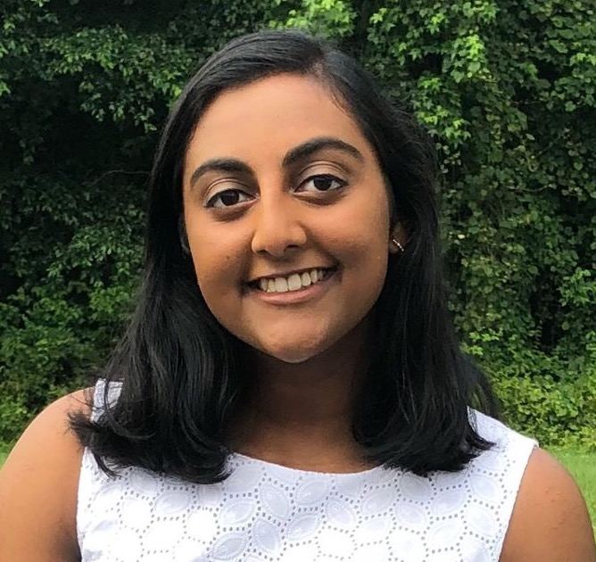
Sruthi Katakam
Microbacteriophages ChickenKing and Benjalauren share synteny but low homology in the the EA cluster
Sruthi Katakam, Lucas Polack, Benjamin Fry, JHU PhageHunters, Emily J Fisher
PhagesDB currently lists 1474 pages isolated on M. foliorum, 177 of which have been sequenced. Of those, 88 are in the EA cluster. This year, students at Johns Hopkins University discovered and annotated the genome of ChickenKing, a siphoviridae that defines a new subcluster, EA9. The most closely-related genome is that of Schubert, a cluster EA8 page discovered in 2017 at the University of Pittsburgh. Though other EA genomes are not identical in terms of sequence homology, they share most genes and 41/57 genes in ChickenKing are shared in the EA1 genome of Benjalauren, another phage isolated at JHU this year. Like other EA cluster phages, ChickenKing and Benjalauren are lytic and their genomes lack an integrase gene. They also both have two-part tail assembly chaperone genes and we were unable to identify a programmed frameshift that would unite them into one gene. We present comparisons of EA1, EA8, and EA9 genomes and discuss approaches to calling genes in a new subcluster in which Starterator and Phamerator sometimes lack information.

