DO NOT CONSIDER FOR TALK
11th Annual SEA Symposium Abstract
University of Detroit Mercy
Detroit MI
Corresponding Faculty Member: Stephanie Conant (conantsb@udmercy.edu)
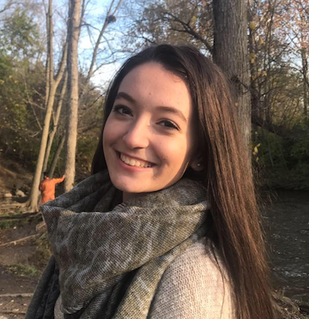
Demitra Loucopoulos
Annotation of the M. foliorum specific EA1 Bacteriophage Ioannes and Zada
Demitra Loucopoulos, Andrea Sandoval, Akhteyar Jaeran, Ali Zamat, Ken Dada, Jayla Anderson, Tania Anderson, Michael Avalos, Adrian Avila, Sheku Bangurah, Kiefer Degener, Razan El Yaman, Mohammad Hadeed, Leen Issa, Katelynn Kowalski, Yamere Lloyd, Vanessa Manzo, Nicolas Nunez, Semaj Shelton, Steven Taddei, Jonathan Finkel, Stephanie Conant, Jacob Kagey
Two Microbacterium foliorium specific bacteriophage were isolated from Michigan soil samples and purified. DNA was extracted and sent to the University of Pittsburg for sequencing, followed by genome annotation by the 2018-2019 SEAPHAGE course at the University of Detroit Mercy. The phage annotated were Ioannes and Zada, both EA, subcluster EA1 members. The EA1 subcluster has only 64 total phage identified and annotated thus far specific to the M. foliorium host as a part of the HHMI SEAPHAGE consortium. Annotations of these phage genomes identified gene mis-calls, insertions, false positive and false negatives within each genome. Because of the close similarity of the Ioannes and Zada genomes, phylogenetic comparison of Ioannes and Zada with other EA1 subcluster members was performed to investigate conserved genome similarities and protein-folding assessment was performed to identify potential differences resulting from minor nucleotide sequence changes.

