CONSIDER FOR TALK
11th Annual SEA Symposium Abstract
University of California, San Diego
San Diego CA
Corresponding Faculty Member: Rachel Dutton (rjdutton@ucsd.edu)
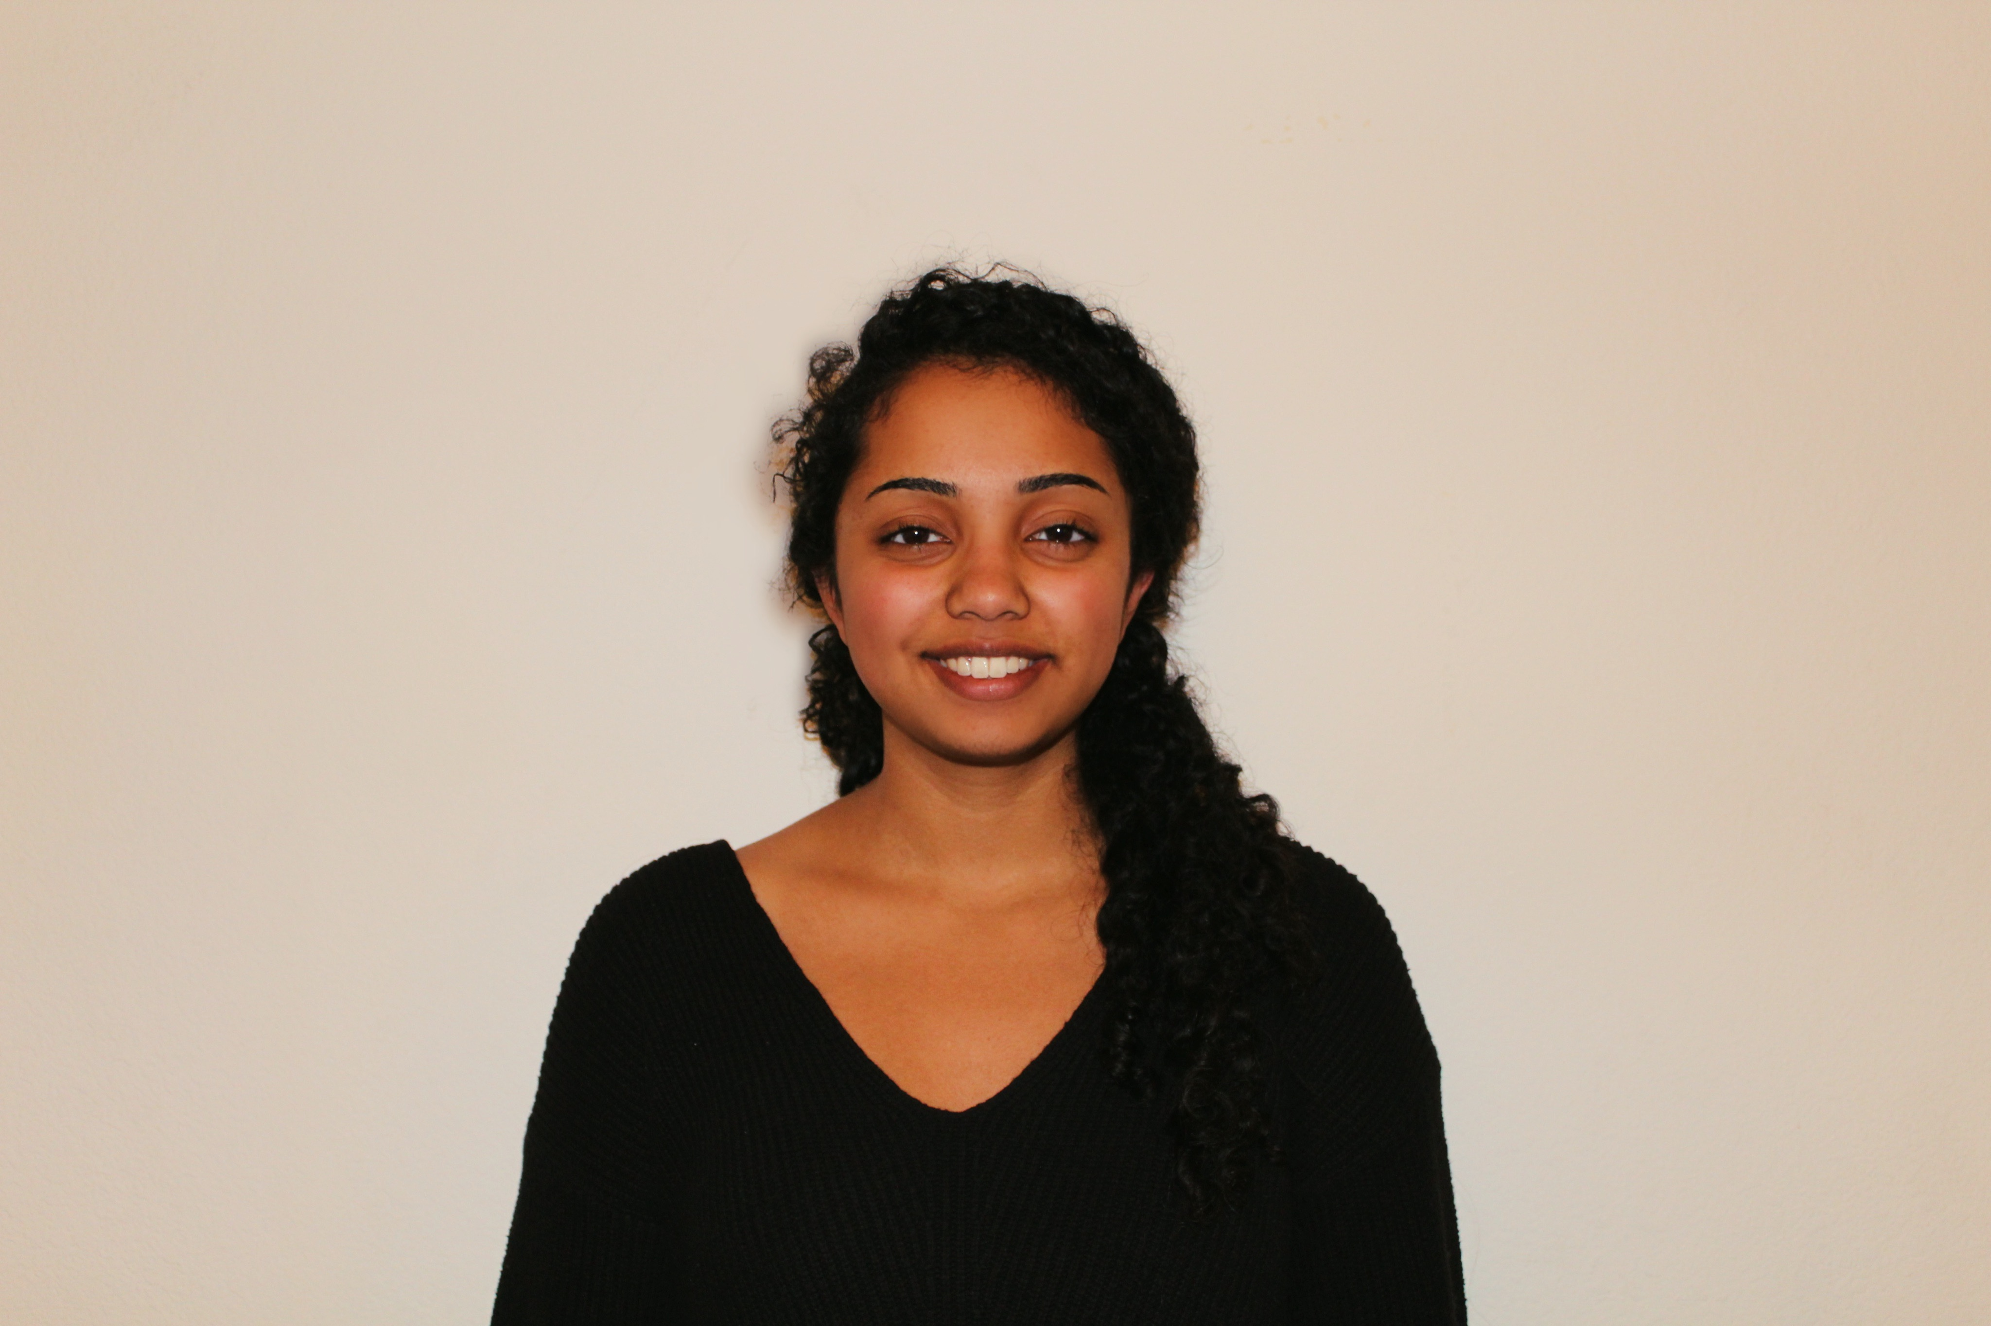
Avani Mylvara
Isolation and Characterization of A0 subcluster Arthrobacteriophage King2 and BK1 subcluster Streptomyces bacteriophage Beuffert from soil samples in San Diego County
Avani Mylvara, Isaac Chang, Samantha Tuohey, Lauryn Reugg, Chaylin VanDenburgh, Tracy Le, Madeline Dunsmore, Liliana Zamora, Paty Esquer-Romero, Jennifer Park, Jeffrey Keller, Alison Washburn, Patrick Akarapimand, Grace Kim, Ceasar A De La Fuente, Emily Morton, Calvin Ha, Andrew Mueller, Lena Krockenberger, Adrianne N Santa Romana, Lou Devanneaux, Brian Khov, Taylor Lichtenberg, Thisha Thiagarajan, Lydia Irons, Victoria Ortiz, Samantha Licona, Rachel Dutton, Swarna Mohan
In the Phage Genomics Research initiative course at UCSD, students isolated 9 Streptomyces platenis phages from soil samples and another 9 Arthrobacter sp. phages. The phages were characterized after direct isolation by restriction enzyme digestion and gel electrophoresis.
Genomes of one Arthrobacteriophage, King2, and one Streptomyces phage, Beuffert, were sent to the Pittsburgh Bacteriophage Institute for sequencing. Phage King2, a lytic myoviridae phage, belongs to subcluster AO1, all of which only infect Arthrobacter sp., strain ATCC 21022. King2 and has 75 genes in 50,000 base pairs. 30 of these genes had known functions while the remaining 60% of genes had unknown functions; King 2 does not encode for any tRNAs.
Phage Beuffert, a lytic siphoviridae phage, belongs to subcluster BK1 and infects Streptomyces platensis MJ1A1. Beuffert has 130,000 base pairs with 238 genes and GC content of 47.7%. 39 of these genes had known functions, making 83.6% of gene functions unknown. Beuffert also encodes for 34 tRNAs. Comparisons of Beuffert and King2 to other phages in their subclusters using BLAST and Phamerator revealed several highly conserved genes and potential functions. Our research revealed substantial diversity in the final draft annotation of these phages’ genomes by identifying genes and comprehensively examining their functions. Our annotations can benefit other researchers in determining further unknown, novel gene functions in similar phages and can benefit other researchers in finding new uses for such phages, like phage therapy.

