CONSIDER FOR TALK
11th Annual SEA Symposium Abstract
Southern Connecticut State University
New Haven CT
Corresponding Faculty Member: Nicholas Edgington (EdgingtonN1@SouthernCT.edu)
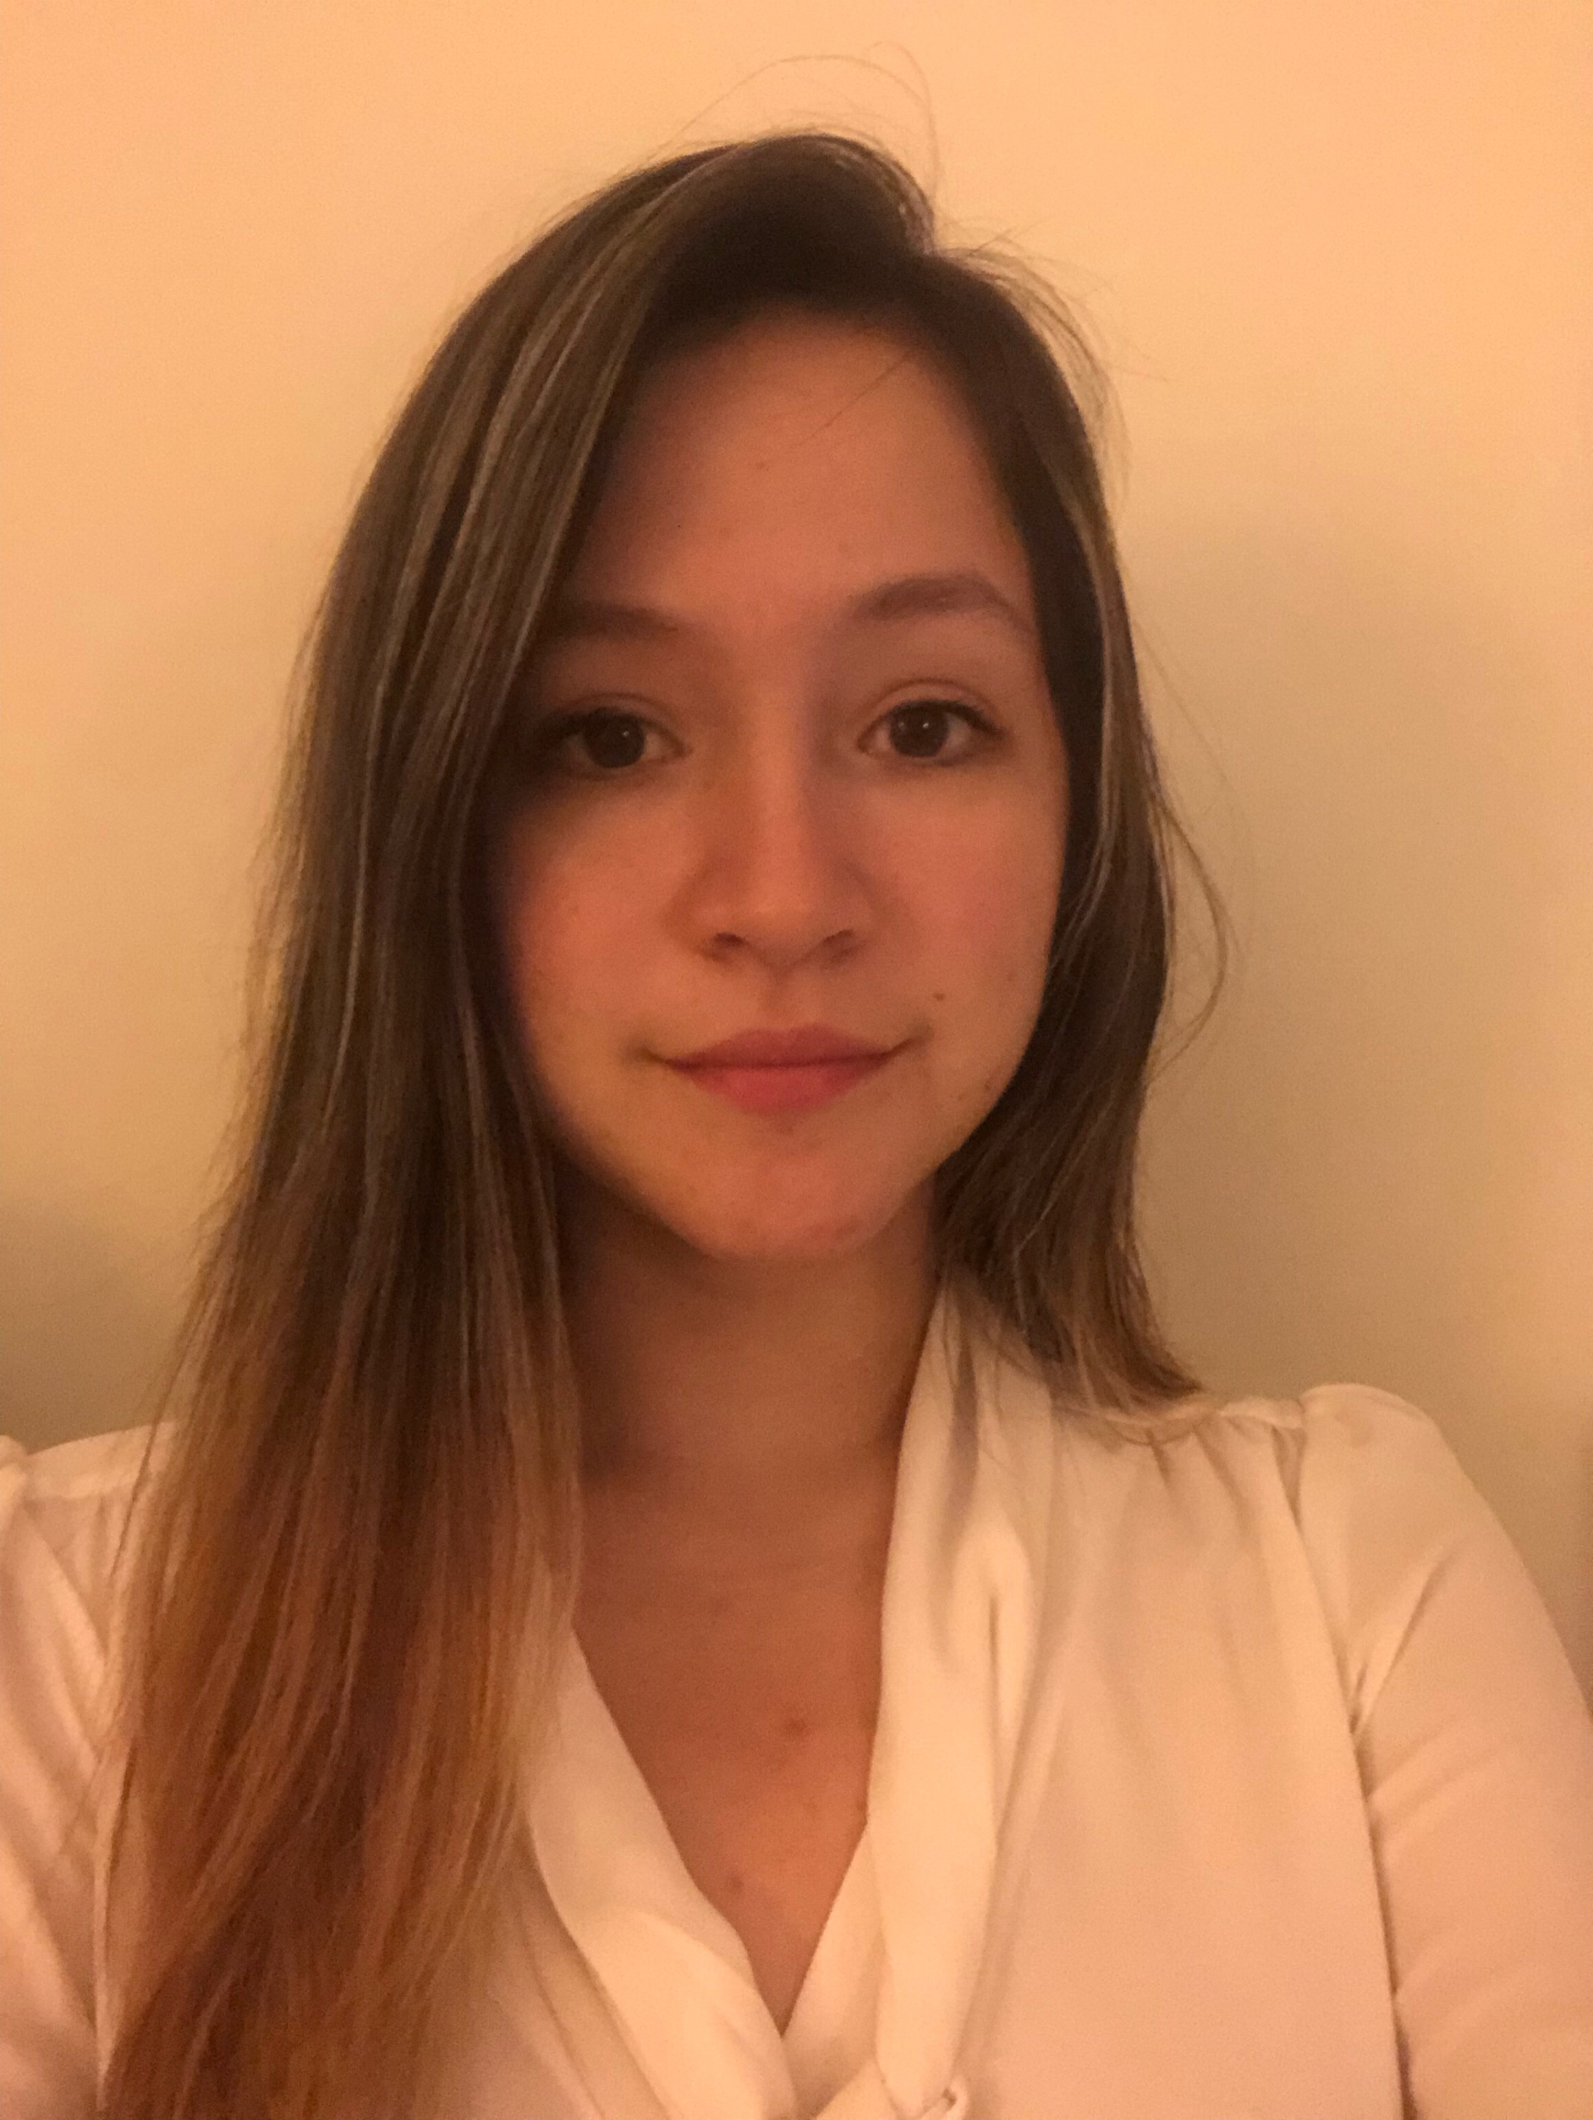
Stephanie Preising
Amelia Hoyt
Characterization of a new Microbacterium foliorum Cluster EB phage 'Stromboli': A tale of toxins, giant lysins, HNH endonucleases, and a gene cluster predicted to regulate nucleotide levels.
Stephanie Preising, Zachary Williams, Karina Martinez, Lindsay Kashuba, Perpetual Taylor, Mia Forgione, Faruk Senturk, Eleanor Tinsley, Richard Szeligowski, Johnesha Brown, Shannon Barrett, Amelia Hoyt, Nicholas P Edgington
Stromboli is a new member of the Cluster EB, a cluster that infects the bacterial host Microbacterium foliorum. It has a 41,594 bp genome and a GC% of 68.8. It is one of eighteen members in this cluster, is in the Siphoviridae family, produces a 'bullseye' plaque morphology, and is predicted to be a lytic phage. It has an unusually large lysinA which contains several repeats. We will present a phylogenetic analysis of the Type II HicAB system predicted in Microbacterium and actinobacteriophages. Stromboli also contains two predicted HNH endonucleases, tRNAs, and several genes that are predicted to encode enzymes that regulate nucleotide levels in the bacterial host.

