CONSIDER FOR TALK
11th Annual SEA Symposium Abstract
University of Maine, Honors College
Orono ME
Corresponding Faculty Member: Sally Molloy (sally.dixon@maine.edu)
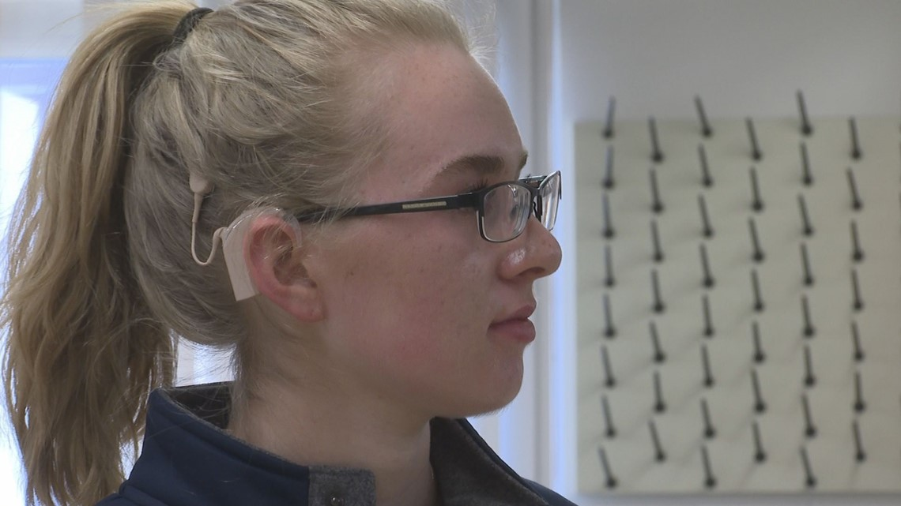
Jessica Hayden
Andrew Fournier
A study of phage with attitudes: defensive Gordonia phage Sidious and MagicMan and crazy Rhodococcus phage Whack and SleepyHead
Jessica Hayden, Emmie Baillargeon, Alec Ballinger, Alex Barrios, Jack Beaulieu, Angela Burke, Jack Burnell, Jacob Cote, Matthew Cox, Morgan Crapo, Samuel Deelsnyder, Hope Dorr, Trevor Dugal, Andrew Fournier, Caiden Fraiser, Remi Geohegan, Benjamin Gove, Keegan Gray, Hanna Griffin, Kaitlyn Jodoin, Nate Jordan, Marissa Kinney, Sarah Latario, Sarah Low, Victoria Mayers, Kyle Murawski, Eva Nazim, Erika Pacheco, Jenn Quezada-Loja, Zeke Robinson, Matt Seuch, Gabby Spencer, Dylan Taplin, Marc Thibodeau, Zach Williams, Ryan Worthington, Melissa Maginnis, Melody Neely, Sally Molloy
Through use of multiple bacterial hosts in the SEA PHAGES classroom, UMHC, isolated and sequenced two singleton Rhodococcus phage and six novel Gordonia phage belonging to clusters A15, CT, CZ7, DB, DC, and DU. Two of the Gordonia phage, Sidious and MagicMan, are temperate and encode viral defense systems. Sidious is the sole member of subcluster CZ7. Its genome is 51,789 bp in length, has a GC content of 66.6%, and encodes 84 putative genes. Sidious shares an immunity repressor with cluster CZ1 phage BatStarr and Nymphadora and G. terrae lysogens of Sidious are homoimmune with these phage. Sidious lysogens are also immune to infection by phage that do not have related immunity repressors: Yeezy and BaxterFox (CZ3); BetterKatz (DI) and Sitar (DE1). This heterotypic immunity may be due to Sidious genes gp41 and 40, which encode a putative abortive infection system, RexA and RexB, respectively. MagicMan is a cluster DB phage with a 47,598 bp genome with 67% GC content. The genome encodes 70 putative genes including an integrase (gp37), immunity repressor (gp38), and putative BrnT-like toxin (gp35). An obvious anti-toxin gene was not identified; however gp36 is divergently transcribed relative to gp35 and the gene product has a C-terminal ribbon-helix-helix domain, consistent with the antitoxin BrnA. Rhodococcus phage SleepyHead and Whack are temperate, singleton phage. The SleepyHead genome is 43,943 bp in length, has 61% GC content, and encodes 67 putative genes, including 37 orphams. SleepyHead encodes an immunity cassette that includes a reverse oriented immunity repressor (gp40), a peptidase (gp39) and tyrosine integrase (gp38). The peptidase has a strong HHPRED match to ImmA Zn-dependent peptidases and could function as an anti-repressor. There are 11 reverse genes between the integrase and the minor tail proteins that include 2 transposases, a ribonuclease and a membrane protein. Rhodococcus phage Whack has a 49,660-bp genome with 61.9% CGC content. Whack is also a singleton, sharing only 25% of its 77 putative genes with its closest relative, singleton Rhodococcus phage, REQ2. Nearly half of Whack’s genes (43%) belong to orphams, including the immunity repressor and tyrosine integrase. Downstream of the integrase are 7 reverse oriented genes that include 3 DNA binding proteins, 2 membrane proteins and a lipoprotein.

