CONSIDER FOR TALK
11th Annual SEA Symposium Abstract
University of Colorado Boulder
Boulder CO
Corresponding Faculty Member: Christy Fillman (christy.fillman@Colorado.EDU)
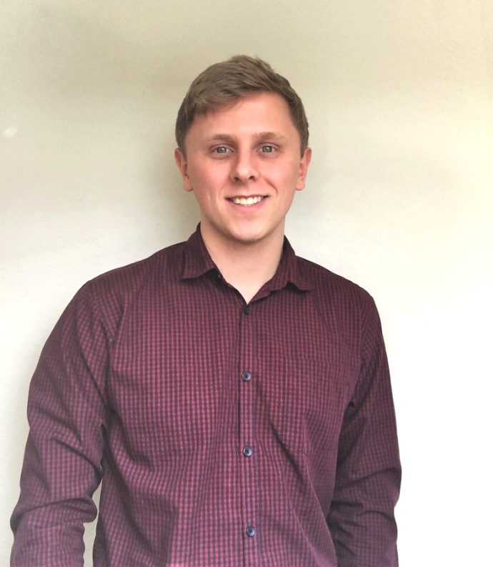
Daniel Feeny
Characterizing Genetic Elements in the Cluster O Mycobacteriophage Blessica
Daniel Feeny, Daria Nicke, Jack Carter, Luis Deschamps, Sarah Grout, Alex Haberman, Caleb Hanson, Jordan Kassanoff, Sophie Nabb, Daniel Petito, Gregory Prahl, Zachary Rotblatt, Ojaswi Uprety, Josh Wild, Nancy Guild, Christy Fillman
Cluster O bacteriophage genomes are highly conserved and contain several characterized genetic elements including a MPME (Mycobacteriophage Mobile Element), inverted repeat sequences, and SigA promoter sequences. In this study we compared a new cluster O phage, Blessica, to other cluster O mycobacteriophages and identified these sequence elements, which provided insight into the evolutionary history of these phages.

