CONSIDER FOR TALK
11th Annual SEA Symposium Abstract
Truckee Meadows Community College
Reno NV
Corresponding Faculty Member: Tina Slowan-Pomeroy (TinaBina@me.com)
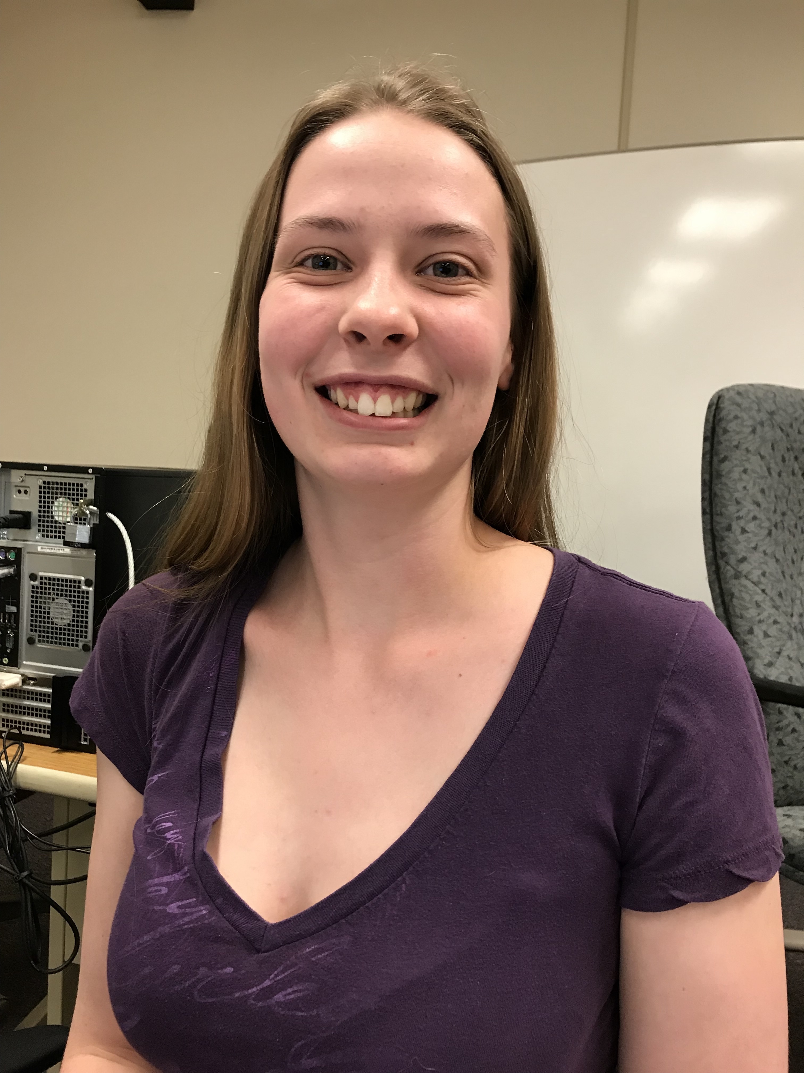
Abigail T Peterson
Characterization and Genomic Analysis of Mycobacteriophages Lewan and Heathen, Including Host Range Investigation of Phage Heathen
Abigail T Peterson, Keziah Dutt, Heather Bohn, Kristen Sommerfeld, Ethan Pierrot, Deanna Lewis, Frank H Robertson, Tina Slowan-Pomeroy, Laura A Briggs
The goal of this research was to isolate, purify, and characterize bacteriophages found in Northern Nevada soils. In conjunction with the Howard Hughes Medical Institute’s Science Education Alliance Phage Hunters Advancing Genomics and Evolutionary Science (SEA-PHAGES) program, this research expands our understanding of the diversity of bacteriophages in this region. The focus of this study was on mycobacteriophages Heathen and Lewan. Both phages were isolated from soil in Reno, NV using the host Mycobacterium smegmatis mc²155. Heathen was found in 2015 and Lewan was found in 2018. Each phage was isolated and purified by the plaque purification method until uniform plaques were obtained. Lewan has turbid plaques ranging in size from 1-2 mm in diameter, indicating possible lysogeny. Heathen has bullseye plaques 3mm in diameter, also indicating possible lysogeny. Phage DNA was extracted from both lysates and sent for sequencing at the Pittsburg Bacteriophage Institute, followed by annotation using PECAAN and Phamerator. Lewan is a subcluster L2 mycobacteriophage with a GC content of 59.0% and a genome length of 76734 base pairs with 137 genes and 13 tRNAs. Heathen is a subcluster A3 mycobacteriophage with a GC content of 64.0% and a genome length of 50143 base pairs with 87 genes and one tRNA. Heathen contains 2 orphams and Lewan contains 4 orphams. Heathen shows 99.7% and 98.14% sequence similarity to A3 phages HelDan and Fred 313, respectively. Lewan shows 98.08% and 98.07% sequence similarity to L2 phages mkalimitinis3 and Crossroads, respectively. Host range analysis of 7 actinobacterial strains, showed Heathen can cross infect Gordonia terrae 3612, Rhodococcus erythropolis RIA643, Mycobacterium phlei NCTC8151 and Mycobacterium tuberculosis H37Ra. Host range testing for Lewan is pending. Heathen contains both a tyrosine integrase gene (gp32) and an immunity repressor (gp70) while Lewan contains a tyrosine integrase gene (gp38), immunity repressor (gp40), Cro (gp41), and excisionase (gp42), all suggesting possibly lysogeny. Future research will investigate the temperate nature of these two mycobacteriophages.

