CONSIDER FOR TALK
7th Annual SEA-PHAGES Symposium Abstract
The Evergreen State College
Olympia WA
Corresponding Faculty Member: Jim Neitzel (neitzelj@evergreen.edu)
Marissa Horan
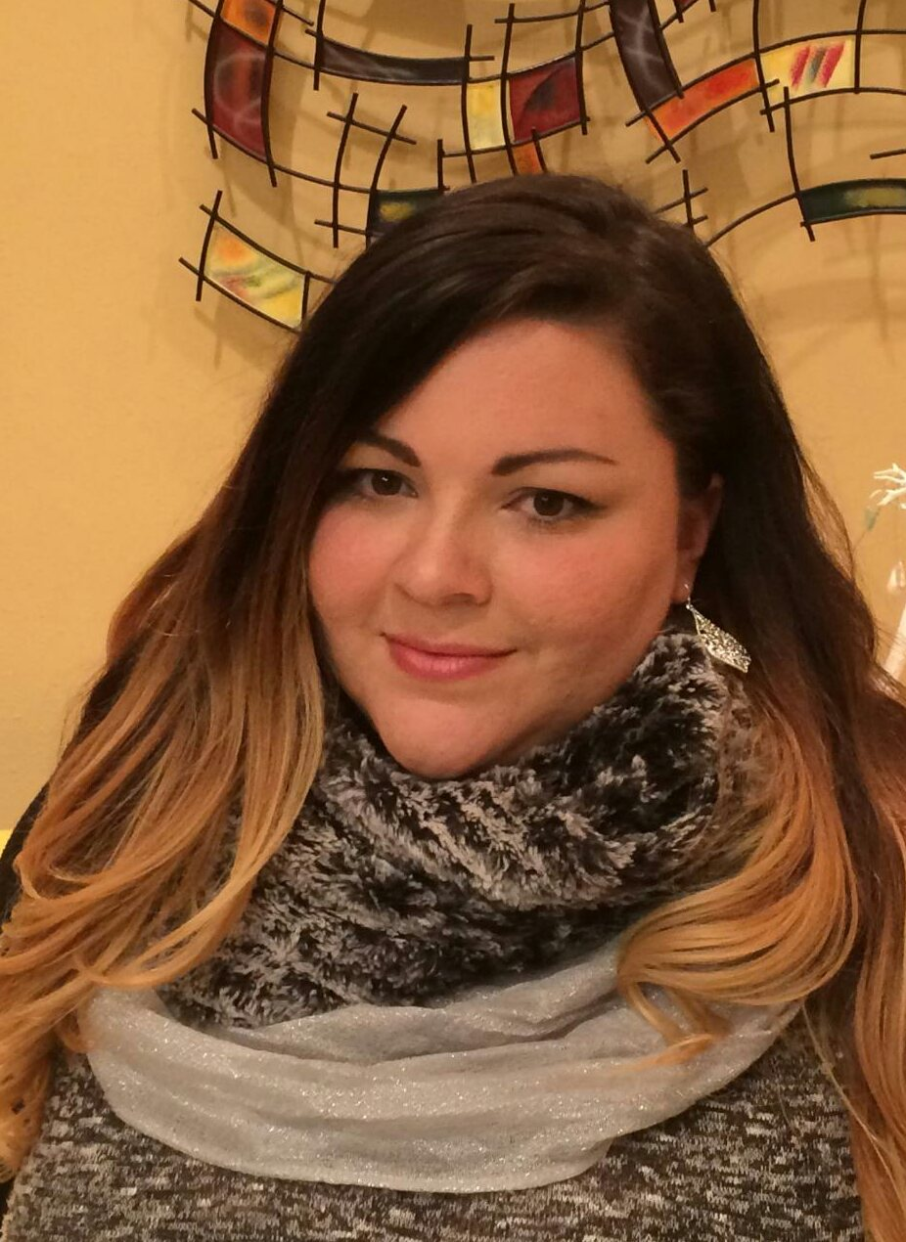
Aubriel P Kepler
The Same and Yet Different: Two New Mycobacteriophages from Olympia, Washington
Marissa Horan, Aubriel P Kepler, Keith Adams, Juniper Anzalone, Aeja Anderson, Arianne Aquino, Abigail Arnold, Megan Bennett, Alexander Bill, Jordan Billiot, Alexander Boisner, Gabrielle Bourassa, Quinn Briceno, Bianca A Brown, Elizette Brown, Nicholas (Psy) Bruni, Kaela Jo Bugg, Emily Cain, Matt Campbell, Joelle Charon, Madision Cogswell, Dawn Coleman, David Cook, Ethan Cornell, Natasha Krstvova Coumou, Jesse Craft, Cameron Crocker, Kyle Cruse, Sandra Dearinger, Daniel DeGeare, Armando DeLao, Jared Fahmy, Kayla Forayter, Isobel Francis, John Gabbard, Gabriella Greene-Dittz, Yurika Harada, Nathan Helman, Juanita Hopkins, Devin Hunter, Lukas Hunter, Kennedy Jackson, Tessa L Jacobs, Emily Donkin Jones, Andrew Kern, Andrew Kirwin, Robert Knox, Marko Krepel, Zoe Mangold-White, Ashley Marie, Patrick McGee, Jobim Morris-Gavrieli, Natalie Moss, Christian Nakabayashi, Hannah Nishman, Zachary Nixon, Ariel Page, Tyler Paradise, Edward Parnel, James Christian Perkins, Brittany Perryman, Megan Riley, Bailey Rivers, Ketl Rodakowski, Collin Ross, Crystall Searcy, Emily Smith, Ian Stehr, Lorraine Stone, Marlaina Strand, Samantha Sullivan, Sydney Sullivan, Ella Ware, Faron Watts, Jessica Wieandt, Catherine Woodward, Alberto Napuli, James J Neitzel
The student participants in our second cycle of the SEA-PHAGE project were again members of the interdisciplinary program Introduction to Natural Sciences, a year-long, full-time learning community with integrated instruction in biology and chemistry. During the fall quarter students collected and purified phages using enrichment cultures of Mycobacterium smegmatis mc2 155 as a host. This year 33 phages were isolated from local soils, purified, and entered into the PhagesDB collection. These will be archived. This set of phages had their DNA purified and analyzed by restriction enzyme digestion and gel electrophoresis. Successful DNA extractions were completed for 30 of the phages. There were 28 successful restriction enzyme experiments that revealed in some cases extremely different cutting patterns. Phages were also analyzed by transmission electron microscopy after negative staining with uranyl acetate. This resulted in clear images of 30 of the isolated phages, all of which appeared to be siphoviridae.
The phages sequenced were SoilDragon and Rimmer. DNA from these phages was sequenced using the Illumina process at the Pittsburg Bacteriophage Institute. The sequence of SoilDragon revealed a 50,293 bp linear double stranded DNA genome with a ten bp 3’ overhang and with a GC content of 64 %. Analysis of the sequence of this phage confirmed that it was a siphoviridae in the A3 subcluster. We also examined an A3 phage (P28Green) in last year’s work. BLASTn and dot-plot comparison (using Gepard) of SoilDragon and P28Green indicated that although there was overall similarity in nucleotide sequence and gene content, there were two distinct areas that showed little or no nucleotide similarity between these two phages. BLASTn results showed that SoilDragon phage was most closely related to the previously annotated phage Jobu08.
Rimmer’s genome is a 75660 bp dsDNA with a 9 bp 3’ overhang and a GC content of 63%. BLASTn results indicated its closest relatives were Cluster E phages Willez and Sassay. Dotplot analysis indicated the presence of an inserted DNA sequence not present in Willez. Both genomes were analyzed for potential protein coding open-reading frames using Glimmer and GeneMark, and protein functions were predicted by BLASTp and HHPred, as well as examining synteny with related phages. Preliminary results suggest the presence of at least 86 protein coding genes in SoilDragon and 142 in Rimmer. The Aragorn algorithm also identified three tRNA genes in SoilDragon and two in Rimmer. Further work is being conducted to identify and confirm all protein coding regions and to identify functions for predicted protein products.

