CONSIDER FOR TALK
11th Annual SEA Symposium Abstract
Monmouth College
Monmouth IL
Corresponding Faculty Member: James Godde (jgodde@monm.edu)
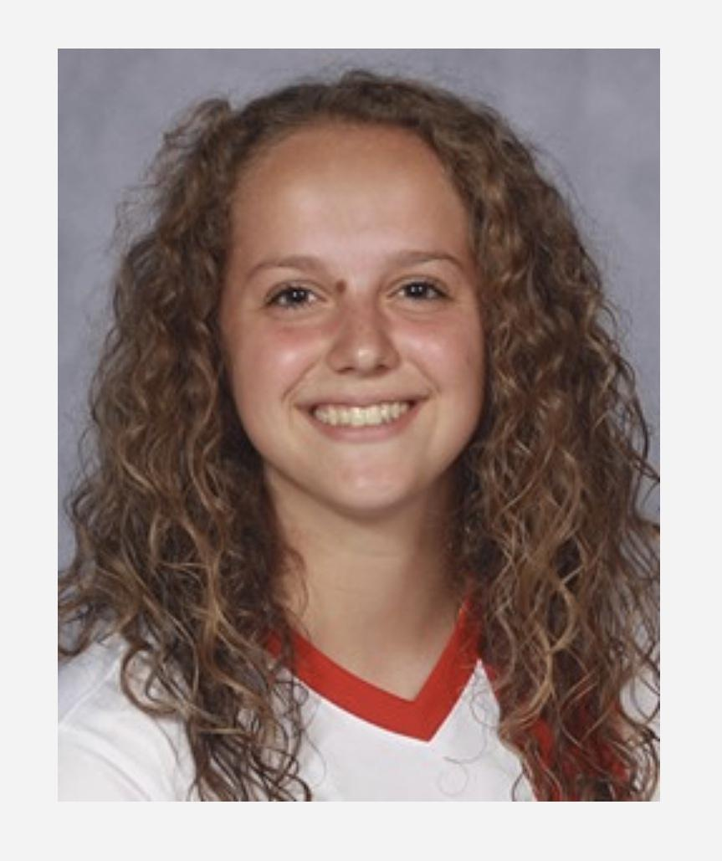
Sarah A Poirier
Isolation and Genomic Annotation of Novel Microbacterium Phages: Is the EC Cluster Losing Its Tail Assembly Chaperone Slippery Sequence?
Brendan G Guenther, Ashley N Long, Piper N Miller, Jordan M Peckham, Sarah A Poirier, Eric M Engstrom, James S Godde, Timothy J Tibbetts
In 2018 Monmouth College joined SEA-PHAGES (Cohort 11). To contribute to expanding the number and diversity of well-characterized phage genomes, we are working to isolate novel Microbacterium foliorum bacteriophages. One phage we discovered, PiperSansNom, is a novel member of the EC cluster. In evaluating the tail assembly chaperone translational frameshift “slippery” sequence of PiperSansNom, we concluded that this phage lacked a slippery sequence. However, we noted that a minority of EC phages exhibit annotated slippery sequences, specifically CCCCCCTA. In all other Microbacterium clusters, either all cluster members exhibit annotated slippery sequences, or all clusters lack these sequences. We performed phylogenetic analysis on the first (universally transcribed) EC tail assembly chaperone genes. Relationships of these genes suggest a loss of slippery sequences within the EC cluster.

