DO NOT CONSIDER FOR TALK
11th Annual SEA Symposium Abstract
Coastal Carolina University
Conway SC
Corresponding Faculty Member: Daniel Williams (dwilliams@coastal.edu)
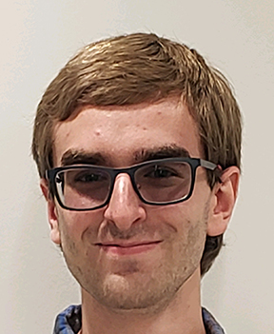
Tyler Cutaia
Isolation and Annotation of Gordonia Bacteriophages Mayweather and Kenosha
Tyler Cutaia, BIOL 492 Students, Daniel C Williams
With the goal of exploring bacteriophage diversity, Phage Discovery students at Coastal Carolina University discovered 7 new phages in the fall semester of 2018. The phages, which infect the host bacterium Gordonia rubripertincta, were isolated using enriched isolation techniques. Two of these phages, Mayweather and Kenosha, were sequenced and annotated the following semester. Both phages had plaques of various morphologies, but Mayweather’s plaques were very clear, suggesting that this is a virulent phage. Mayweather is a CT cluster phage with a 48,382 bp genome and GC content of 60.6%. We verified 75 predicted genes and assigned functions such as terminase and minor tail proteins to 25. There was little support for functions of the remaining 50 genes and interestingly 9 of them are orphams. In contrast, Kenosha is a DJ cluster phage with a longer genome of 60,899 bp and has a GC content of 51.8%. This phage has 92 predicted genes, 8 of which are orphams. We assigned functions to 20 genes that code for common gene products such as HNH endonuclease, lysin A, and holin. Future research from Coastal students will involve working as part of the SEA-GENES project, where wet bench experiments will be performed to assess whether predicted genes have cytotoxic effects on bacterial host cells.

