CONSIDER FOR TALK
11th Annual SEA Symposium Abstract
University of North Texas
Denton TX
Corresponding Faculty Member: Lee Hughes (lhughes@unt.edu)
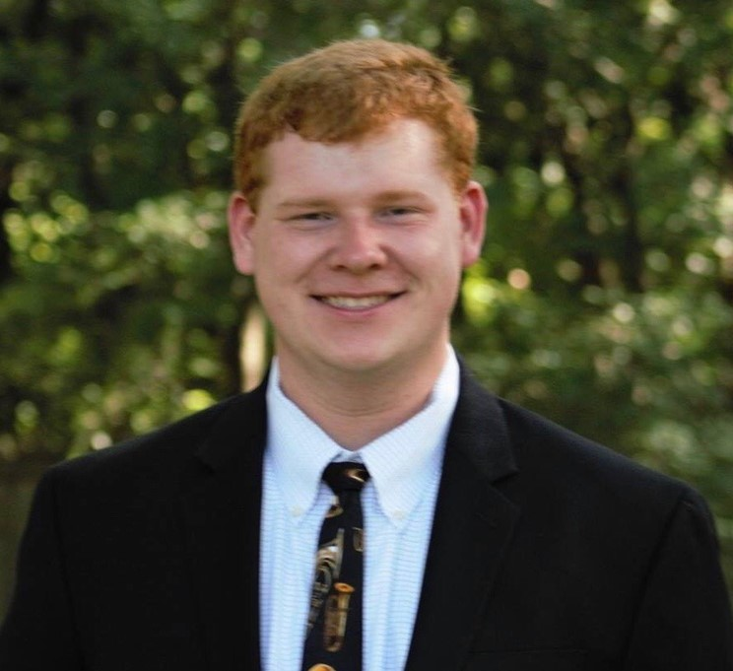
Brendon Williams
Examination of Orphams following the Tape Measure of Streptomyces phage Celia, the first member of Subcluster BD6
Brendon Williams, Julia Lopez, Katherine N Ball, Lee E Hughes
Streptomyces phage Celia was isolated on the host Streptomyces xanthochromogenes NRRL B-5410 in 2018 at the University of North Texas. Celia was sequenced at the University of Pittsburgh and found to be the first member of subcluster BD6. UNT students annotated the genome in the spring semester of 2019. Of Celia’s 80 genes, 22 were found to be orphams, including a small region consisting of four genes in the region just after the tape measure gene. This region, which is expected to contain minor tail proteins, has been examined in other BD phages where a variety in both numbers of genes and the phams the genes belong to has been found. We are comparing Celia's genome with these other phages in order to better understand the implications of the orphams found in this region of Celia's genome.

