DO NOT CONSIDER FOR TALK
11th Annual SEA Symposium Abstract
Salem State University
Salem MA
Corresponding Faculty Member: Amy Sprenkle (asprenkle@salemstate.edu)
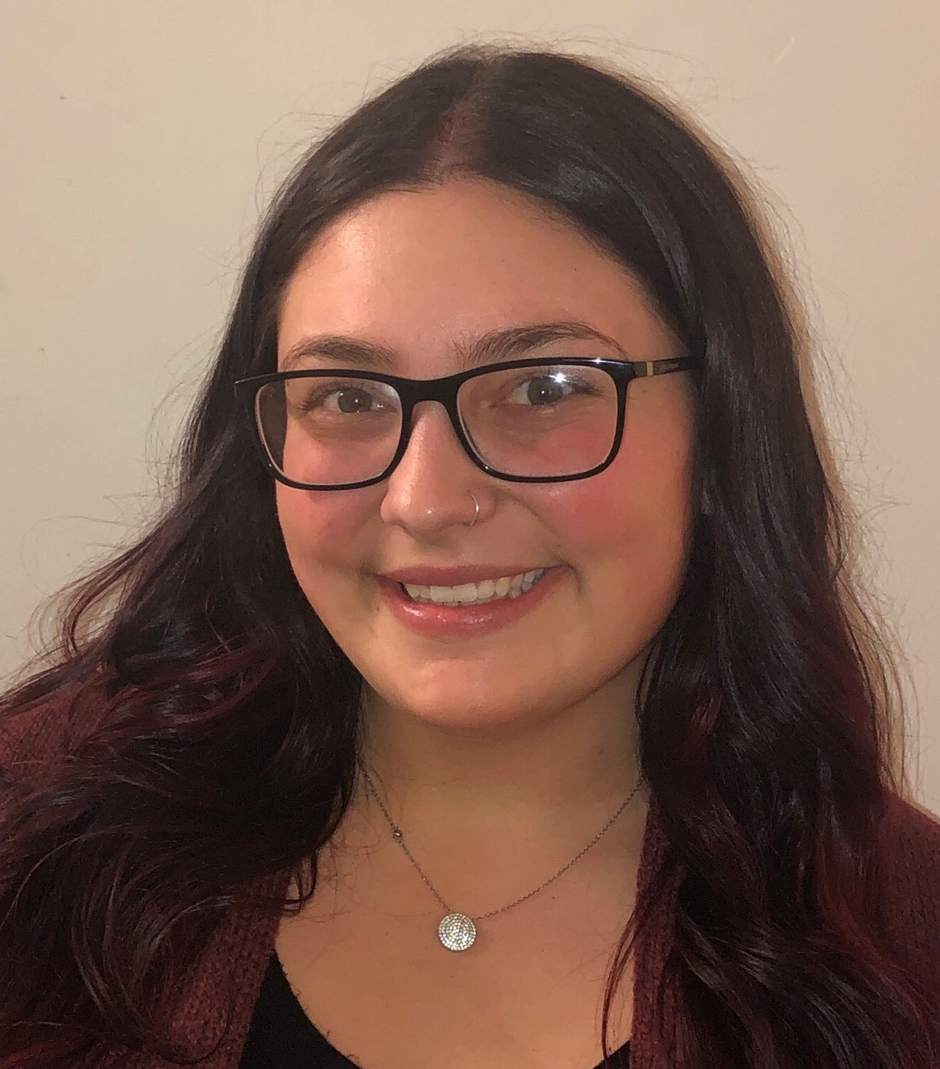
Cassandra R Kysilovsky
A Study in Contrasts; Annotation of an AR and J Cluster Actinobacteriophage from the Genome Exchange.
Cassandra R Kysilovsky, Amy B Sprenkle
In the inaugural SEA-PHAGES Bioinformatics semester at Salem State University, we annotated two phage genomes from the Genome Exchange at the Acintobacteriophage Database. The phage genomes were selected to provide the optimal training in developing the curriculum around using the bioinformatics tools provided by the program. The first phage annotated was the Arthrobacter phage Mordred. Mordred is a lytic Siphoviridae found in Northampton, MA from a direct isolation. Mordred’s genome is just over 70 kilobase (kb) pairs and is in the AR cluster. We found the genome to be very closely related to members of the cluster, with no orphams or unusual annotation challenges. The second phage was the Mycobacterium phage Hannaconda, a lysogenic Siphoviridae found in a potted succulent from a Pittsburgh, PA Ikea also from a direct isolation. Hannaconda is in cluster J, and is over 111 kb. This large genome was significantly less related to members in cluster J, which is characterized by large genomes with orphams, mobile genetic elements, intron splicing in capsid proteins, and tRNAs, all of which provide a much more significant genome annotation challenge. The online bioinformatics guide, DNA Master, Phamerator and PECAAN were all thoroughly explored and utilized to complete the annotation of our phirst phage genomes.

