CONSIDER FOR TALK
11th Annual SEA Symposium Abstract
Drexel University
Philadelphia PA
Corresponding Faculty Member: Susan Gurney (smrw@st-andrews.ac.uk)
Nicholas Barbieri
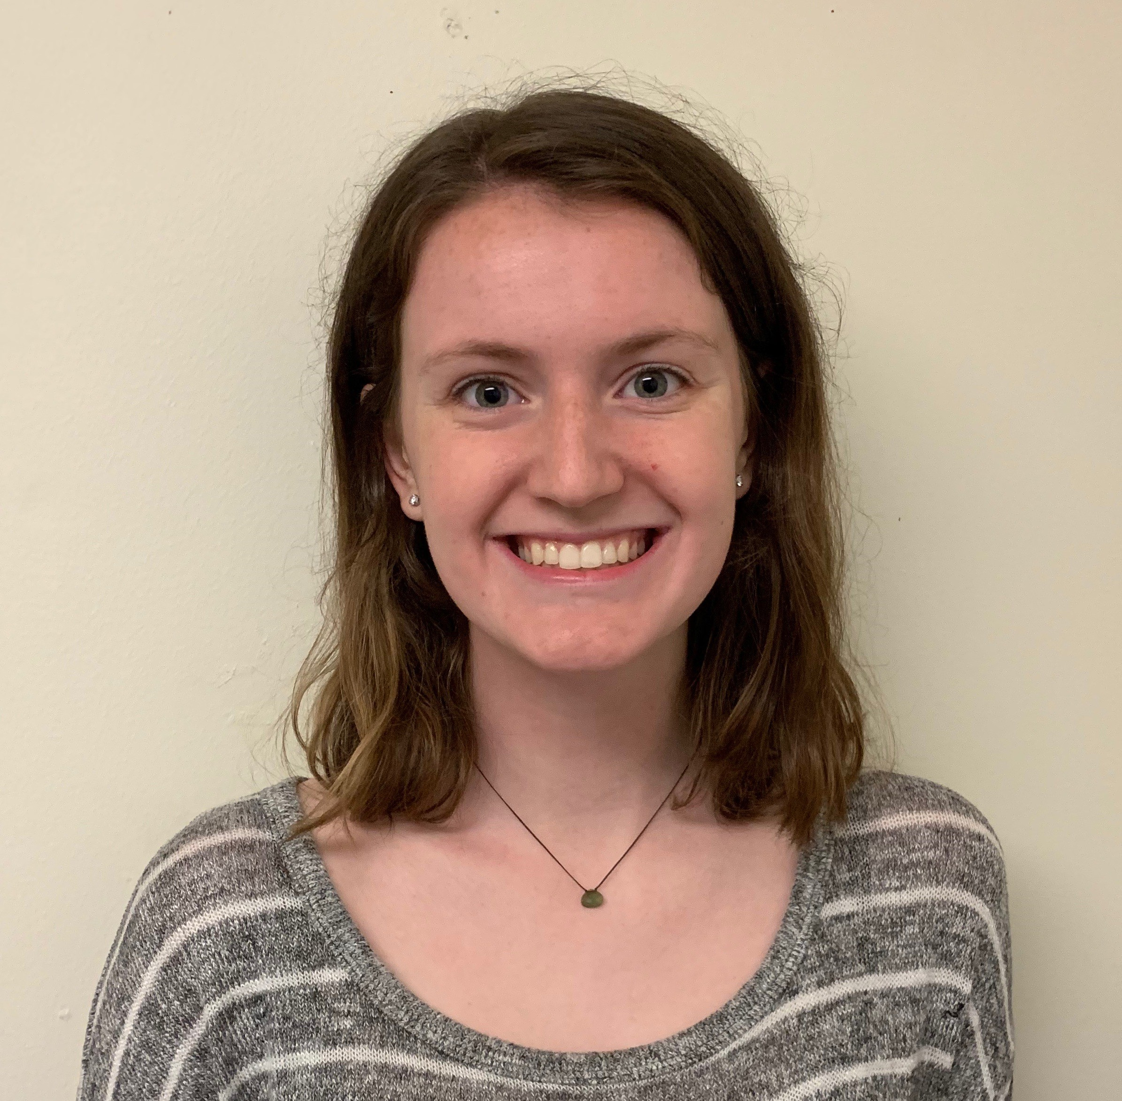
Erin Gallagher
Novel Bacteriophages Against Environmental Phactors – Phage stability Put to the Test!
Nicholas Barbieri, Erin Gallagher, Amal Ahmed, Sanya Ailani, Deeksha Ajeya, Mervin Alexander, Gabriela Almanzar, Shehbeel Arif, Neil Bal, Pooja Balar, Sam Beane, Vincent Beggarly, Sumaiya Begum, Atharva Bidaye, Meg Bindiganavale, Amber Bolli, Nowrin Borsha, Sydney Bucher, Sarah Busby, Steven DeLuca, Chloë Denley, Emmett Dessimoz, Spoorthi Dingari, Capri DiSaverio, Vesa Dobi, Alexander Fahmy, Prachi Gaddam, Ayaan Gill, Dale Glova, Nishunta Gopalasundaram, Virginia Granato, Sayema Hakim, Samuel Hawk, Dakota Heizman, Aaron Jeong, Kailee Johnson, Gianna Joyner, Sammy Khalouf, Chaeyeon Kim, Joyce Kim, Nila Kirupaharan, Hetal Lad, Yong Hui Lin, Vincent Liu, Kaylen Louie, Isabella Mancini, Zachary Mandell, Tracy Marcelis, Bhakti Marfatia, Akos Marfo-Sarbeng, Kathleen Marsili, Ryneisha McKenzie, Derek Mock, Riyaz Mohamed, Assal Nasir, Anh Nguyen Quach, Isabella Pappano, Pallavi Pareek, Nidhi Patel, Prarthana Patel, Shruti Patel, Thara Patel, Arathi Pillai, Anjali Pradhan, Shrey Pradhan, Anjani Ravi, Sophie Redila, Byron Ruf, Mekhala Santebennur, Elana Sargent, Shivashree Sekar, Elisa Selamaj, Simran Shamith, Mekhala Santebennur, Elana Sargent, Shivashree Sekar, Elisa Selamaj, Simran Shamith, Harsh Sharma, Kumal Siddiq, Seena Soroush, Annika Surapaneni, Almas Thaha, Summer Thompson, Amy Varghese, Akhil Vindyala, Pavithra Vinnakota, Haider Virk, Nisha Vora, Lincoln Wu, Merry Xiang, Seth Zurlo, Ritu Dalia, Susan Gurney, Svetlana Khakhina
In the Fall of 2018, Drexel University students isolated 36 novel bacteriophages using Microbacterium foliorum as a host. All phages were isolated using enriched isolation and 8 of them were sequenced. The Illumina sequencing of these phages demonstrated that all phages have lytic cell cycle, siphoviridae morphology and belong to EA1, EA4 subclusters and EC cluster. These phages were successfully annotated using DNA Master, Phamerator, NCBI Blast and PECAAN and submitted to GenBank. During the Spring quarter, we investigated the effect of varying environmental factors on phage stability by evaluating changes in the plaque forming units (pfu) observed. Phages were exposed to acidic or basic pH, high temperature, different glucose concentrations or UV light. Additionally, the protective effect of whey protein concentrate (WPC) and alpha-lactalbumin on phage stability, when exposed to high-temperature, was also investigated. Full plate plaque assays were conducted in all the experiments. If phage stability was adversely affected, the number of pfu would decrease. Conversely, an increase in pfu would indicate that the tested condition has enhanced the ability of the phages to infect the bacterial cell. Our results demonstrated that exposing phages to acidic or basic conditions or UV light showed a decrease in pfu counts. Another interesting observation was that exposure to glucose also significantly decreased phage stability, probably due to osmotic shock and phage lysis. Other experiments showed that adding whey protein to phage lysates stabilized the phage during high-temperature shock, suggesting that it has a protective effect which enhanced phage infectivity. Surprisingly, alpha-lactalbumin had an opposite effect on phage stability, when exposed to high temperature, because decreased pfu results were observed when compared to the control plates (using phage buffer alone). Based on these observations we conclude that phages can tolerate exposure to a range of environmental factors and are still able to perform bacterial cell infections.

