DO NOT CONSIDER FOR TALK
11th Annual SEA Symposium Abstract
Illinois Wesleyan University
Bloomington IL
Corresponding Faculty Member: Dave Bollivar (dbolliva@iu.edu)
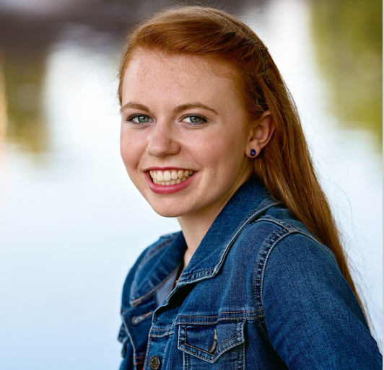
Katie Vogler
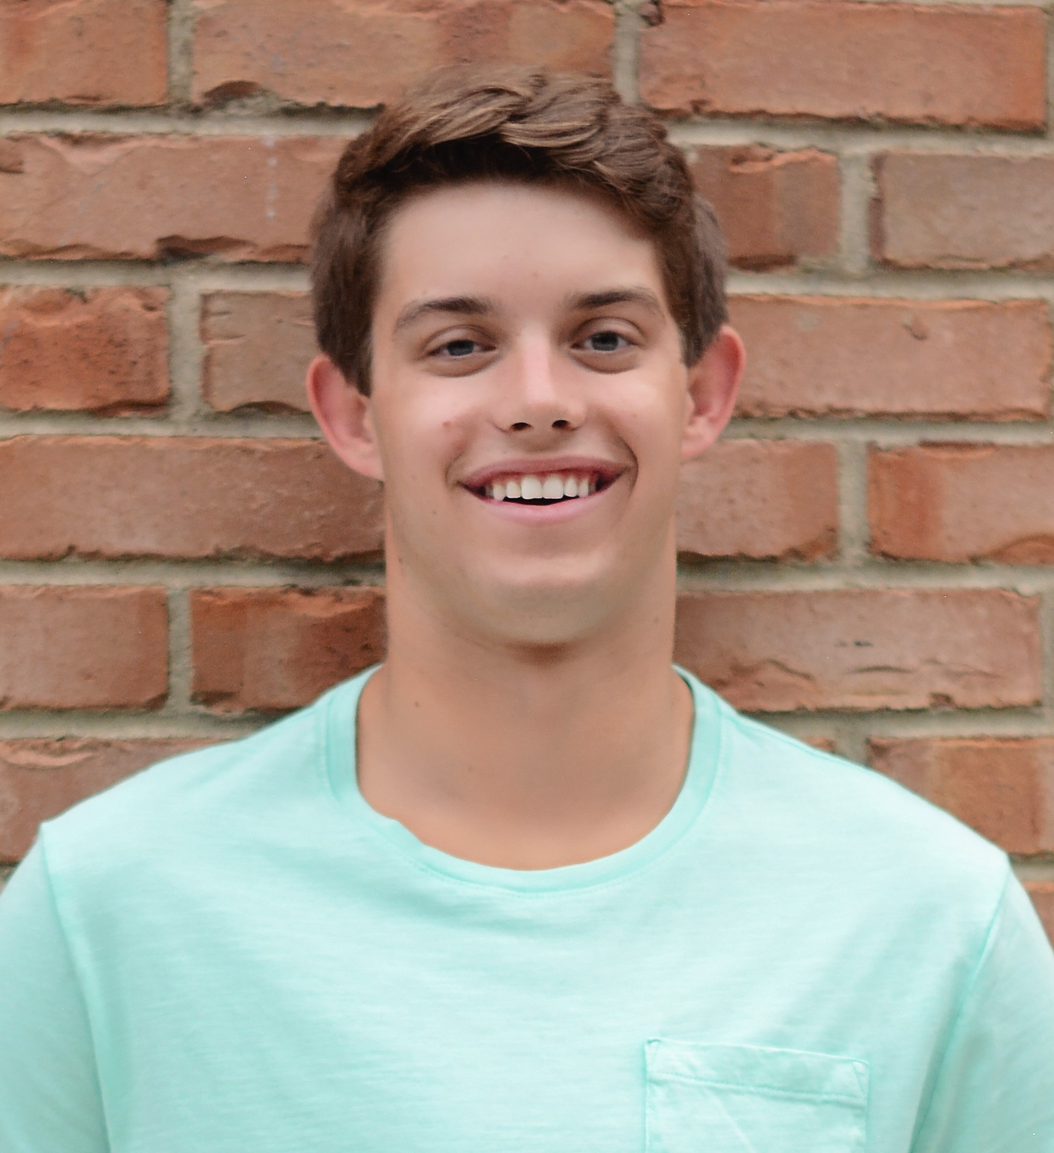
Jackson Rapala
A Phamily of Phages: Sucha, Warren, and Celaena
Katie Vogler, Jackson Rapala, Emmet Agting, Vanessa Chapa, Matt Crosse, Ivy Do, Maeghan Eaker, Anjali Nimavat, Manish Pathuri, Kylie Spiegel, Saralexis Torres, Lane Warren, Saylor Williams, Richard Alvey, David Bollivar
Bacteriophages are the most numerous known biological entities on Earth yet relatively few have been cultured and even fewer have had their genomes sequenced and analyzed. Throughout the 2018-2019 school year students at Illinois Wesleyan University were able to discover 16 unique bacteriophages that infect the host Microbacterium foliorum NRRL B-24224 SEA. From these, three were selected to be sequenced and functions were assigned for their identified genes using PECAAN and DNA Master. These phages were chosen because they showed the greatest probability of being unique based on laboratory experiments including lysogen testing, polymerase chain reaction (PCR) with primers designed to detect the most common M. foliorum phage clusters, and because of their interesting plaque morphologies and transmission electron micrographs. Lysogeny did not occur for any of these phages and the absence of integrase genes in the genomes supports this observation, suggesting they are virulent with a lytic lifestyle. The three Siphoviridae phages sequenced were Sucha, Warren, and Celaena. Warren and Sucha were paired with singletons to form the new clusters GA and EJ respectively. Celaena is a new member of the EB cluster. Despite being in different clusters, annotation of Sucha and Warren showed that these two phages shared many highly similar predicted proteins with many genes being in the same pham. In a Splitstree analysis of the sequenced M. foliorum phages, these EJ and GA clusters appear to be closely related but are quite distant from Celaena.

