DO NOT CONSIDER FOR TALK
11th Annual SEA Symposium Abstract
University of Puerto Rico at Cayey
Cayey PR
Corresponding Faculty Member: Edwin Vazquez (edwin.vazquez4@upr.edu)
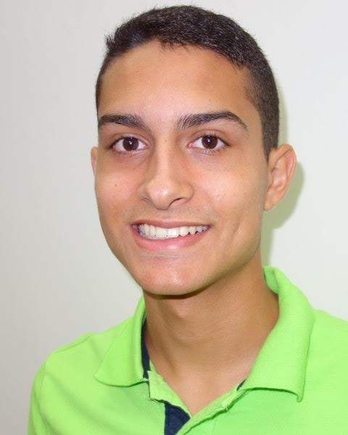
Nayid E Jana-Martinez
Genomic comparisons of a set of diverse bacteriophages isolated from Puerto Rico
Nayid E Jana-Martinez, Bonmarie Pedraza-Lopez, Denniel A Rosado-Nunez, Hector N Romero-Soto, Alondra Rivera-Cruz, Miosotty Aleman-Lozada, Fabiola Aponte-Olivieri, Ines N Aviles-Rivera, Hector Cartagena-Torres, Maria A Cruz-Velazquez, Samira J Diaz-Dingui, Bryan J Diaz-Melendez, Noelis Falcon-Lizardi, Nectar G Gonzalez-Negron, Karian A Martinez-Pagan, Valerie V Medina-Santiago, Andres S Millan-Laboy, Perla M Miranda-Melendez, Charlie Mercado-Mulero, Lizmary Morales-Diaz, Sophia L Negron-Caez, Robert J Nieves-Ayala, Maricelys Ortiz-Castro, Keishlean M Osorio-Medina, Kathya M Reyes-Laureano, Adriana Reyes-Soto, Yanidelis Rios-Rosa, Alondra Rivera-Cruz, Nicole S Rivera-Espinal, Edgar J Robles-Arocho, Fabian E Rodriguez-Cotto, Cynthia M Rodriguez-Cruz, Kevin I Rodriguez-Otero, Andrea N Rosa-Flores, Eliomar Rosa-Ramon, Janely M Rosa-Vazquez, Gabriel Rosario-Ortiz, Alondra Rosario-Valdes, Gabriela V Seda-Alvarado, Juan A Vargas-Alvarez, Alondra Vargas-Lopez, Joe A Vazquez-Valentin, Roberto J Herrera-DelValle, Joelis M Lama-Diaz, Carlos E Ocasio-Caldero, Priamo A Pichardo-Gonzalez, Jose O Silva-Martinez, Mariceli Fernandez-Martinez, Michael R Rubin, Edwin Vazquez
The rich diversity of Puerto Rico´s ecosystems is reflected in the variety of bacteriophages isolated during the ten years of participation of our institution in the SEA-PHAGES Program. We have isolated hundreds of different phages of which the genomes of 32 have been sequenced. These include twenty-one mycobacteriophages, ten Gordonia terrae phages, and one Microbacterium phage. We have streamlined the standard protocols to save time, effort and materials, without sacrificing the pedagogical aspects of the hands-on experience, and the deep-conceptual understanding of the biological processes involved. We now report on the isolation, characterization, genomic annotation and comparison of five novel Gordonia phages (Yndexa, Sukkupi, Syleon, MelBins and Keelan) and one Microbacterium phage (Zanella). We have compared their genomes in terms of the gene homology of various highly conserved regulatory and structural genes, and the divergence of others that have apparent essential functions but have probably not been submitted to the same natural selection pressures of the conserved ones. Among the genes studied are DNA-binding, tape measure and capsid proteins, and lysins. Three of the seven CR cluster Gordonia phages in PhagesDB are from Puerto Rico (BiPauneto, Sukkupi and Yndexa). Genome comparisons show that Sukkupi and Yndexa are highly similar, with a few sequence differences on both the left and right ends, indicating a very recent evolutionary divergence from a common ancestor. MelBins is a DE2 cluster phage and Keelan is from cluster DP, again denoting the diversity of the phages isolated. Zanella, the Microbacterium phage, has the smallest genome size, at 42,108 bp, which is reflected in its short-predicted tail length based on the number of amino acids comprising the tape measure protein, at only 45 nm versus 325 nm for Syleon. Our results contribute to understanding the enormous genetic diversity of bacteriophages and the underlying similarities that point to their common evolutionary origin.

