DO NOT CONSIDER FOR TALK
11th Annual SEA Symposium Abstract
James Madison University
Harrisonburg VA
Corresponding Faculty Member: Louise Temple (templelm@jmu.edu)
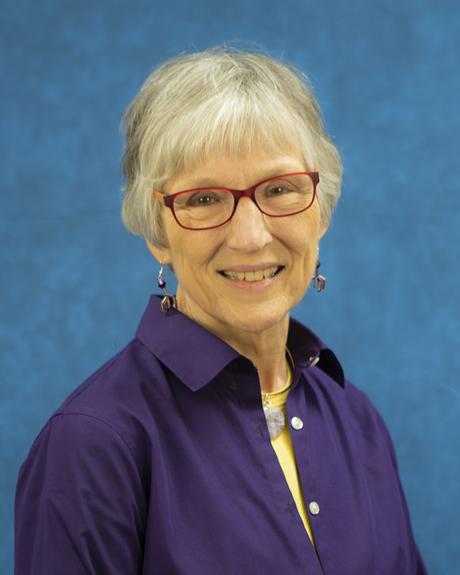
Louise Temple
Give Them An Inch And They’ll Take A Mile: Creative Phage Projects
Louise Temple, Stephanie Stockwell
Calling all phage groupies! Want to play a phage board game? Work a puzzle? Listen to rap or song with unique lyrics? Read a children’s book? Stand in awe of amazing poetry? Just ask your students to create something—anything creative, really—about their own experiences with discovery and analysis of phages. “I could never think of anything,” they often say, when I announce this assignment. And yet, semester after semester, clever, unique, surprising contributions are presented to classmate and added to my growing collection of Phantastic Phun Phage Art. A number of items will be displayed at the symposium for your enjoyment and amazement.

