CONSIDER FOR TALK
11th Annual SEA Symposium Abstract
Washington University in St. Louis
St. Louis MO
Corresponding Faculty Member: Chris Shaffer (shaffer@wustl.edu)
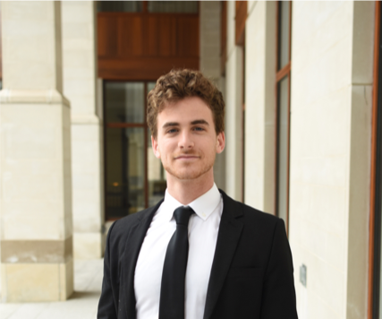
Nitan Shalon
Analysis of Six Novel Bacteriophages Isolated from the St. Louis Area
Nitan Shalon, Members of Bio 192
Students at Washington University in St. Louis isolated six novel bacteriophages from the greater St. Louis area: Zuko, Phettuccine, Issmi, Bmoc, Kardashian, and Saftant. Analysis of these phage genomes contributes to the understanding of phage ecology in St. Louis, MO and the set of phages capable of infecting Streptomyces griseofuscus. The bacteriophages were isolated using a plaque assay, and their morphology characterized by transmission electron microscopy. Each phage was then sequenced using shotgun sequencing and subsequently annotated. The bacteriophages were placed into clusters BI, BE1, BD2, BD1, BD3, and one was in a singleton. Kardashian’s BI subcluster is still being finalized, and may belong to a new, fifth subluster. Through a BLASTn query on PhagesDB, Zuko’s 82,302 bp genome has only 0.25% of its genome align to its most similar phage (Nesbitt). Due to Zuko’s dissimilarity, it was placed into a singleton cluster, 64.5% of its putative proteins assigned unknown function, and many of its expected structural proteins remain unidentified. Bmoc has a large 132,885 bp genome, appears to have a lytic lifestyle, and includes an array of 41 tRNA’s and 1 tmRNA. Despite Bmoc’s similarity with other BE1 cluster phages, there were only 61 identifiable proteins within its 239 genes. Saftant displays strong synteny with other BD3 cluster phages and contains an Ocr antirestriction protein, which has not been previously described in PhagesDB, that inhibits type I restriction and modification systems. Within this group, Phettuccine and Issmi are the two most similar phages, and have a 49,530 bp genome with 73 genes and a 50,643 bp genome with 79 genes respectively.

