CONSIDER FOR TALK
11th Annual SEA Symposium Abstract
Queensborough Community College
Bayside NY
Corresponding Faculty Member: Urszula Golebiewska (ugolebiewska@qcc.cuny.edu)
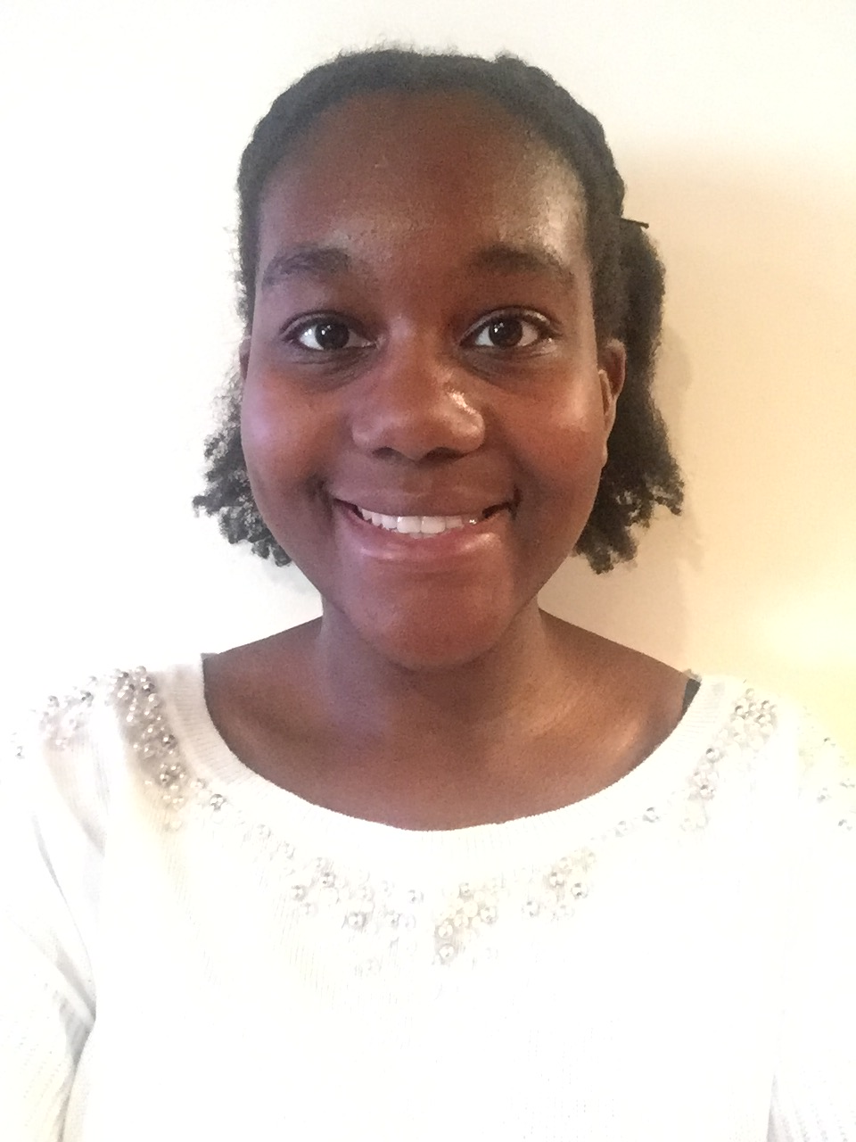
Valesca Polycarpe
Annotations and Analysis of LilMoolah
Valesca Polycarpe, Deidre Seepersaud, Muhabbat Ahmedova, Calli Atamian, Biling Chen, Yiching Chen, Winnie Chow, Samentha Duffault, Brettania Gordon, Kamaljeet Kaur, Prabhjot Kaur, Dhanmattie Khan, Amirabbas Maghsoudi, Nishat Neela, Jennifer Ogbozor, Anastasia Parks, Megan Pirtle, Yusra Raza, Pamela Joy Tabaquin, Divya Thakur, Roxine Tyndale, Britney Vasconcellos, Vincent Zhong, Urszula Golebiewska
Students at Queensborough Community College annotated and analyzed the genome of Mycobacterium phage LilMoolah, a phage discovered in 2017 by Chanel Turner, a student of Queens University of Charlotte in Charlotte, North Carolina. It was isolated from Mycobacterium smegmatis mc^2 155. LilMoolah is a member of the Siphoviridae family, characterized by double-stranded DNA and a long, noncontractile tail. It belongs to cluster F, subcluster F1. Its genome is 58,136 base pairs in length and made up of 109 genes. Various bioinformatics programs were used for gene annotation and analysis, such as DNA Master, BLAST, Starterator, HHpred, Phamerator, and others. These were used to determine each gene’s length, coding potential, reading frame, possible function, and possible relatives. The first half of LilMoolah’s genome contains larger genes, many of which have well-defined functions; these include terminase, lysin A and lysin B, holin, major and minor tail proteins, tape measure protein, integrase, and others. However, 65 of LilMoolah’s genes, many of which are found in the second half of the genome, are much smaller in size and have no defined function. Most of the genes are read in the forward direction. The closest relatives to LilMoolah are RitaG, Mattes, and Nivrat, with Nivrat sharing the highest number of homologous genes with LilMoolah.

