DO NOT CONSIDER FOR TALK
11th Annual SEA Symposium Abstract
Virginia Western Community College
W. Roanoke VA
Corresponding Faculty Member: Heather Lindberg (hlindberg@virginiawestern.edu)
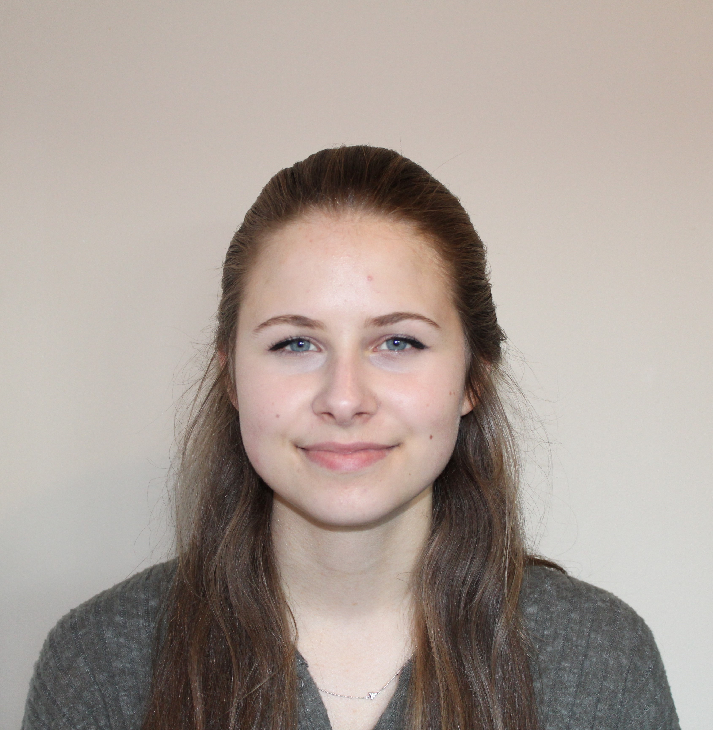
Elizabeth Burrell
The Isolation of Barry and the Genome Analysis of three A cluster mycobacteriophages: Dr.FeelGood, SoilDragon and NothingSpecial.
Heather Lindberg, Elizabeth Burrell
At Virginia Western Community College, over the course of the 2018- 2019 academic year, we isolated Barry, a unique bacteriophage with a prolated capsid head. Barry was isolated from soil collected in the Roanoke Valley using Mycobacterium smegmatis mc155 as the host bacterium. Unfortunately, we were unable to successfully separate Barry from another siproviridae phage, meaning we were unable to submit Barry for sequencing. Instead, we annotated two A cluster phages, SoilDragon and Nothing Special. We chose to annotate these cluster A phages in order to compare them to DrFeelGood, which was annotated here at VWCC last year. SoilDragon and NothingSpecial share more similarity to each other than either share with DrFeelGood. Most of the similarity lies in the left side of the genome, which is not unexpected, given that much of the left side of the genome contains the genes needed for capsid development. Hopefully, through continued comparisons between annotated phages, we will be able to gain a deeper understanding of phage genetics and the evolutionary pressures which have shaped the genomes we see.

