CONSIDER FOR TALK

10th Annual SEA Symposium Abstract

Iowa State University

Ames IA

Corresponding Faculty Member: Nick Peters (ntpeters@iastate.edu)

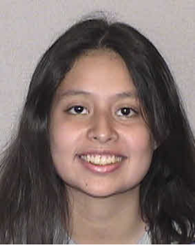

Karin E Resendiz-Medina

Annotation of Two Podoviridae (Microbacterium) Phage

Karin E Resendiz-Medina, Seth B Taylor, Alex L Beers, Faith M Seggerman, Nancy M Boury, Nick T Peters

In the previous semester, the bacteriophages Alex44 and PhriedRice were isolated, and sent to be sequenced at the University of Pittsburgh. Phages are viruses that infect bacteria, and our phages specifically target *Microbacterium foliorum* cells. Once their genomic sequences were known, multiple annotation computer software systems were used to predict the position of their genes using algorithms formulated from known phage genome characteristics and other sources. Then with this information, we sought to answer three questions: is it actually a gene, where does the gene start, and what is the function of the gene? In Alex44 we found a majority of genes had no known function, with one gene needing to be deleted. PhriedRice required several deleted genes and an abundance of genes with no known function. Our work for these genomes corrects the 10% error posible from the computer software systems’ drafts of the phage genome, this keeps mistakes from being amplified, protecting the integrity of further research.