DO NOT CONSIDER FOR TALK
11th Annual SEA Symposium Abstract
Mitchell Community College
Statesville NC
Corresponding Faculty Member: Parks Collins (pcollins@mitchellcc.edu)
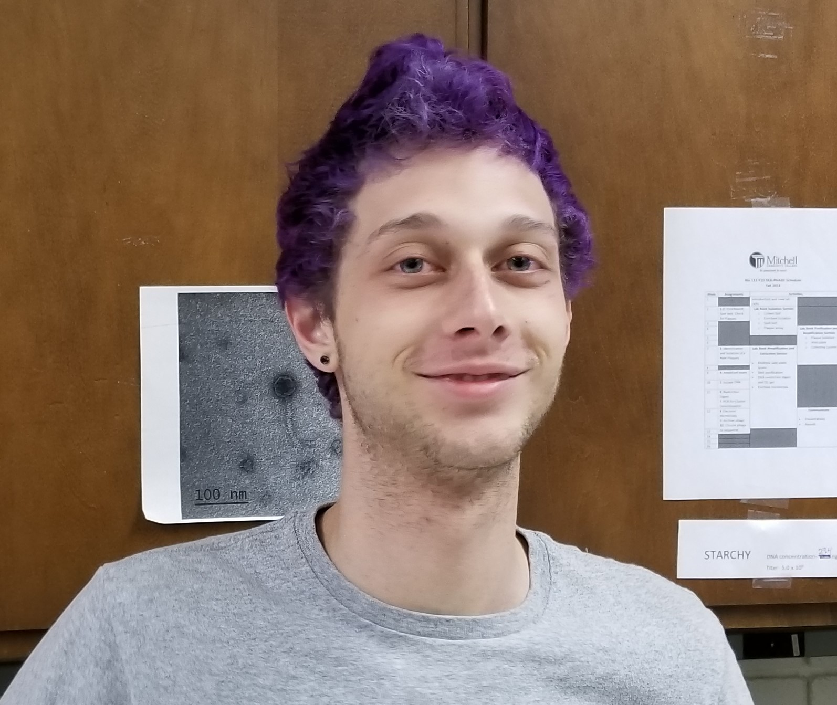
Thomas Ray
LaviMo: Isolation, DNA Analysis, and Comparative Genomics
Thomas Ray, Ryan Kistemaker, Alyssa Moliis
As part of the HHMI SEA-PHAGES program, over 200 Microbacteriophages have been identified, sequenced and classified into clusters. Mitchell Community College in Statesville, NC just completed its first year as part of the HHMI SEA-PHAGES program. In the fall semester, students isolated seven bacteriophages from soil samples. The phage LaviMo was chosen to be sequenced. LaviMo was isolated through direct isolation. Electron microscopy and molecular characterization indicated that LaviMo belonged to Siphoviridae. DNA from LaviMo was isolated and the complete genome was sequenced during the spring semester. Auto-annotation through DNA Master revealed twenty-six open reading frames. Based on average nucleotide identity, LaviMo is classified as a cluster EE microbacteriophage with a 99% sequence identity to phages Scamander and BurtonThePup. Here we present the initial data from the annotation of this new cluster EE phage. This research expands the diversity among cluster EE phages and provides an insight to the evolutionary characteristics of microbacteriophages.

