CONSIDER FOR TALK

11th Annual SEA Symposium Abstract

Cabrini University

Radnor PA

Corresponding Faculty Member: Vinayak Mathur (vm7027@cabrini.edu)

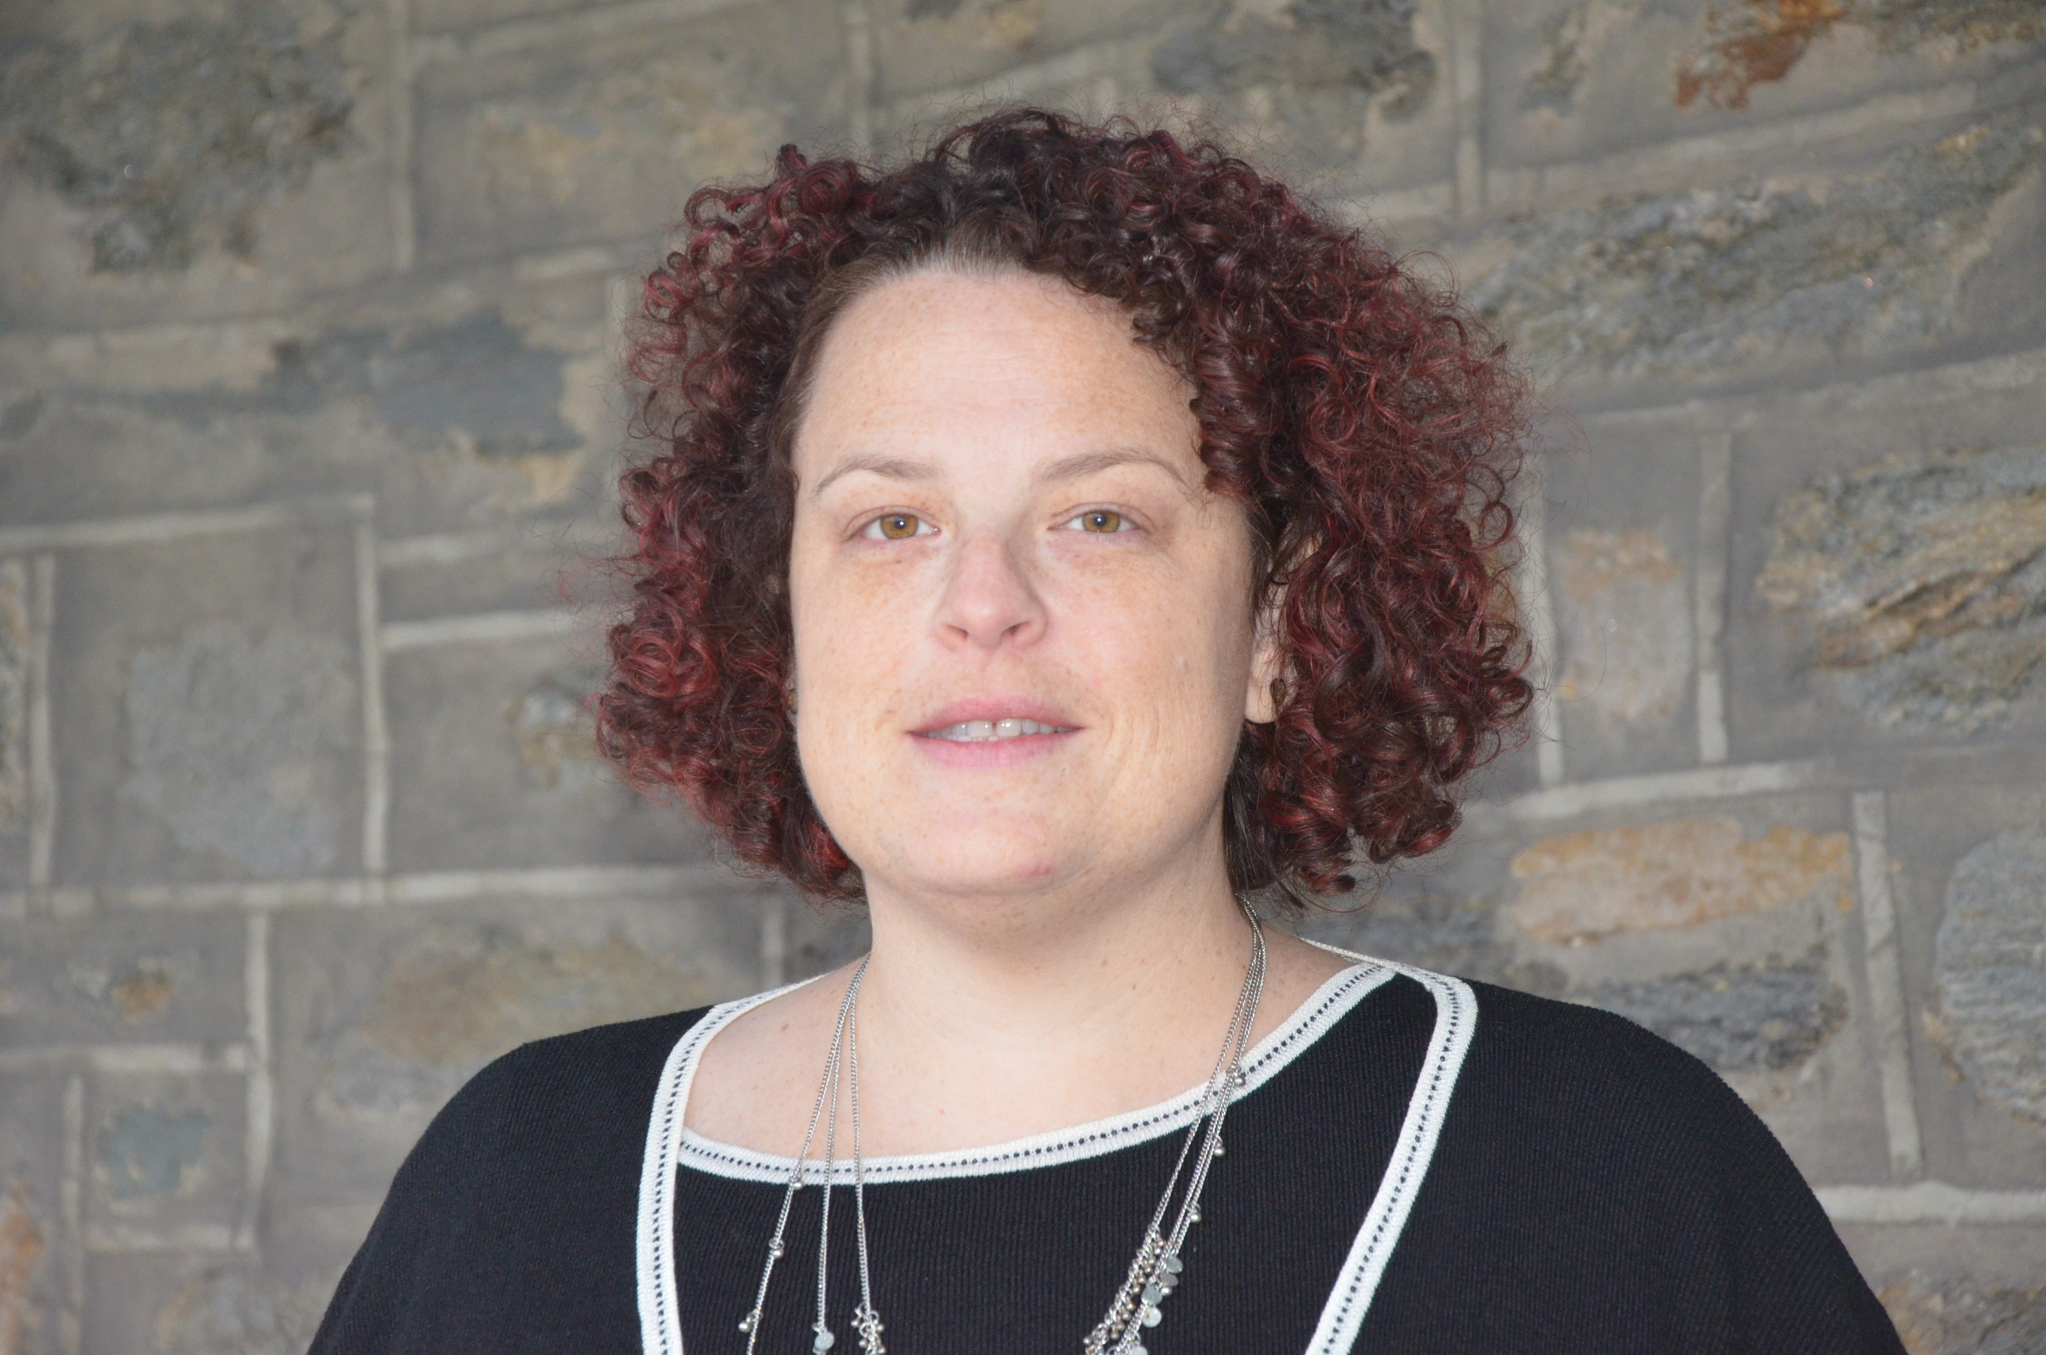

Rya Scull

Discovery and Annotation of Cluster AN and AK Arthrobacter Phages

Rya Scull, Jessica Azzarano, Jordan Abelson, Jessica Baranoski, Lavinia Harrison, Megan M Wojcik, Sonia Spadafora, Kyriaki Gerasimidis, Olivia Mancini, Epoh Fonge, Isabella Romani, Alyson Marshall, Andrew Conboy, Matthew D Mastropaolo\*, Vinayak Mathur, Melinda Harrison

\* Neumann University, Aston PA

Bacteriophages are viruses that infect a bacteria host, potentially leading to strategies for treating, preventing, or diagnosing bacterial infections such as tuberculosis that are resistant to conventional antibiotics. We have discovered novel phages from the bacterial host Arthrobacter sp.ATCC 21022. The phages were collected from soil and water samples by students from various places around South Eastern PA. and Southern NJ. and their genomic DNA isolated. After isolating the genomic DNA, they were photographed through the use of an electron microscope and then the DNA was sequenced. The phages’ genomes were then annotated using various bioinformatics tools, such as DNA Master; Phamerator; HHpred and GeneMark to determine gene location and function. Using comparative genomics, unique characteristics of the phage’s genome were also explored. This study presents a comparison of several bacteriophage genomes specifically from the AN and AK cluster. The genomes of phages Arby and Scuttle were annotated as a collaborative effort by many students and faculty.