CONSIDER FOR TALK
11th Annual SEA Symposium Abstract
Tarleton State University
Stephensville TX
Corresponding Faculty Member: Dustin Edwards (dcedwards@tarleton.edu)
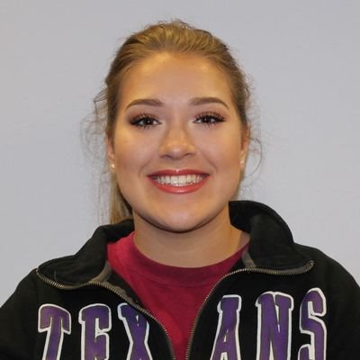
Faith Cox
Isolation of Cluster EA2 Bacteriophage Finny
Faith Cox, Stacy Luka, Tiffany Lee, Michaela Aguirre, Shey Andrews, Kayla Bahr, Abigail Ballard, Matthew Bristerpostma, Leah Dowell, David Kiker, Tiffany Lujan, Haze Murphy, Abbigal Ramirez, Rheaven Sandoval, Kenneth Underhill, Julie Edwards, Dustin Edwards
Bacteriophage Finny was purified from Microbacterium foliorum at 29° C in PYCa media by direct isolation method from a soil sample collected from a chicken coop in New Braunfels, Texas. Following initial isolation, two rounds of serial dilutions and plaque assays were performed for bacteriophage isolation and purification. Bacteriophage Finny plaque morphology consists of small-to-medium-sized lytic plaques with turbid halo rings. High titer lysate was stained with uranyl acetate to visualize bacteriophage Finny by transmission electron microscopy, which showed the virus has Siphoviridae morphology with an icosahedral capsid. DNA was extracted by a zinc chloride method and the whole genome sequenced at the Pittsburgh Bacteriophage Institute. Whole genome sequence comparison determined that bacteriophage Finny is a Cluster EA2 cluster with a circularly permuted genome 40,313 bp in length with 62.1% G+C content. Bacteriophage Finny genome contains 63 predicted protein-coding genes, including lysin A, holin, RecA-like DNA recombinase, AAA-ATPase, MazG-like nucleotide pyrophosphohydrolase, thymidylate kinase, and ThyX thymidylate synthase.

