DO NOT CONSIDER FOR TALK

10th Annual SEA Symposium Abstract

Howard Hughes Medical Institute

Chevy Chase MD

Corresponding Faculty Member: Joslynn Lee ()

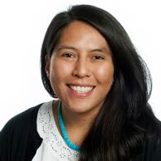

Joslynn Lee

A Workflow for Microbial Community Analysis

Joslynn Lee

The development of the course-based research experience (CRE) aims to increase undergraduate interest and retention in the biological sciences through immediate immersion in authentic, valuable, yet accessible research. Working with HHMI’s SEA, I am developing a microbiome CRE to enable undergraduate researchers to study the microbial community of environmental samples using 16S rRNA amplicon sequencing. This one-semester course is designed in modules for students to start by simply sample collection but advance to running a microbiome analysis pipeline. Presented in the pilot study to profile the microbial community of commercial soils, mulch, garden bed and non-garden bed samples. The microbiome workflow presented can be used to both develop, test, and support hypotheses, while provide undergraduate researchers important microbiology and computational biology skills.