DO NOT CONSIDER FOR TALK
10th Annual SEA Symposium Abstract
Nebraska Wesleyan University
Lincoln NE
Corresponding Faculty Member: Angela McKinney (amckinne@nebrwesleyan.edu)
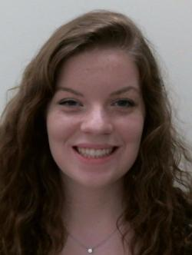
Jenna Whitmore
Isolation and Characterization of Bacteriophage Alleb
Jenna Whitmore, Mackenzie Batt, Caitlin Broekemeier, Claire Landgren, Annie Platt, MaKenzie Saltzman, Leah Treffer, Alison Wilson
During the Fall of 2017, students participated the Science Education Alliance Phage Hunters Genomics and Evolutionary Sciences (SEAPHAGE) program. This research-based program requires students to collect soil samples and isolate a bacteriophage, or virus that infects bacteria. The host used for our study was Microbacterium paraoxydans NWU1. In order to isolate the bacteriophage, basic microbiology techniques were utilized. Once isolated, the bacteriophage was purified and electron microscopy was utilized to visualize the bacteriophage. Finally, genomic DNA was isolated and the genomic DNA was sequenced. During the Spring 2018 semester, one bacteriophage (Alleb) was annotated using the computer software program DNA Master and other online tools. After annotation of the phage genome, it was determined that Alleb contained 113 putative genes. Each gene was investigated to determine its start and stop codons, similarity to other known genes and its function. Genes of interest found in Alleb and the role the genes plays in the bacteriophage life cycle will be discussed.

