DO NOT CONSIDER FOR TALK

10th Annual SEA Symposium Abstract

Brigham Young University

Provo UT

Corresponding Faculty Member: Julianne Grose (julianne_grose@byu.edu)

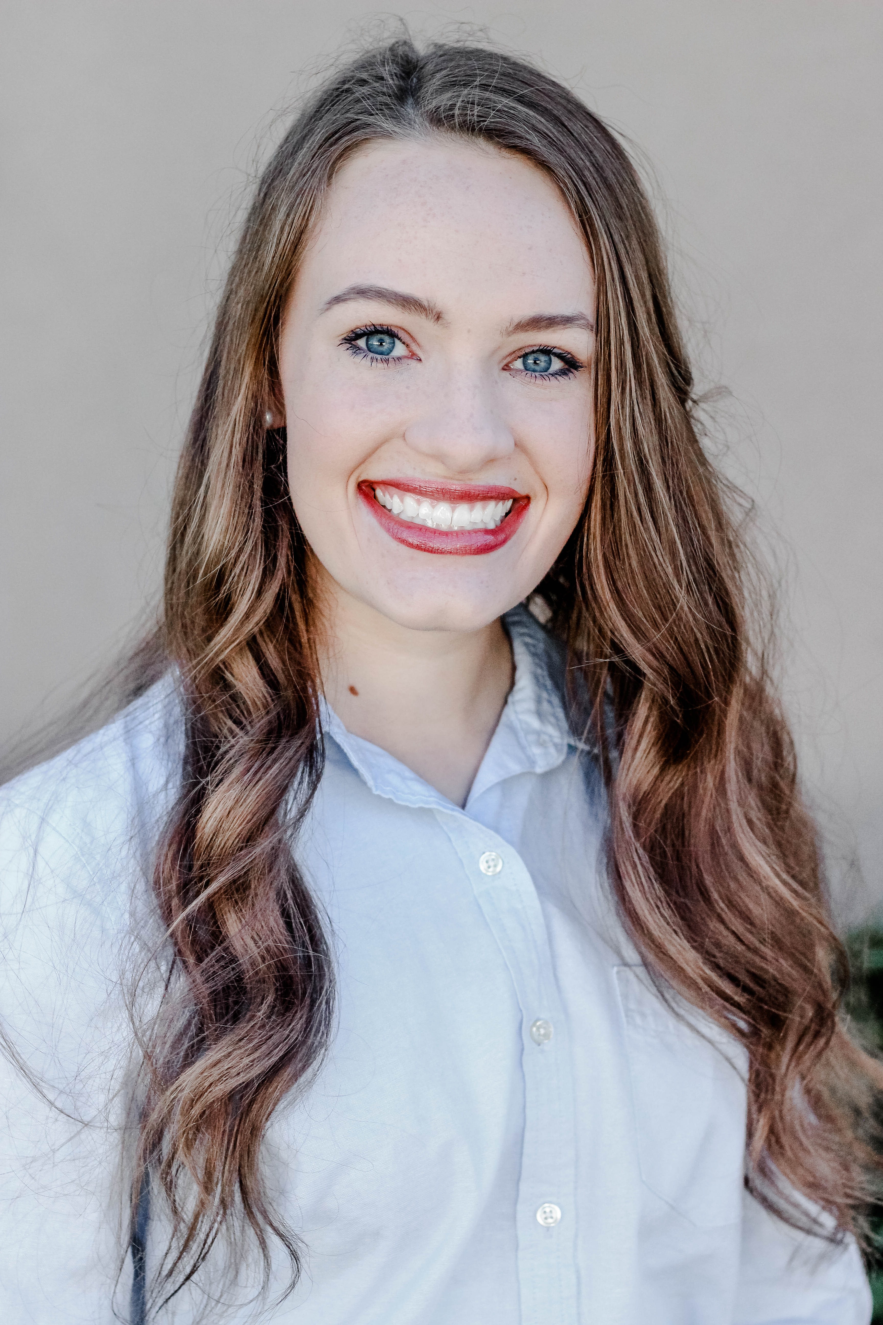

Emily Potts

Searching for Jumbo Bacteriophages that Infect Mycobacterium

Emily Potts, Trever Thurgood, Daniel Thompson, Donald P Breakwell, Julianne H Grose

Jumbo bacteriophages are large phages with extremely large (> 240 kB ) genomes. They are often not found using standard isolation procedures due to their inability to move through standard top agar and form visible plaques. The Brigham Young University phage hunters searched for jumbo mycobacteriophages using non-standard top agar including top agar with lower agar concentrations and agarose-based top agar. We will present the jumbo phages found using these techniques and compare them to previously isolated jumbo phages as well as other mycobacteriophages.