CONSIDER FOR TALK

10th Annual SEA Symposium Abstract

University of Evansville

Evansville IN

Corresponding Faculty Member: Ann Powell (ap96@evansville.edu)

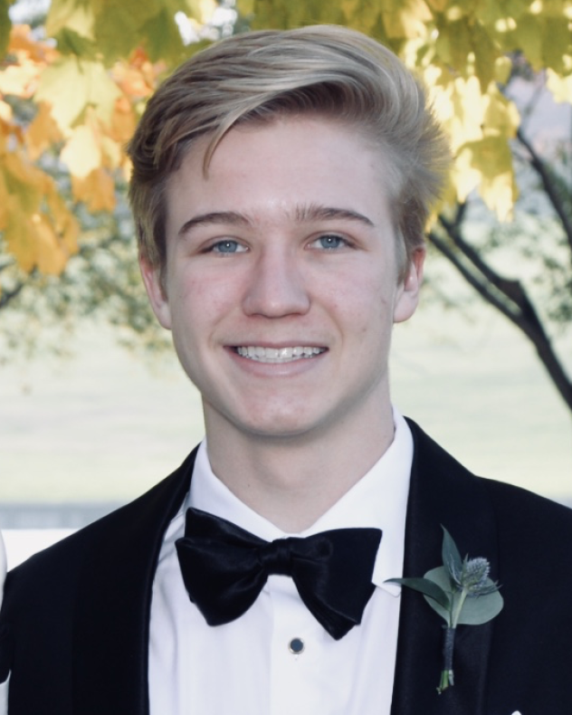

Ian Alberts

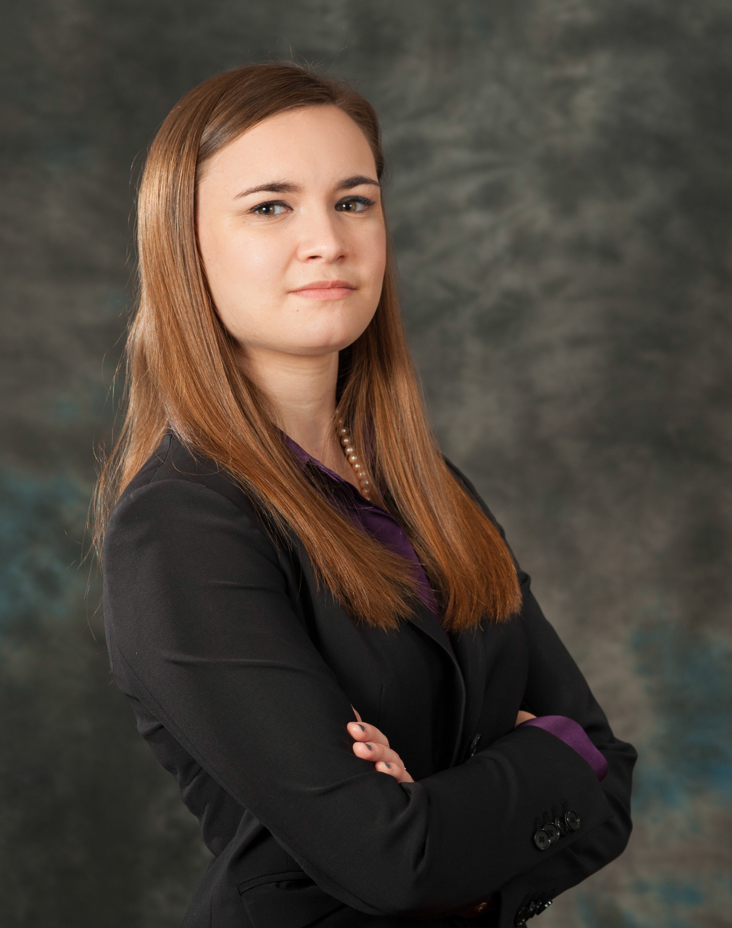

Corinne Croslyn

The discovery of Megamind, an isolation and annotation that required a lot of brain power

Ian Alberts, Corinne Croslyn, Evan Barnett, Tessa Hemmerlein, Jeremy Schmidt, Kristen Sportiello, Margaret Wolf, Ryan Wood, Joyce Stamm, Ann Powell

As part of our participation in the HHMI SEA-PHAGES program, we analyzed the genome of phage Megamind. Megamind produces small, clear plaques about 1 mm in diameter and has the Myoviridae morphotype. Megamind is a member of subcluster C1 and has 99% identity to the mycobacteriophage Ava3. Megamind was auto-annotated with DNA Master using GeneMark and Glimmer predictions. Auto-annotation showed that the Megamind genome was 154780 bp long with 225 genes. We then refined the genome annotation by using BLAST to compare the nucleotide sequence of all auto-annotated genes to genes in the PhagesDB and NCBI databases. We also examined Phamerator maps and Starterator to help determine the correct start of genes and utilized NCBI BLAST, HHPred, and Synteny to assign function to genes. Our analysis showed that Megamind contains 230 structural genes, 5 more than predicted by auto-annotation. Only 46 of these genes have known functions. We also developed PCR primers to determine phage identity for two complete-genome contigs resulting from a DOGEMS sequencing run for a mixture of genomic DNA from three phages (Primrose, Shelob, Tambudzayi). We plan to annotate the genomes for these two phages and compare them to the genome of Megamind.